**MOBILE COMPUTING WORK**

**LECTURE N0:02**

First, we create repository in github named Mobile_Computing_Progress.

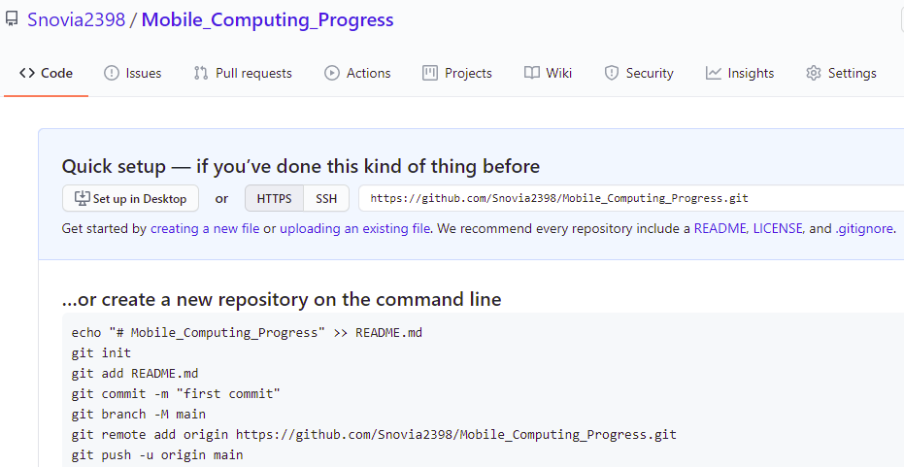

Make folder in your PC named git.



Then using command prompt go to ‘git’ folder using command cd ‘path of that folder’. Run command git clone ‘repository url’.

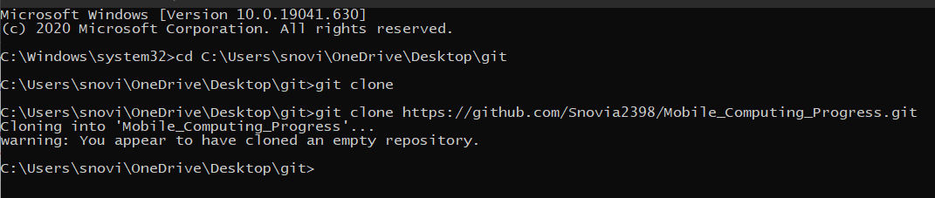

A folder/clone with same name as that of repository is created in folder ‘git’:

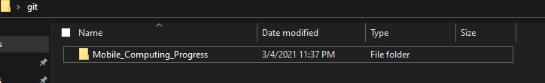

Create a file in this clone/folder and save the file. 1 on the share/Bluetooth video sign shows that same change will have to show in repository.

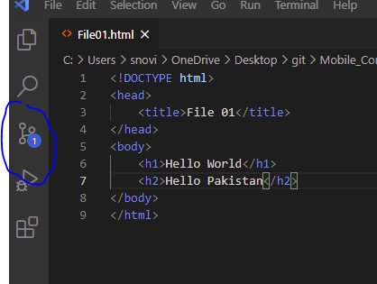

Now add this file to repository using following commands in command prompt.

git add File01.html

git commit -m “First commit ”

git push

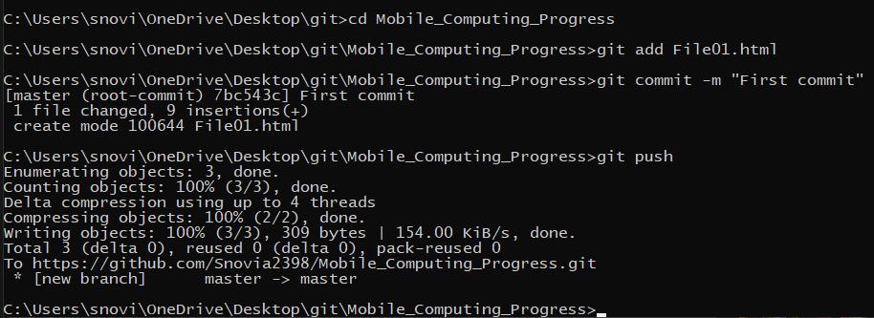

File is added on github

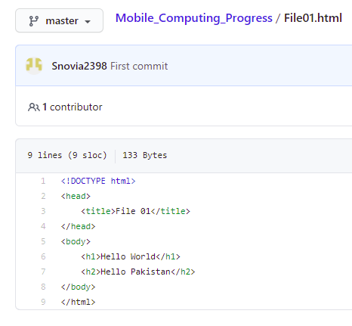

and that sign disappear

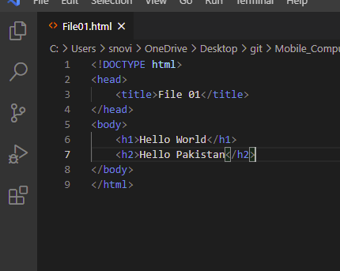

Now make any change in this file in local repository and you see again that sign appear when you save the file because that change is only in local repository but not in online repository.

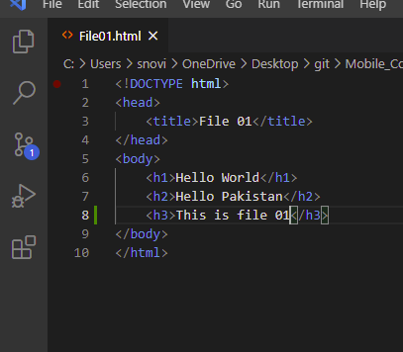

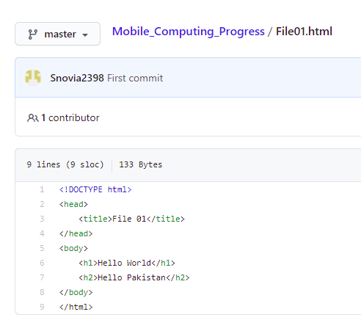

To make changes in online repository also and to remove that sign again run those three commands.

git add File01.html

git commit -m “First commit ”

git push

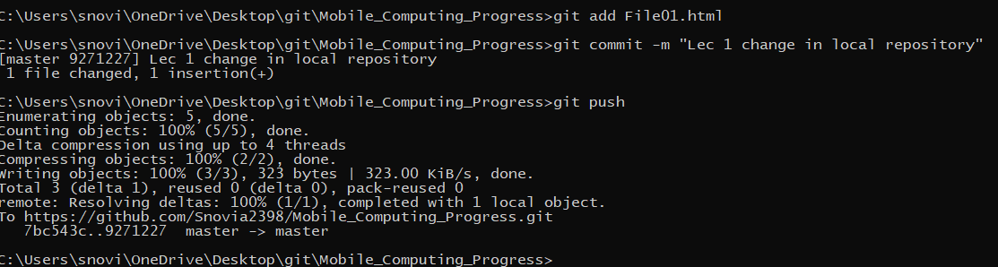

Result is:

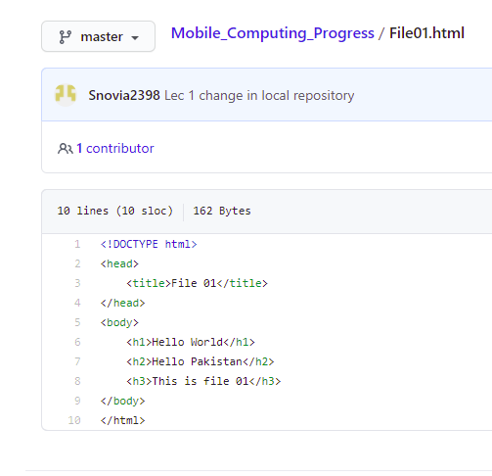

**LECTURE N0:03**

Make any change in file in the git hub online repository not in local repository and you see changes not occur in local repository.

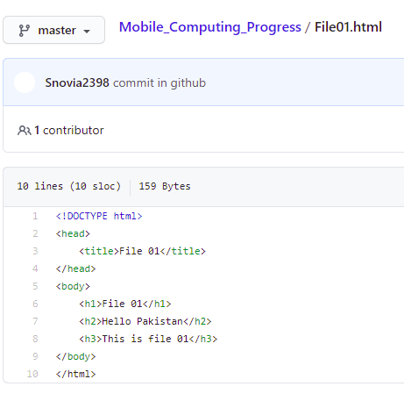

Heading 1 change but that is not changed in local repository.

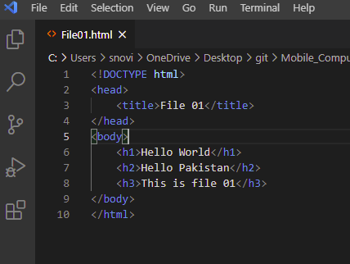

To make change in this file also use command:

git pull

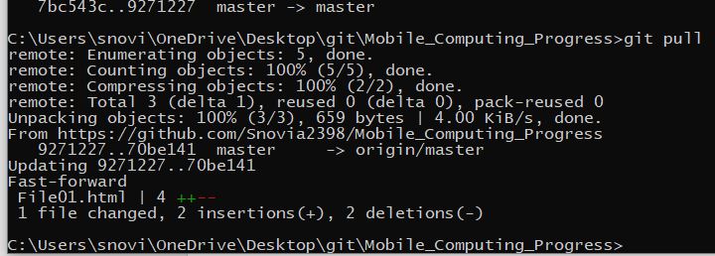

And you see change also occur in local repository.

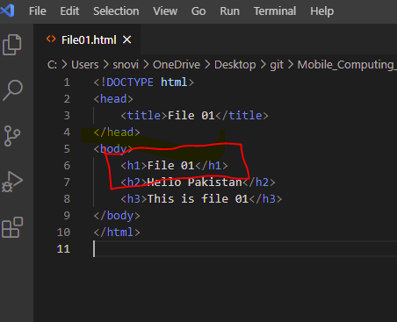

Now see the merge conflict:

When you make changes in both local and online repository conflict occur for example make change in file 1 in online repository

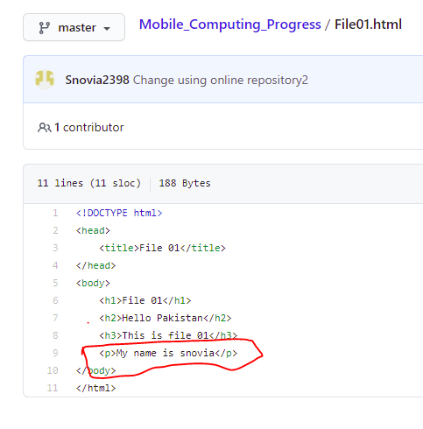

Also change the file in local repository:

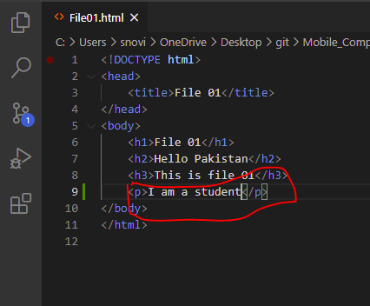

When you commit and push this change to github using command prompt it give error:

git add File01.html

git commit -m “change in local repository2 ”

git push

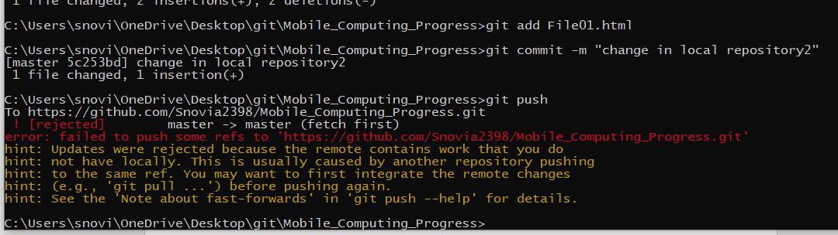

To resolve this issue first run the following command on command prompt

git pull

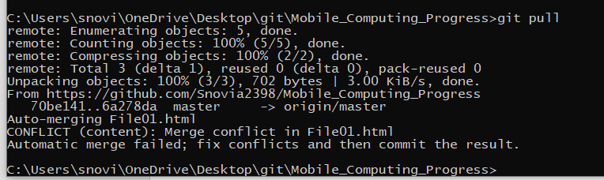

Now in local repository you see file like this:

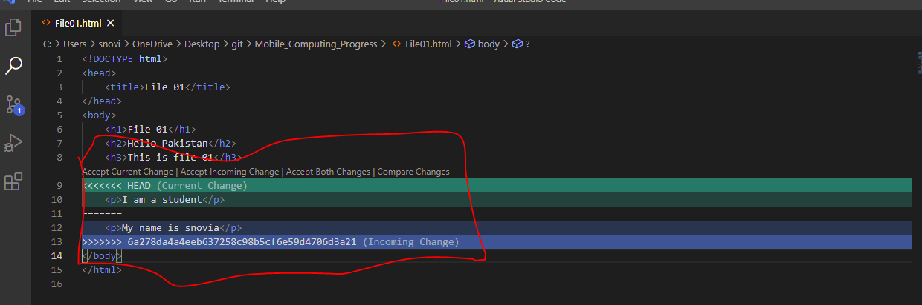

Choose any one option and then push this file to git hub and merge conflict is resolved.

git add File01.html

git commit -m “merge conflict resolved ”

git push

I choose github change by clicking incoming change.

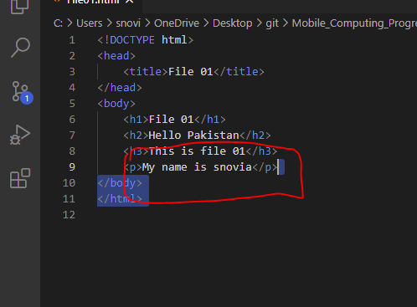

Now run above commands:

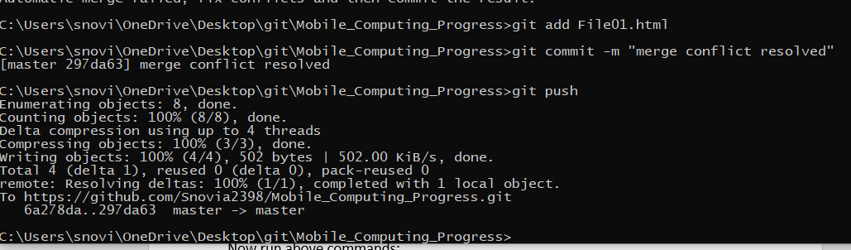

And you see commit change and file in github is present with same change as in local repository.

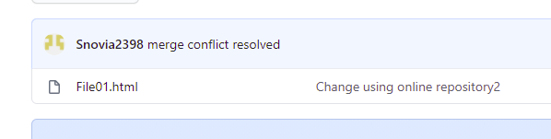

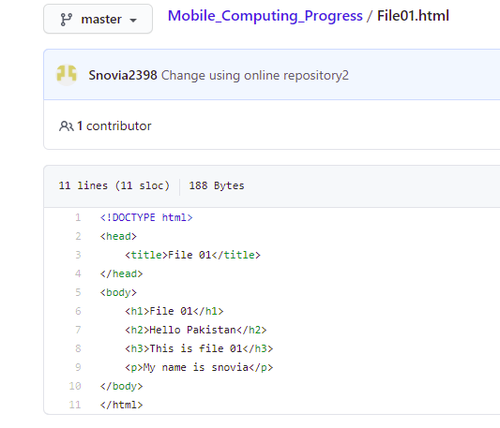

Now make two more files in repository clone

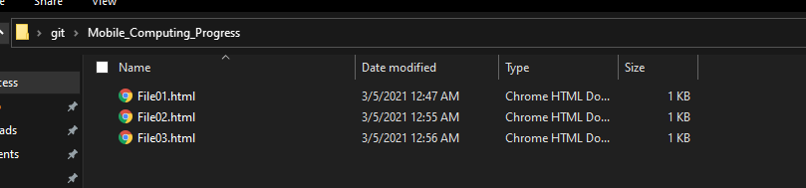

You see two more files are now present in clone folder and now ‘2’ appear because change occur in two files.

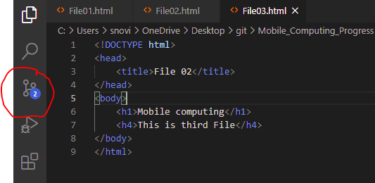

Now push these files to github by using those three commands:

git add File02.html File03.html

git commit -m “Files two and three are added”

git push

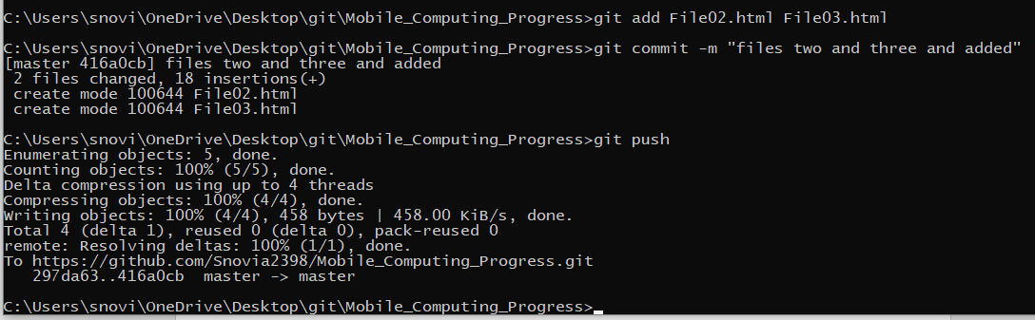

And you see these are present in github

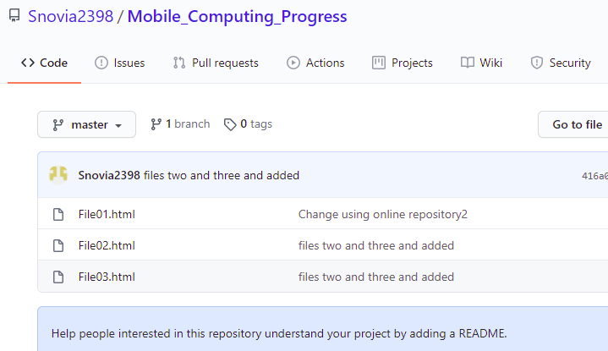

Now delete file 3 by using following command:

git rm File03.html

git add .

git commit -m “”file 3 deleted”

git push

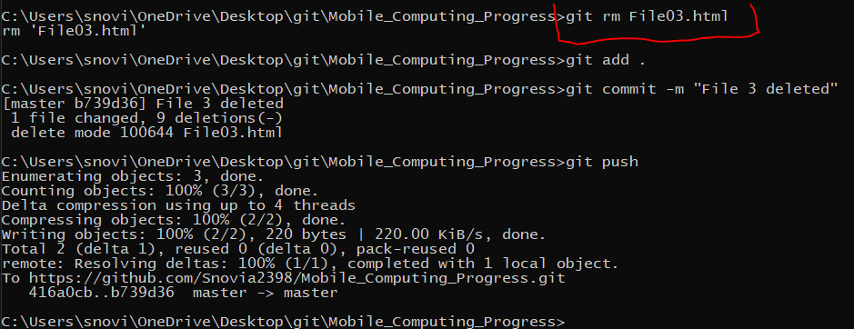

And you see file is deleted

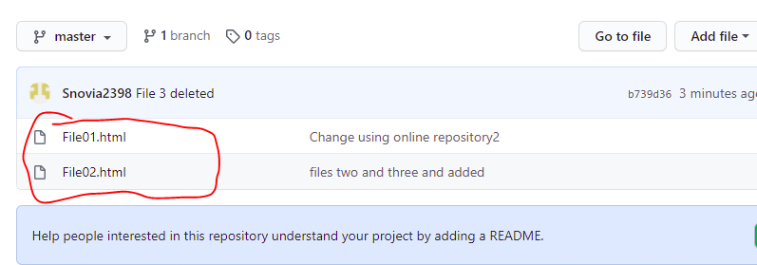

And

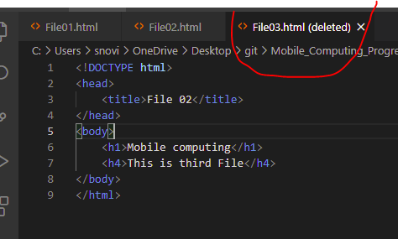

To see the details of commits we use the following command:

git log

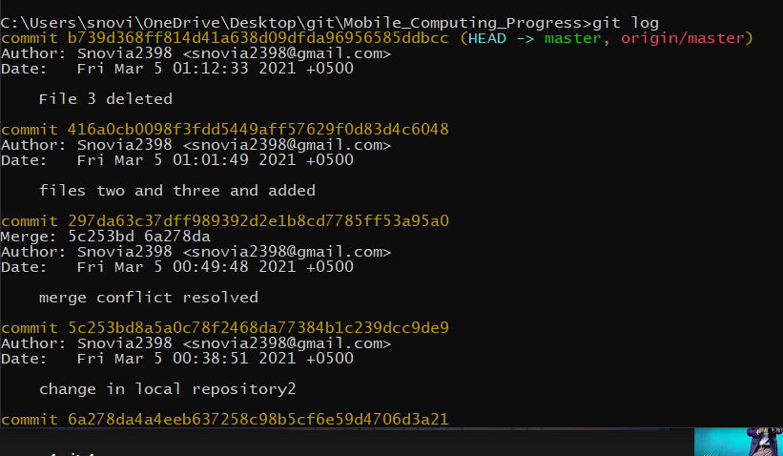

To check the branches we use command:

git branch

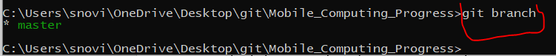

To create new branch we use command:

git checkout -b newBranch



Now your branch is ‘newBranch’

In file02 make changes because you are in newBranch

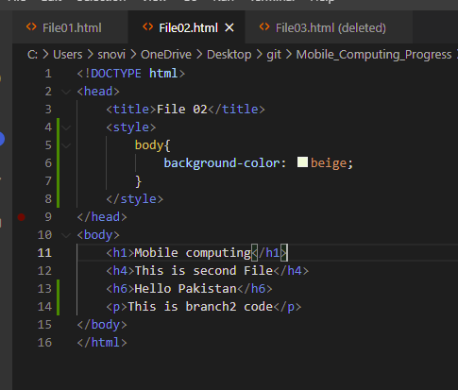

Add this and push this to github:

git commit -am “newBranch changes” (am is use to add and commit both)

git push

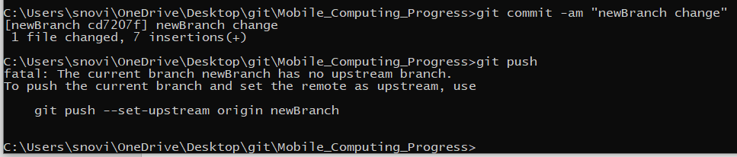

Now you will see when you are in branch ‘master’ code of that branch appear



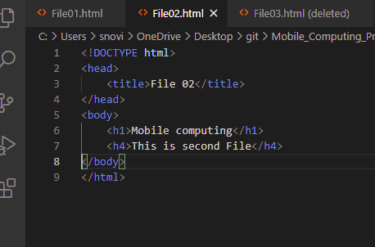

And when you are in ‘newBranch’ code of that appear:

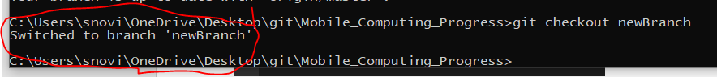

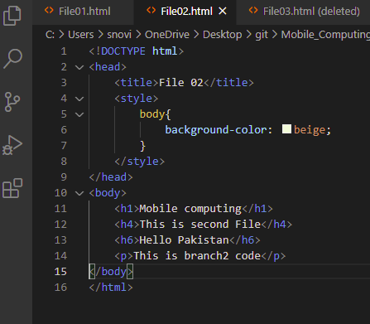

Now merge these two branches code:

First go to ‘master’ branch then following command is used for merging:

git checkout master

git merge newBranch

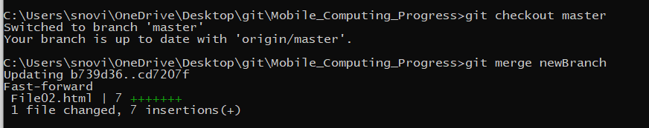

And you see the merging in file

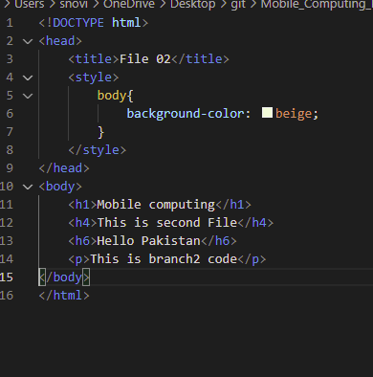

Now delete the ‘newBranch’ by using command:

git branch -D newBranch

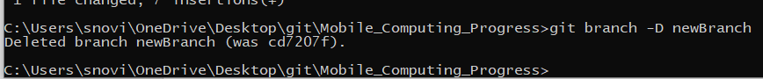

Check the branches:

git branch

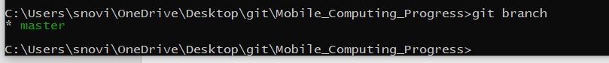

Now add and push the files to github using three commands:

git add .

git commit -a “Testing successful”

git push

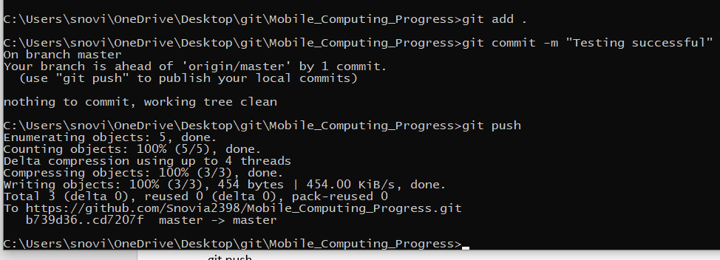

**LECTURE N0:04**

**Class Work:**

Create new repository in git hub as:

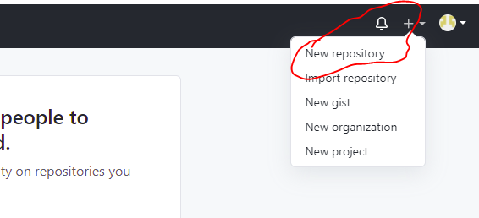

Name this repository ‘Lecture04_Android’ as:

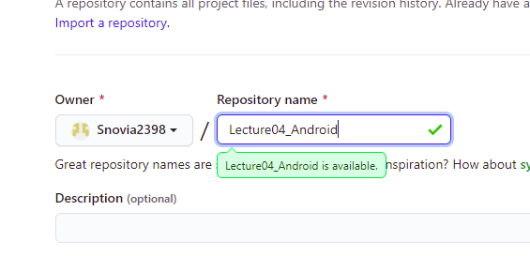

Keep it public and click on create repository as:

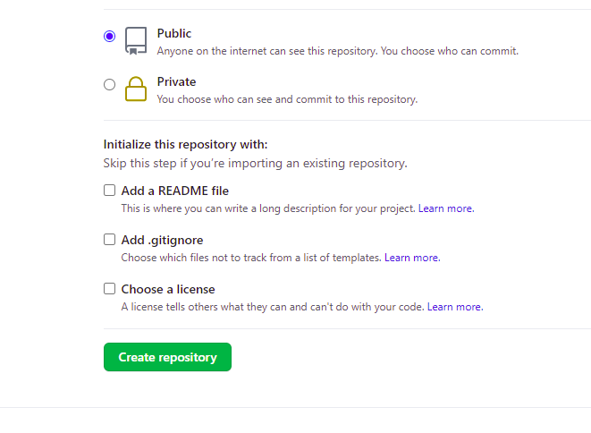

Go to git folder as:

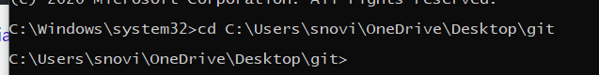

Create clone of repository by giving the url of repository as:

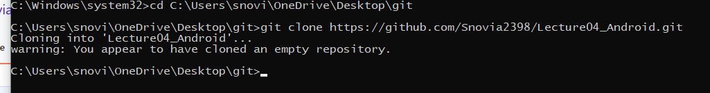

Now go to that clone in git folder:

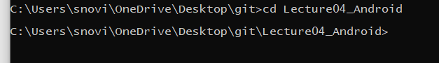

Now create android studio project file in this folder by clicking new project in new in file option:

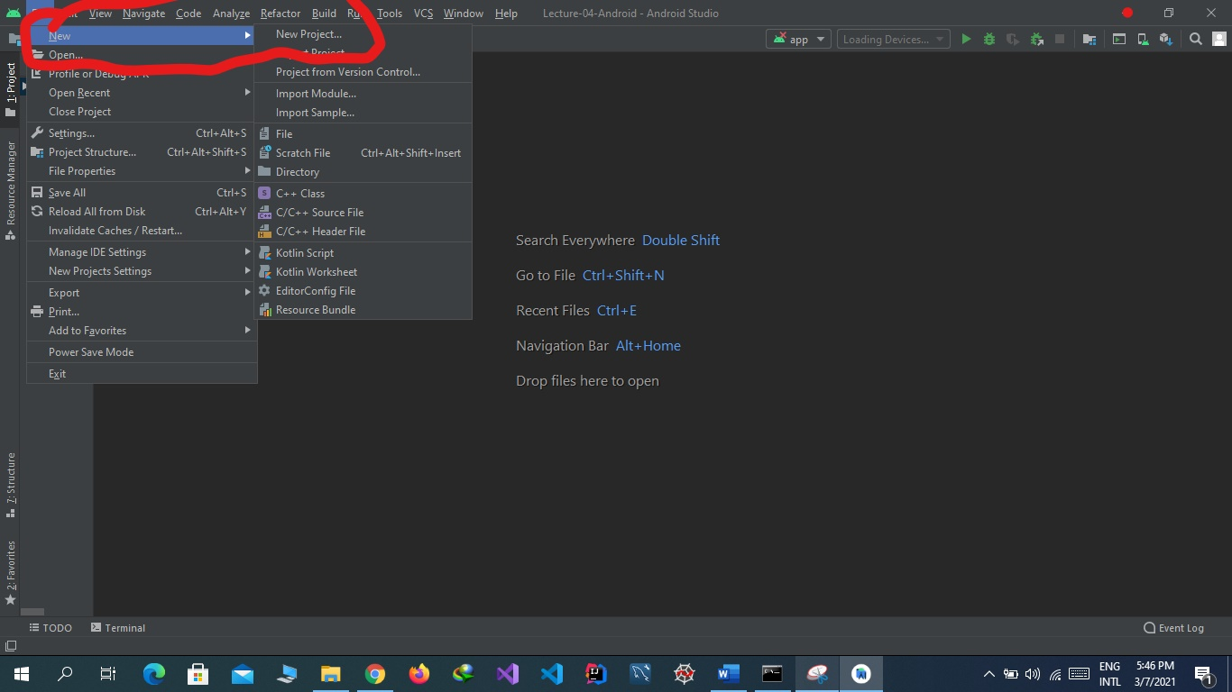

Now select empty project:

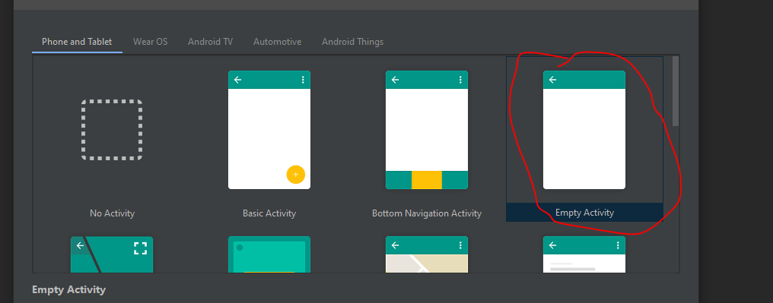

Select name of project, package name that is unique, give location of git hub folder in which clone is present that is location. Select language java and minimum sdk lollipop .

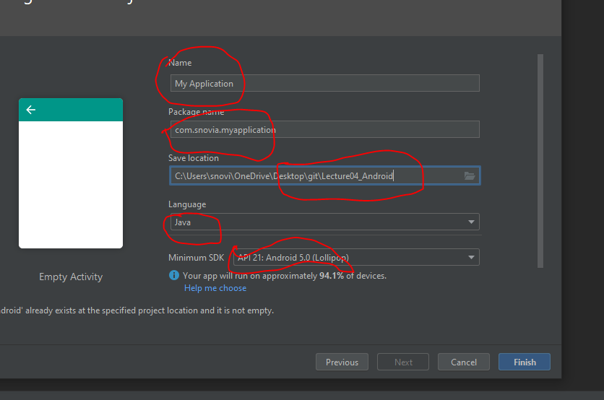

Now go to res option and then layout option and open file activity_main.xml and start work here:

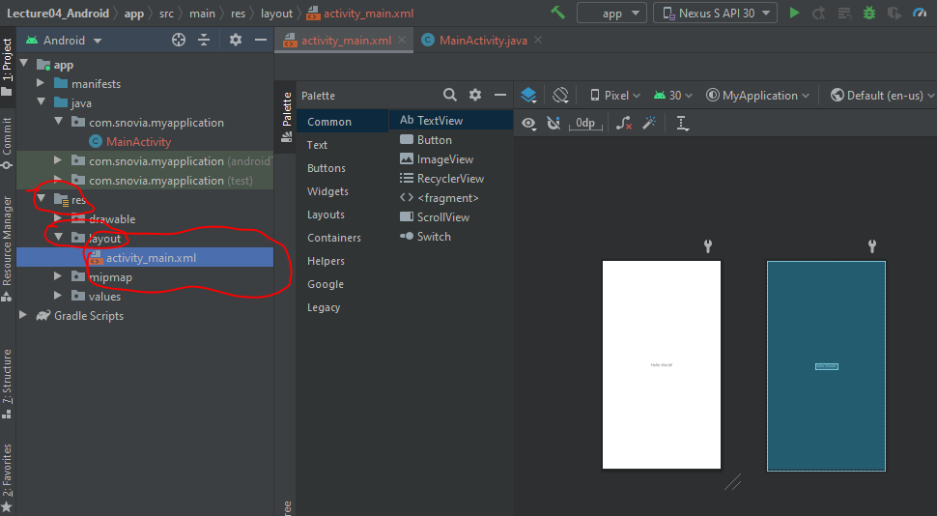

You can choose any design in I choose both:

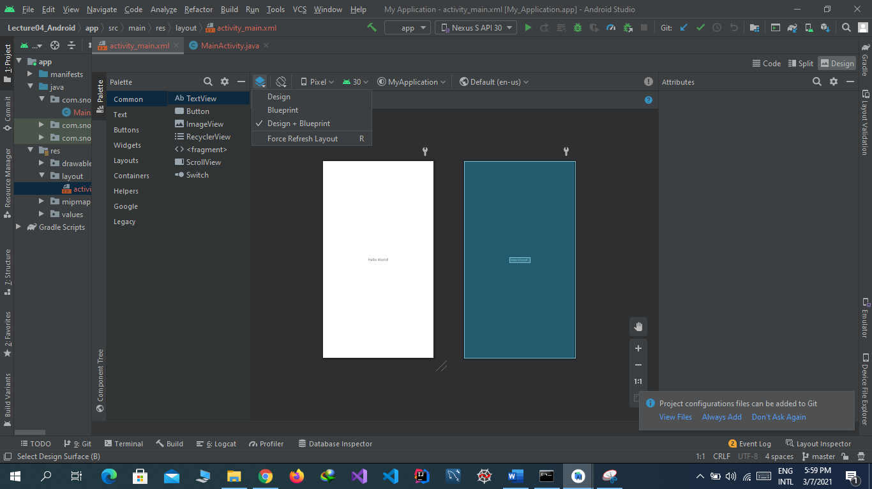

Now the text view attach with four springs. We can adjust position by removing any of these. I remove below spring and see that the text go above.

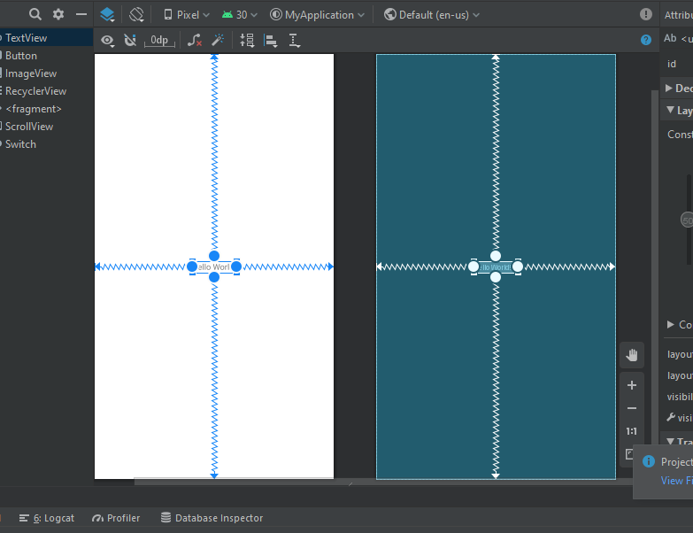

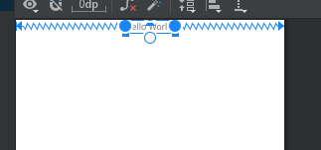

Now change the text by using window tab as select the text view and change the text as:

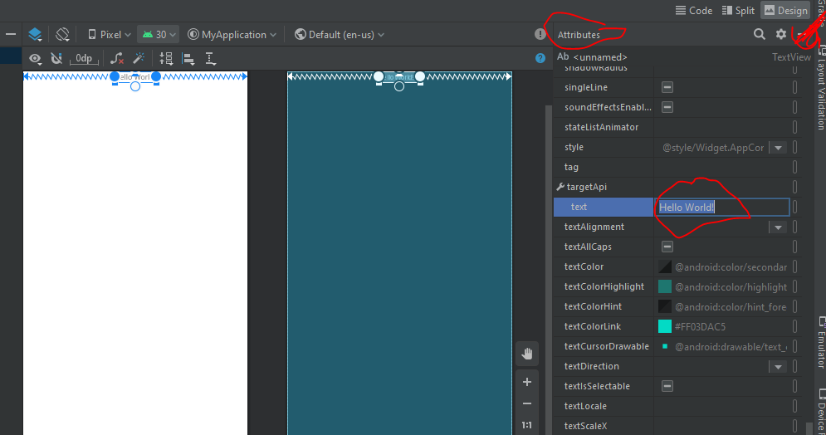

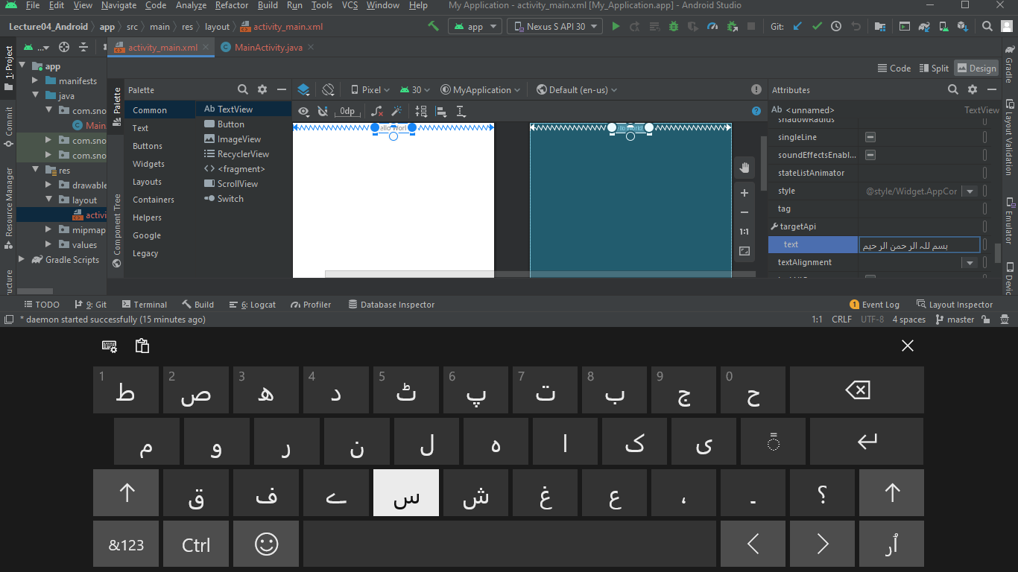

Run code from this:

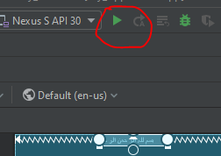

Now see the result:



Now increase its size :

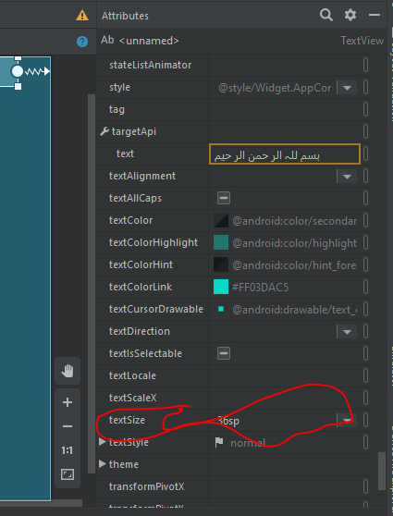

See the result:

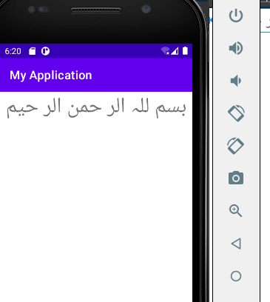

To give padding from the top see this:

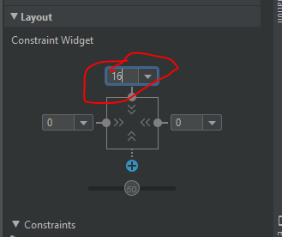

Now see the result:

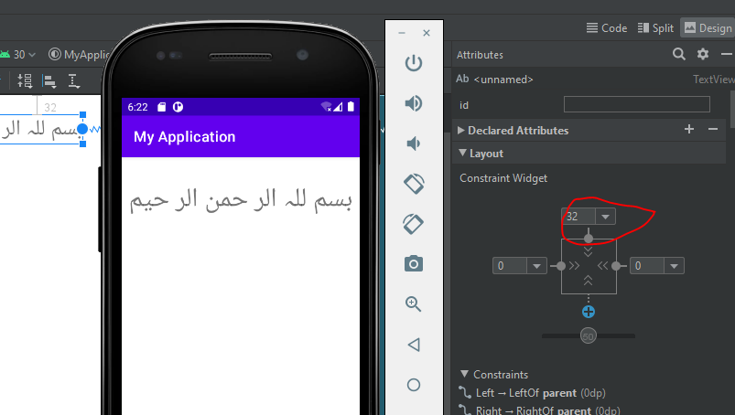

**Home Work:**

**Create three pages**

**First Page:**

Decrease padding to move text to above on the page. Give padding 16 and decrease the size to 14sp.

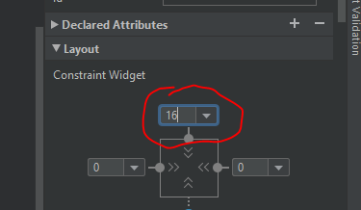

and text size is 14sp:

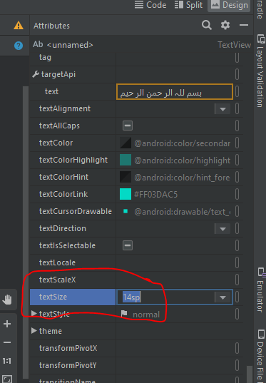

Align text to the center:

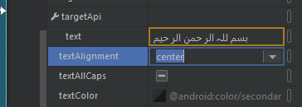

Give italic style:

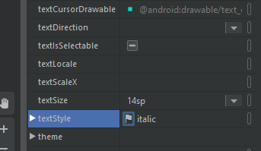

Give color to text now:

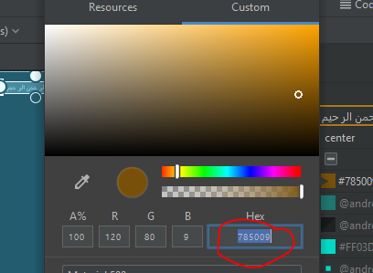

It is in option text color in attributes as:

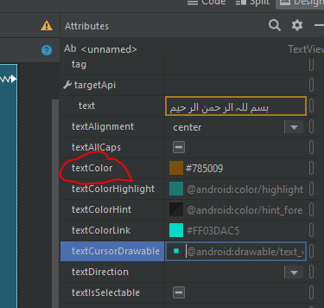

Now see the result:

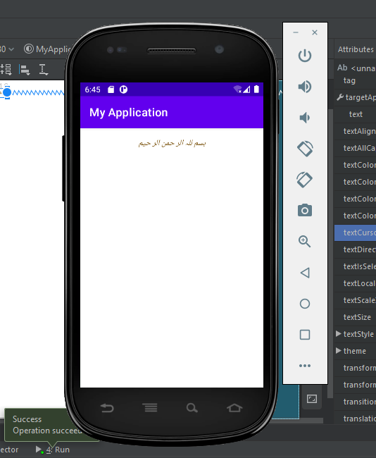

Now add text view by drag and drop from text view option in common option in palette option as:

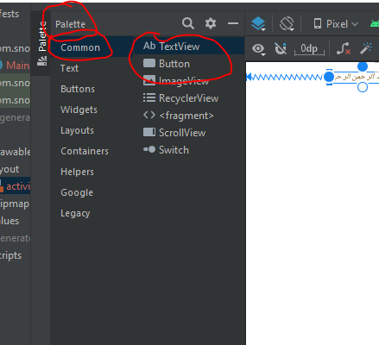

Drag and drop the text view result is :

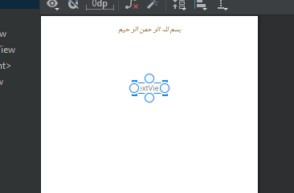

Now add springs from above left and right as:

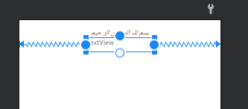

Now add text to it as:

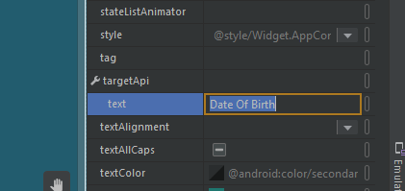

See results:

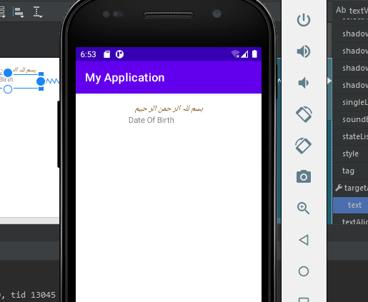

Increase its size:

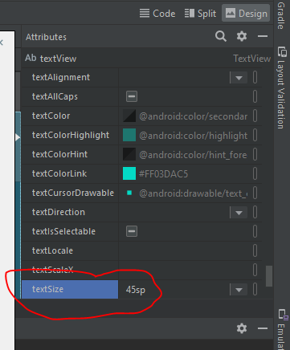

Change the text color:

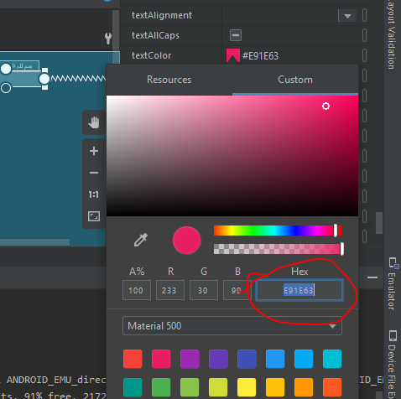

Align this text to center:

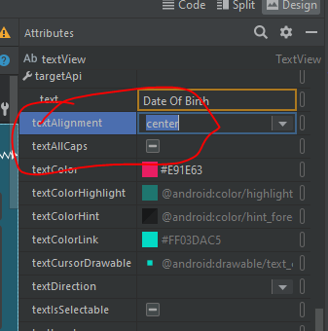

Now give text tyle bold:

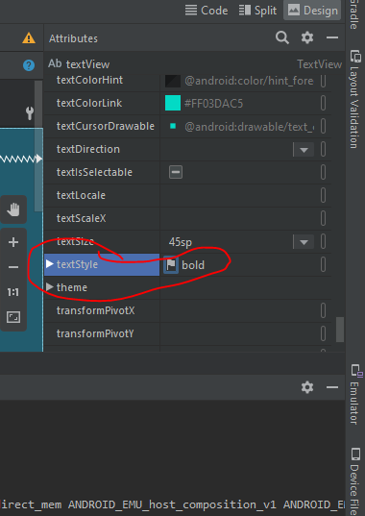

Give top padding 8:

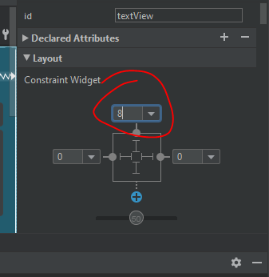

Now see the results:

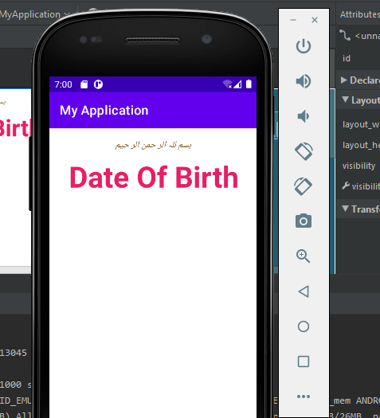

**Second Page:**

Now again add text view by drag and drop from palette->Common->TextView as:

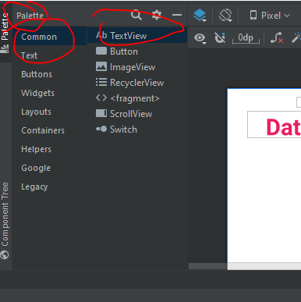

After drag and drop result is:

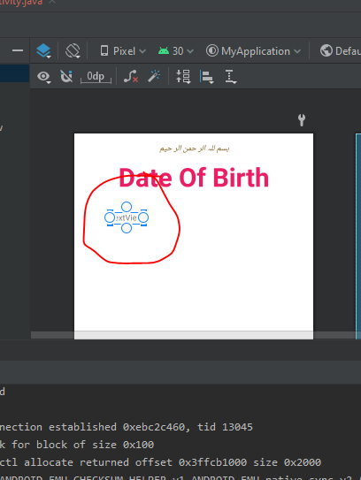

Now add springs from above and left side:

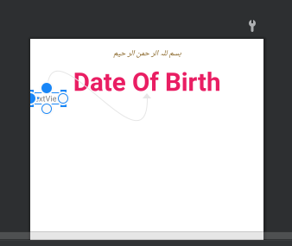

Now add text to it as:

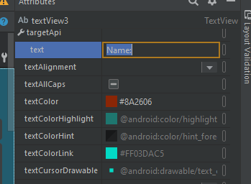

Change the color of text:

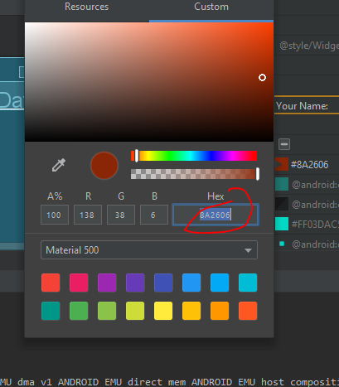

Give text size 18sp:

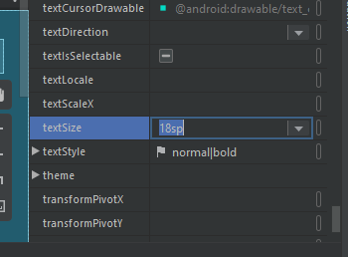

Now give padding from top 16 and from left 8 as:

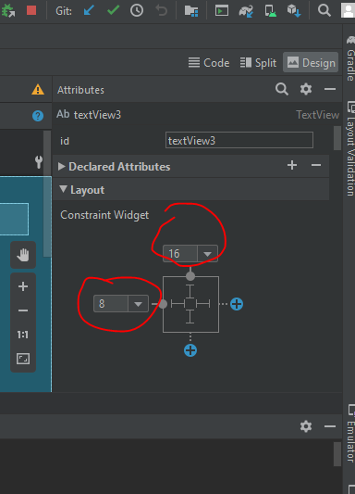

Now see the results:

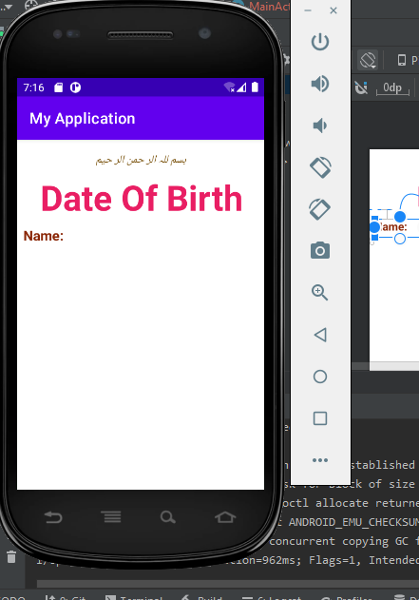

Now add plain text by drag and drop from palette->Text->plaintext as:

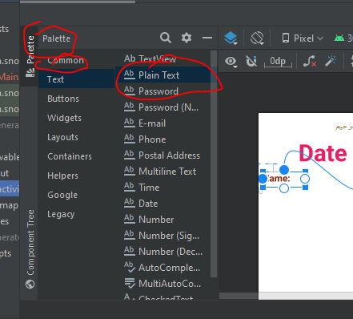

After drag and drop result is:

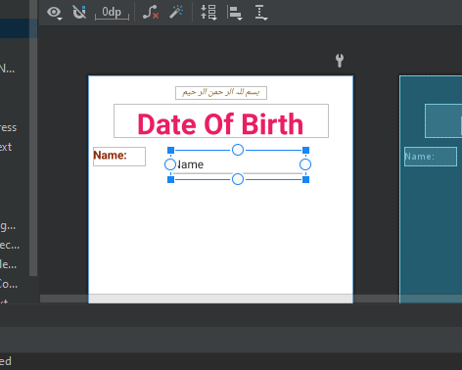

Now add springs:

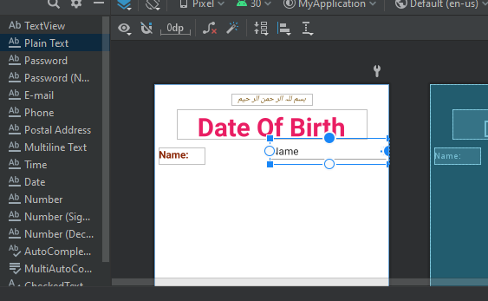

Text keep empty:

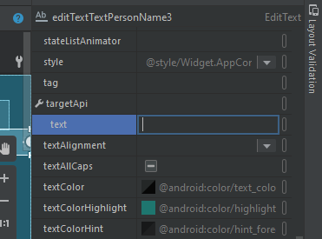

Give size 18sp:

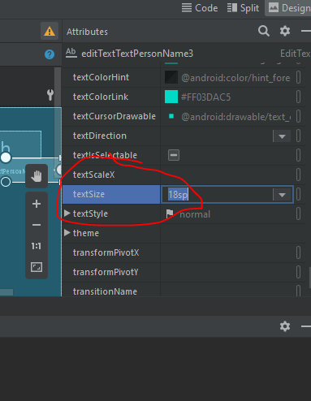

Give color to the text:

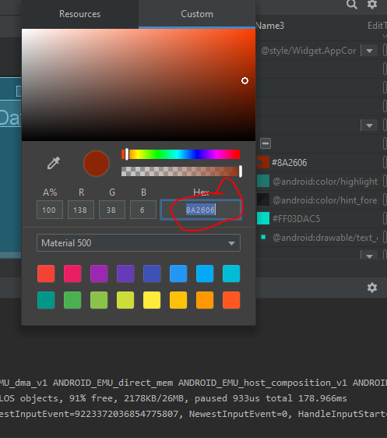

Add padding from right side 16:

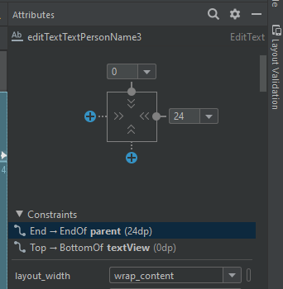

Now see the results:

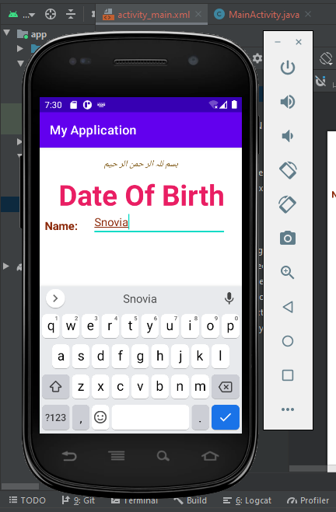

**Third Page:**

Add calendar by drag and drop from palette->Widgets->CalendrarView as:

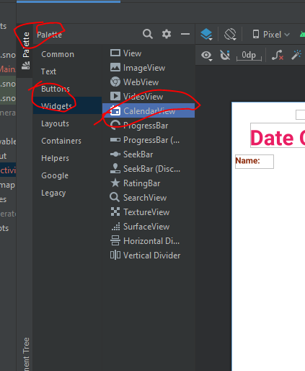

After drag and drop result is:

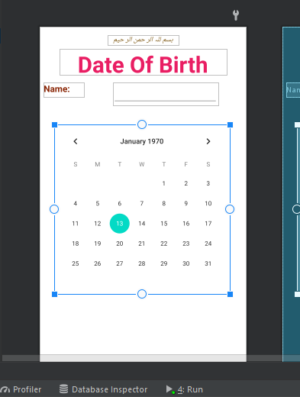

Add springs:

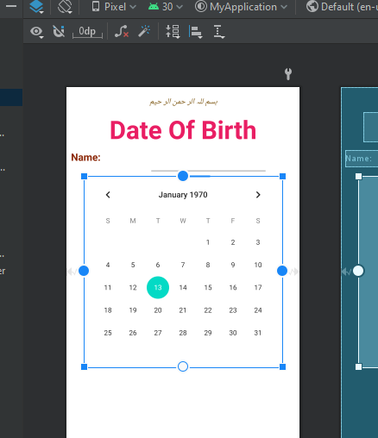

Add padding from the top 8:

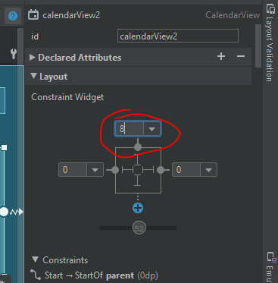

See the results:

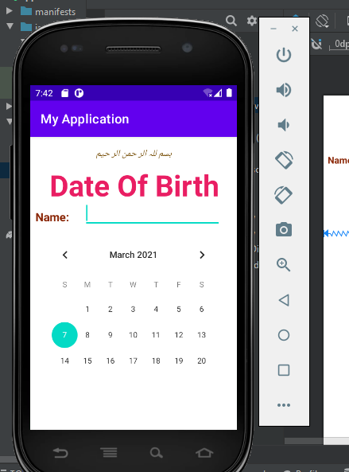

Now add button to submit the data.

For this add button by drag and drop from palette->buttons->button as:

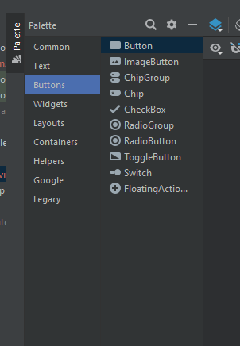

After drag and drop result is:

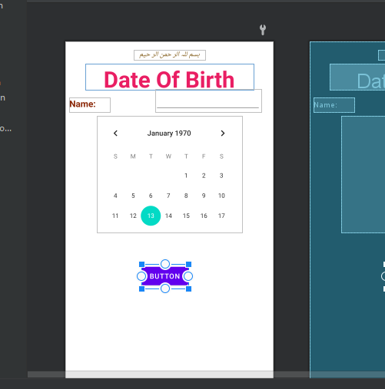

Add springs to left , right and above:

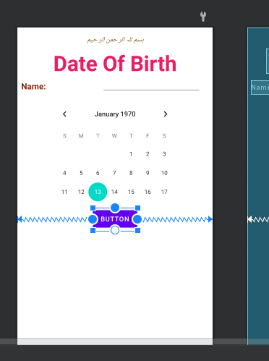

Add text to it:

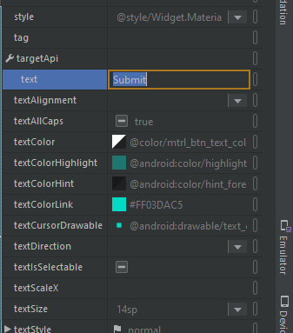

Give color to text:

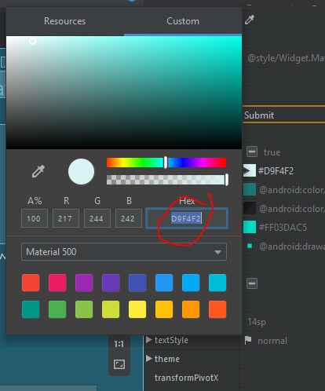

Add padding 8 from top as:

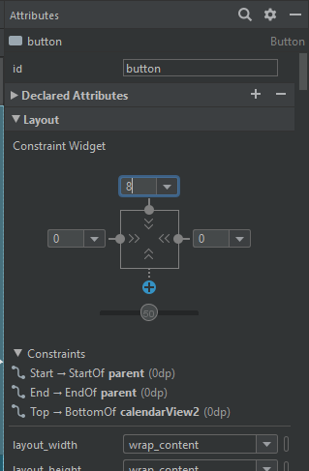

See the results:

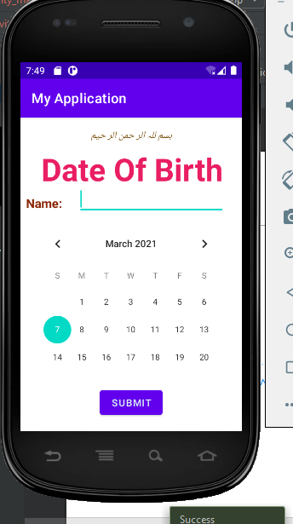

**LECTURE 05**

Create a new repository in github as:

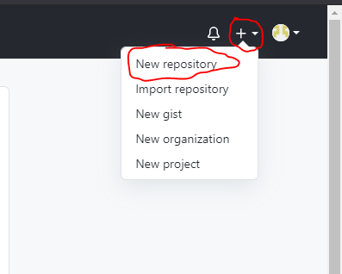

Name this repository lecture05_Android as:

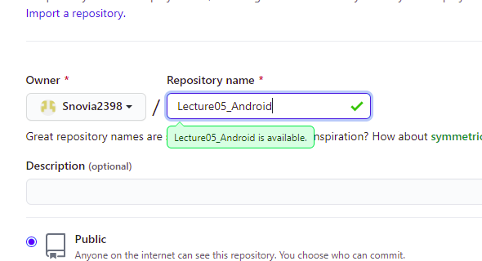

Click on create repository:

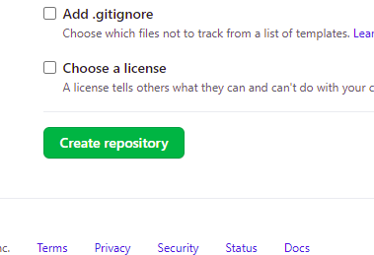

And repository is created:

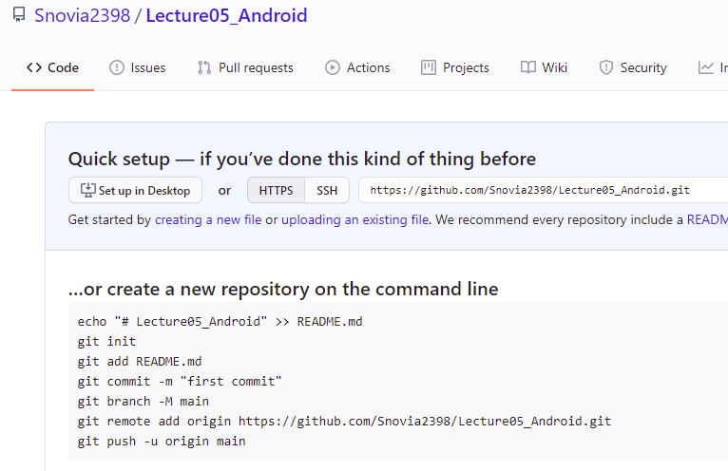

Go to git folder in desktop:

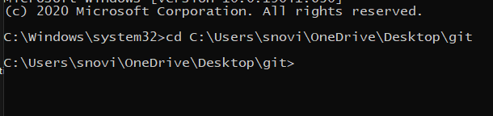

Create clone of repository in this folder by giving the path of repository in command prompt using command git clone address:

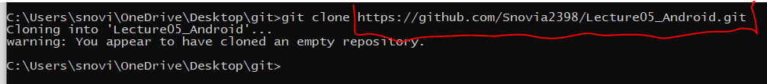

See clone is here:

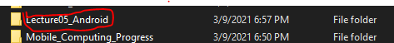

Now create folder in this clone folder named Lecture05:

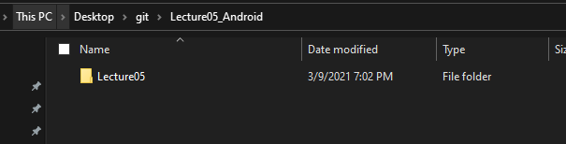

Go to clone folder:

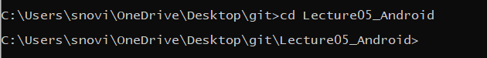

Create a android new project as:

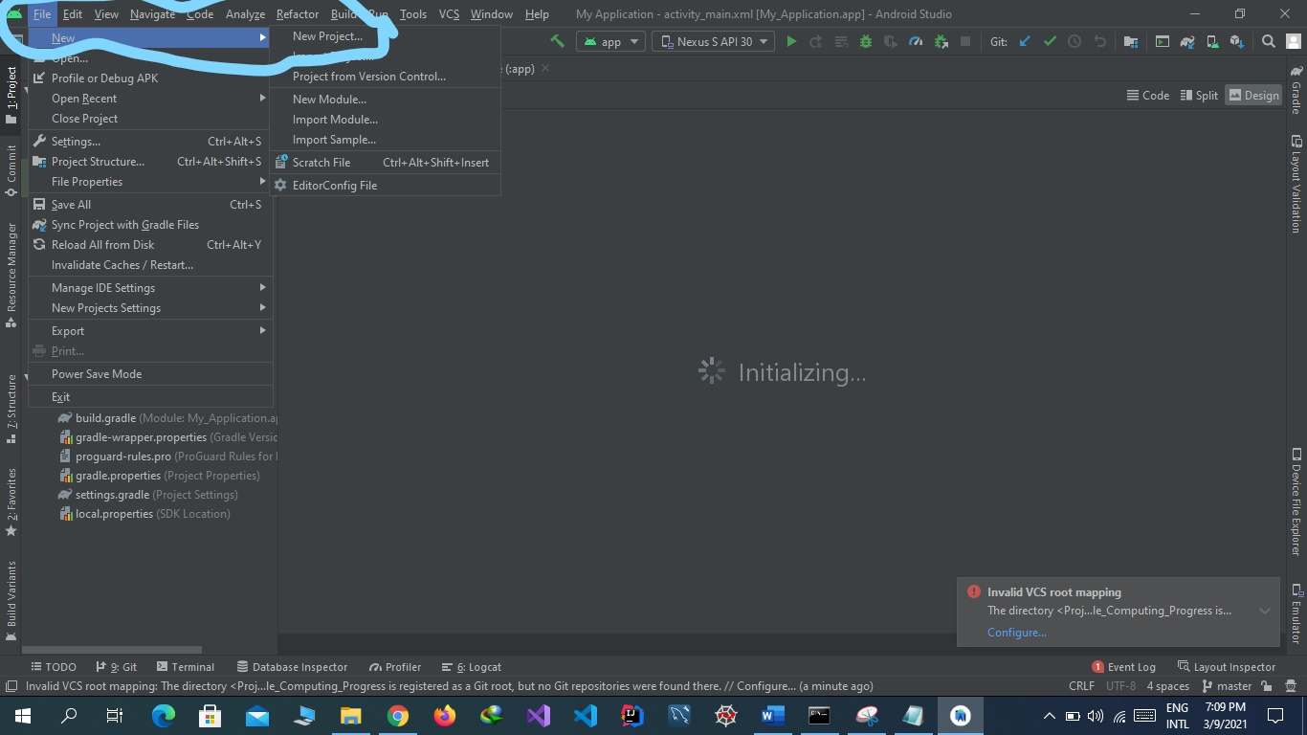

Select empty template and click on next:

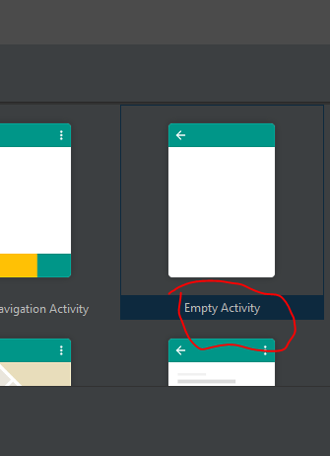

Set name, package name, location language and minimum sdk and click on next button :



Project is created then create a new layout file as:

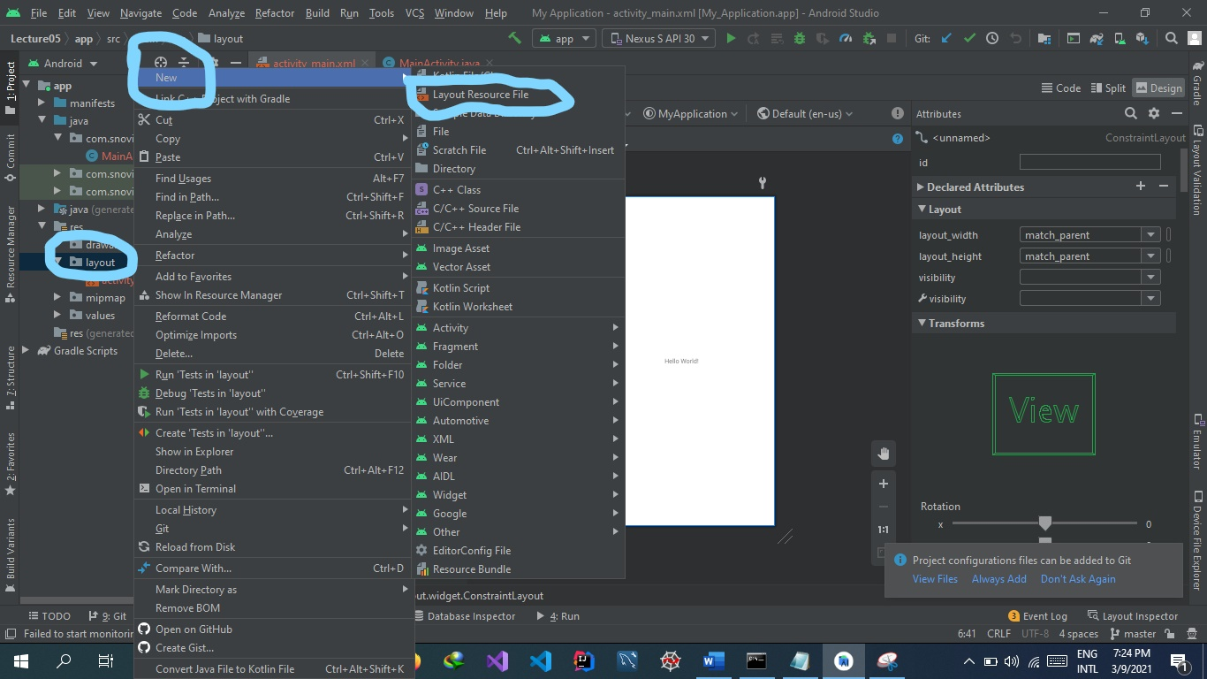

Name this file and select layout and click on finish/ok button:

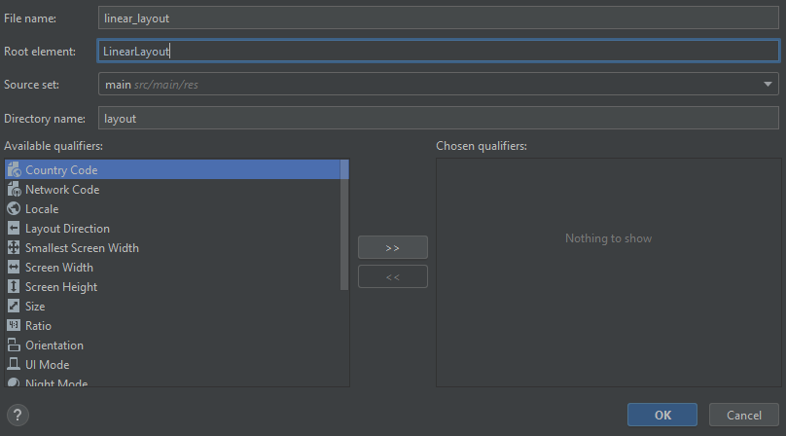

See file layout file is here:

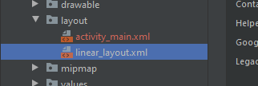

Now insert a textView by drag and drop in its design:

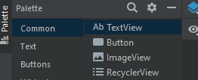

After drag and drop:

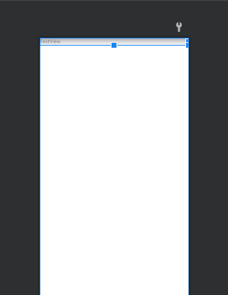

Now add a button by drag and drop: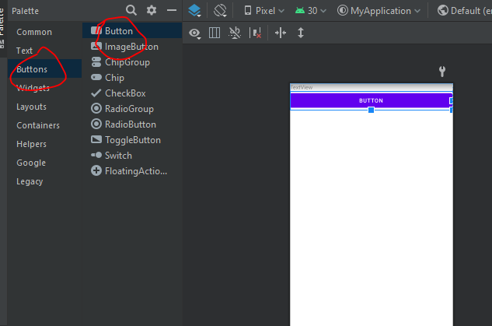

Change the text of text view and button as:

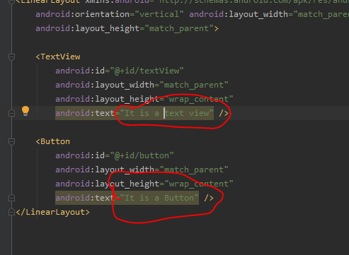

See the text change in design view automatically:

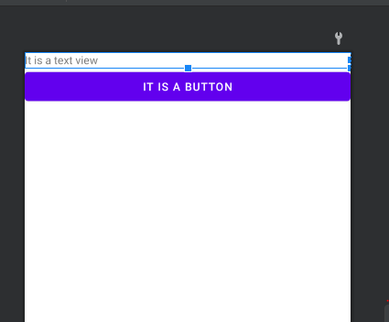

Now set the content type to linear_layout instead of activity_main.xml to run the linear_layout code as:

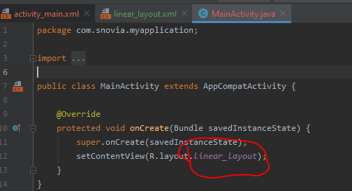

Run the code and see this file output is displayed now:

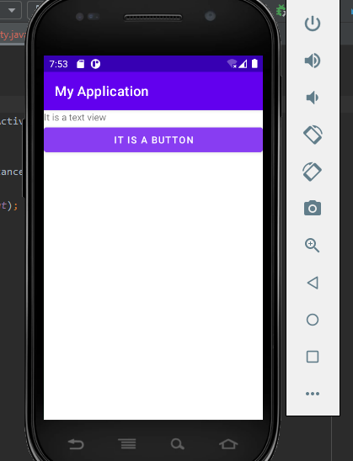

Push the android project folder Lecture05 to github using commands:

git add Lecture05

git commit -m "Linear layout apply"

git push

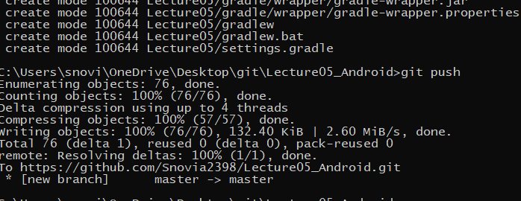

See the folder is in the repository

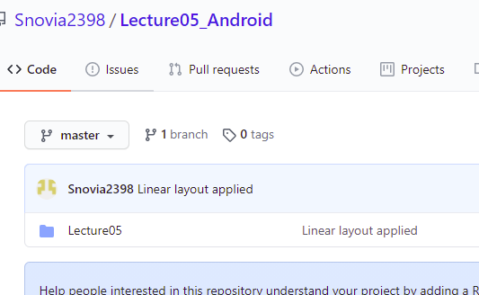

Create a button and add springs to it as:

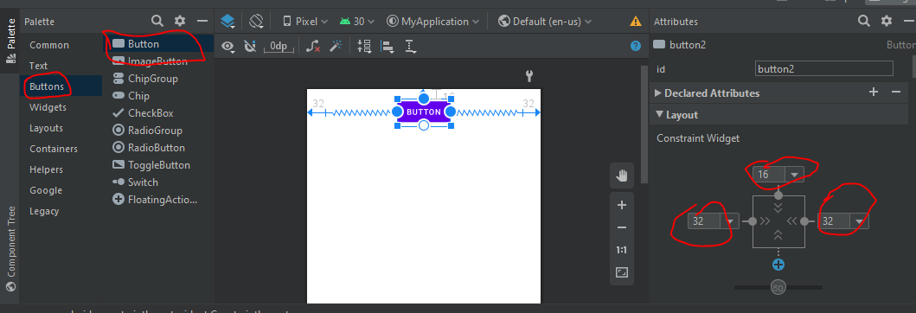

See the results:

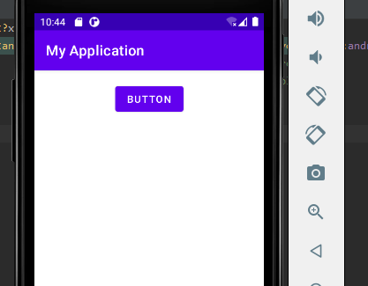

If we right click the button we can delete all constraints as:

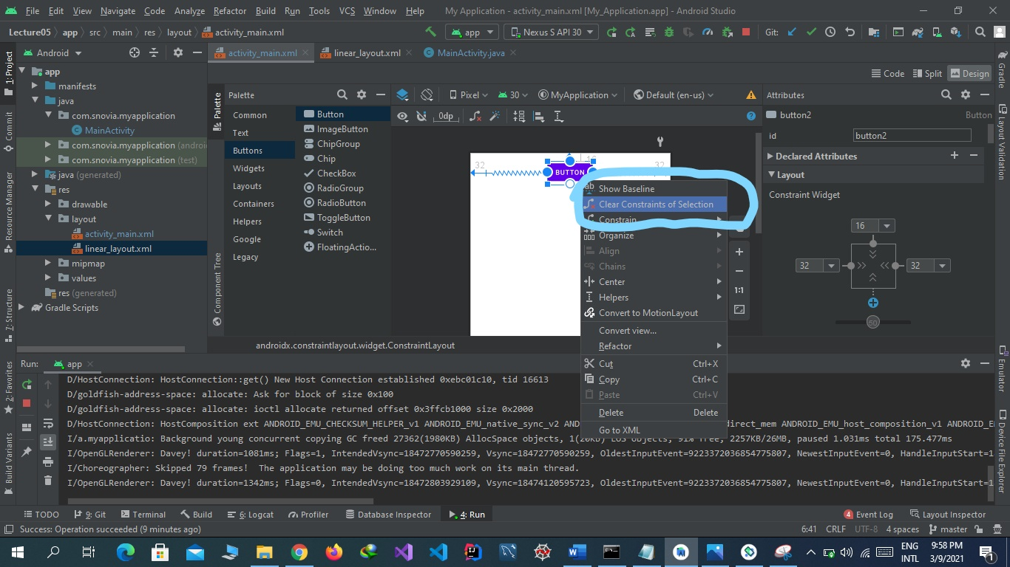

Push this to github as:

git add Lecture05

git commit -m "without constraints"

git push

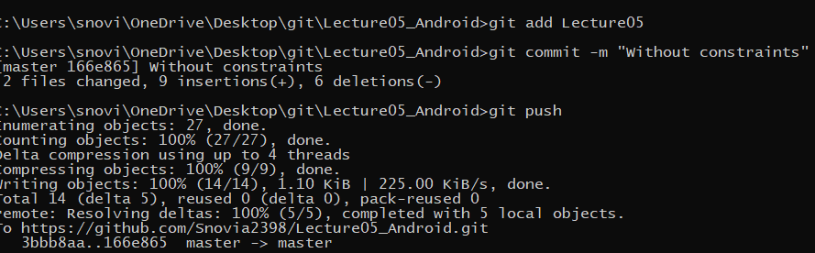

See all constraints are deleted:

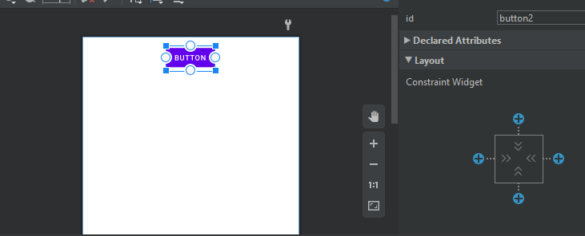

See the result:

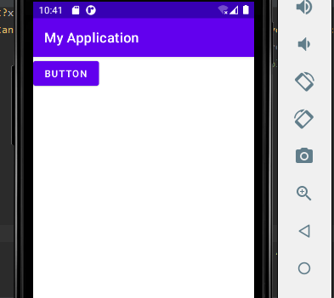

Again add this to github:

git add Lecture05

git commit -m "Delete constraints"

git push

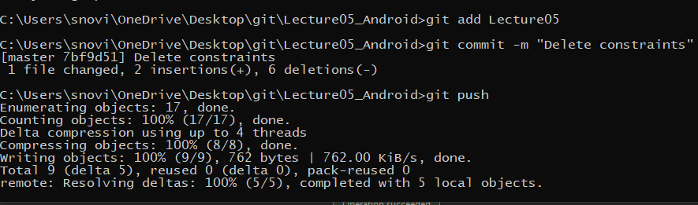

See commit on github:

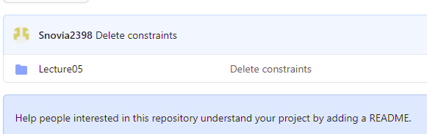

Add 8 buttons by drag and drop as:

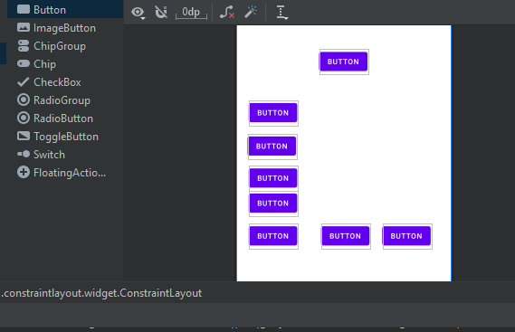

Now add springs:

Above button as:

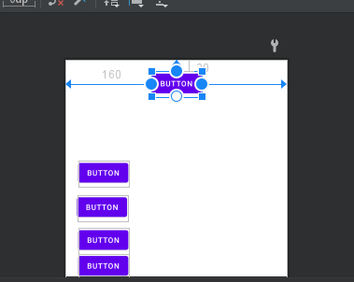

Button 1 as:

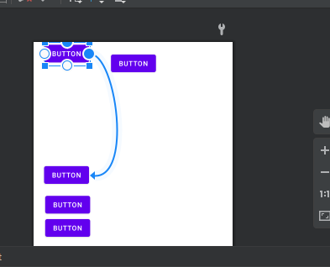

Button 2 as:

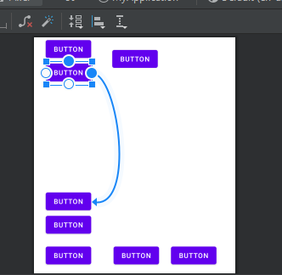

Button 3 as:

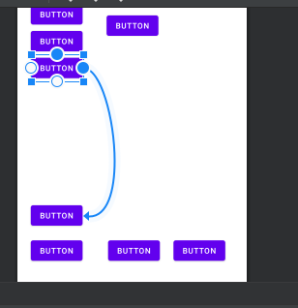

Button 4 as:

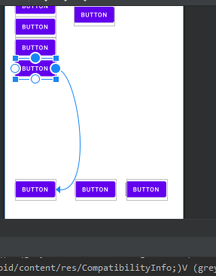

Button5 as:

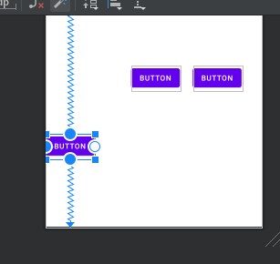

Button 6 as:

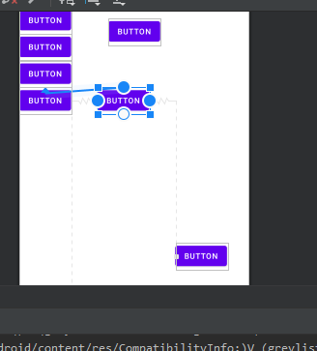

Button 7 as:

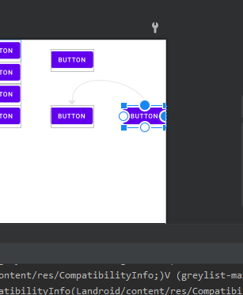

Output is as:

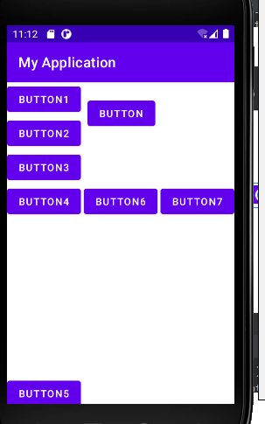

Push this to github:

git add Lecture05

git commit -m "Buttons layout before changing"

git push

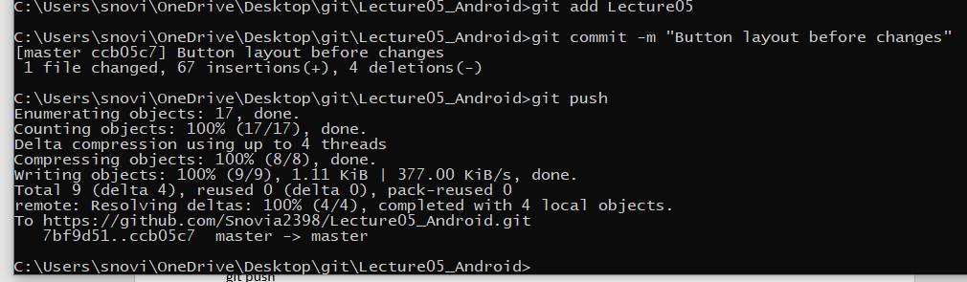

Added:

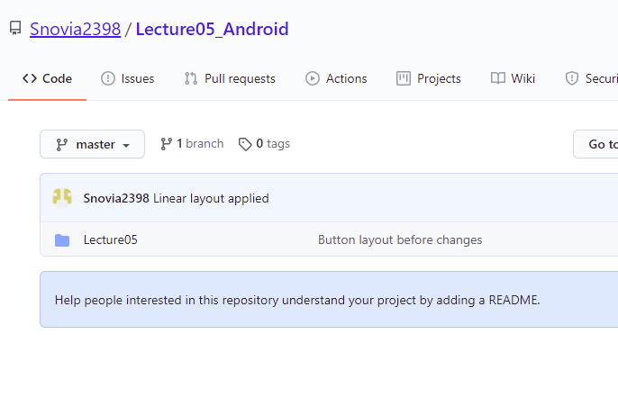

Change upper constraint off button1 as:

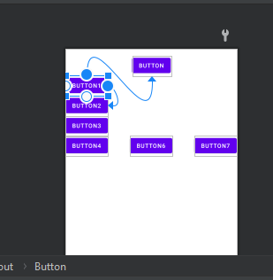

See the results:

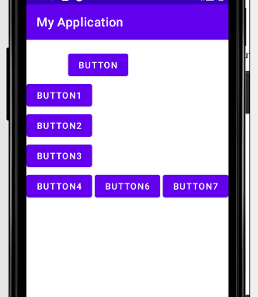

Again change the constraints:

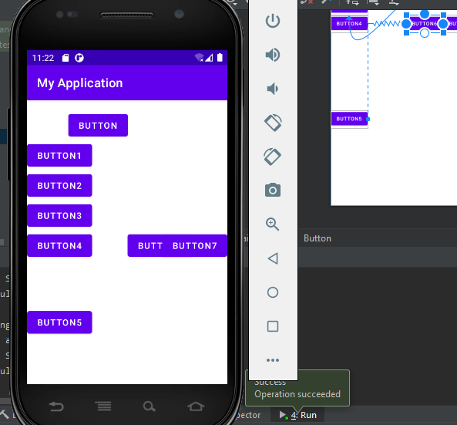

Again change the constraints and result is:

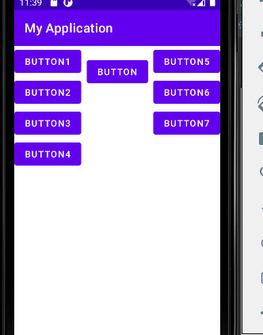

Push this to github:

git add Lecture05

git commit -m "Buttons layout after changing constraints"

git push

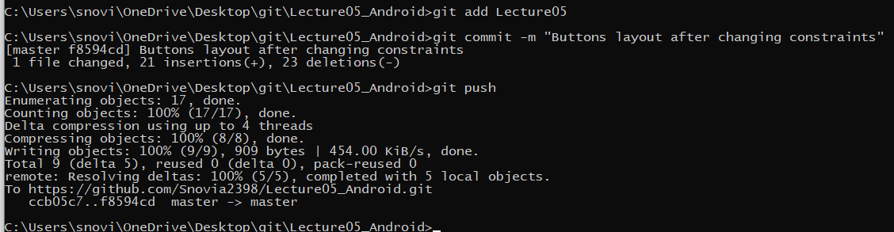

Added:

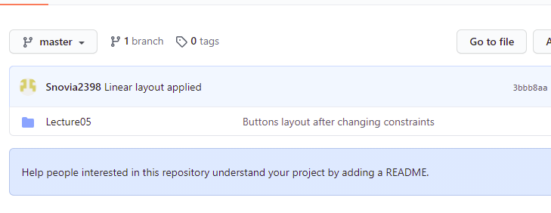

Now copy an image and paste it into drawable:

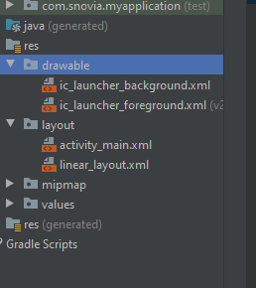

Click on ok button:

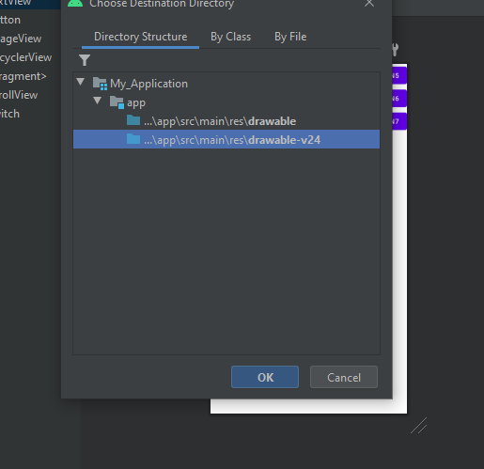

See images are added:

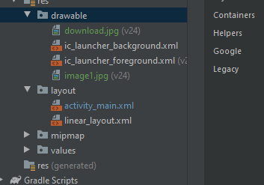

Now add a text view by drag and drop and an image by image view :

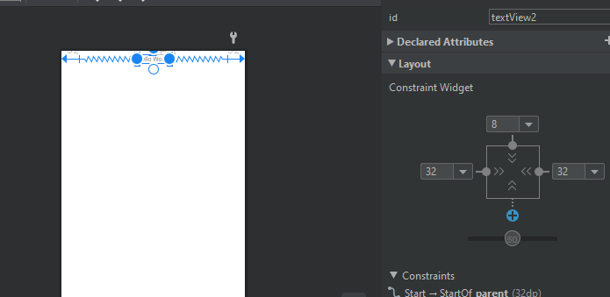

Image by drag image view as:

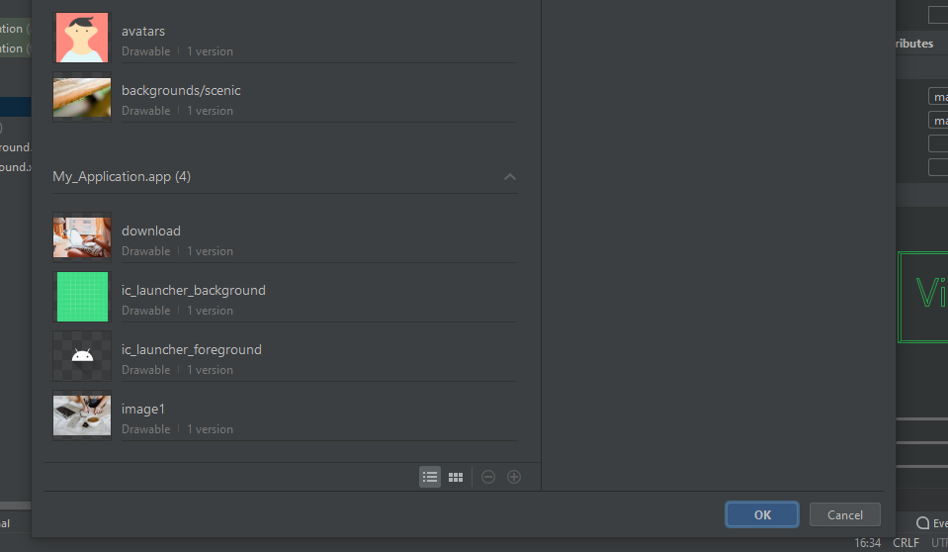

Click on add button and image is added:

C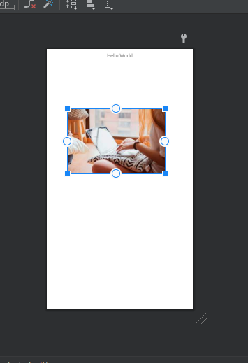

Change the height:

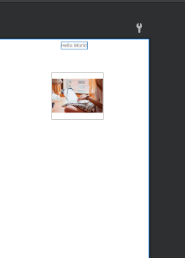

Run the code and see the result:

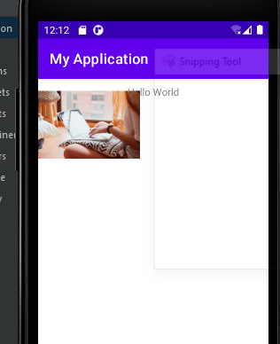

This is because constraints are not added. Now add constraints and see the result:

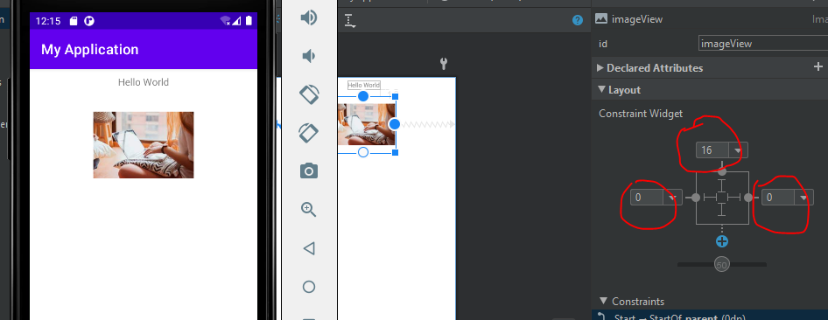

Push to github:

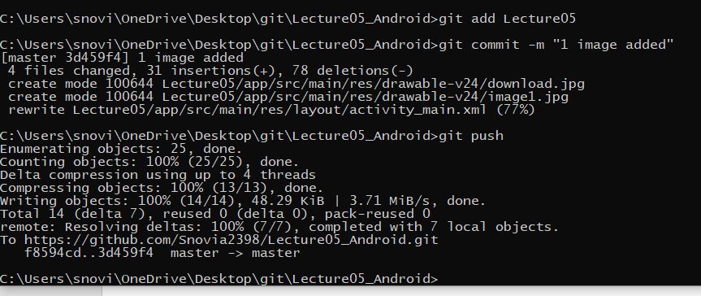

See added:

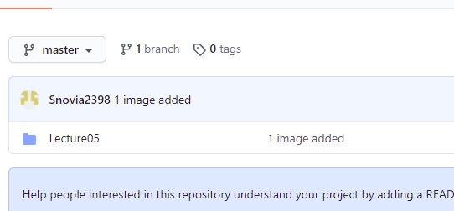

Now add another image:

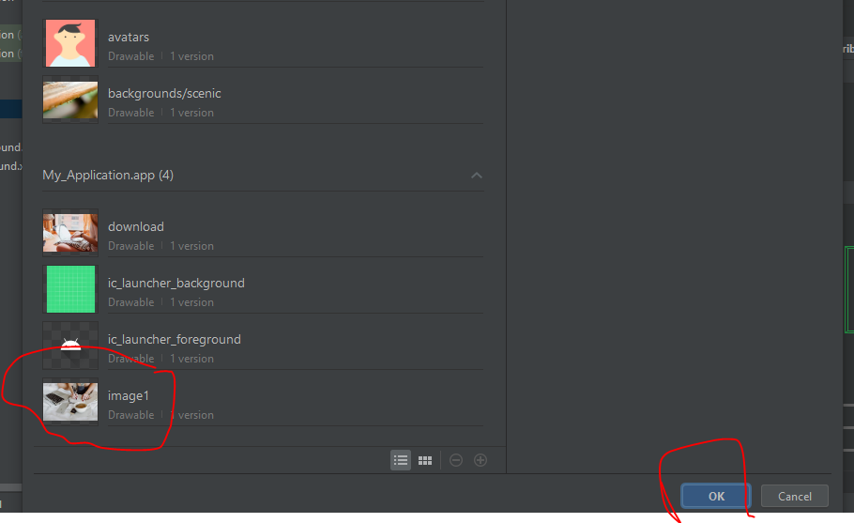

Add constraints and adjust height:

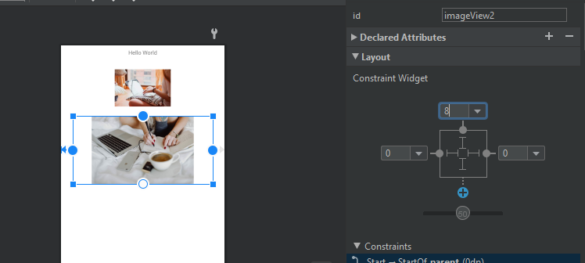

See the result:

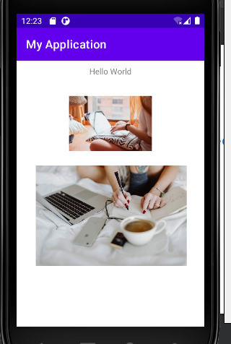

Push to github:

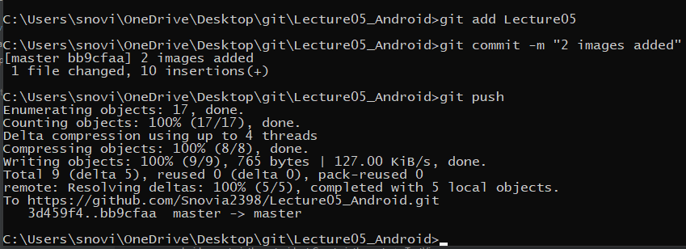

Added:

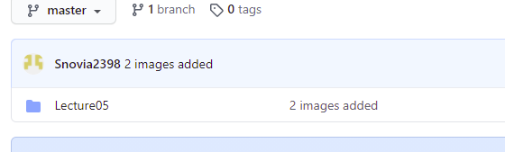

Now adjust buttons:

Drag and drop three buttons:

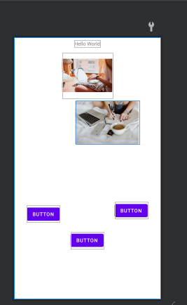

Select three buttons simultaneously and align them :

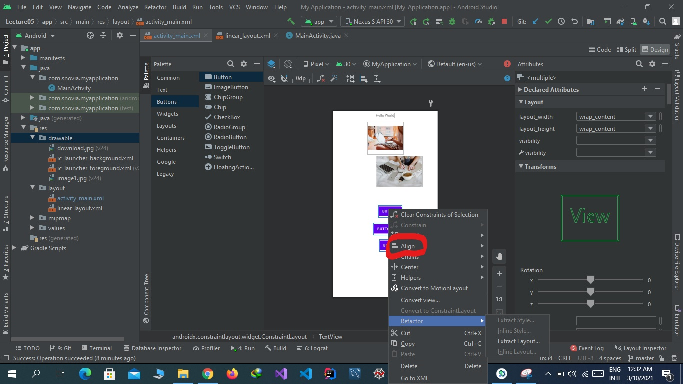

See the results:

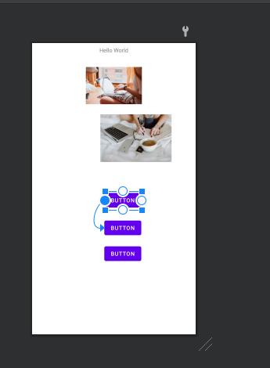

Center the buttons horizontally:

Select buttons and center them horizontal:

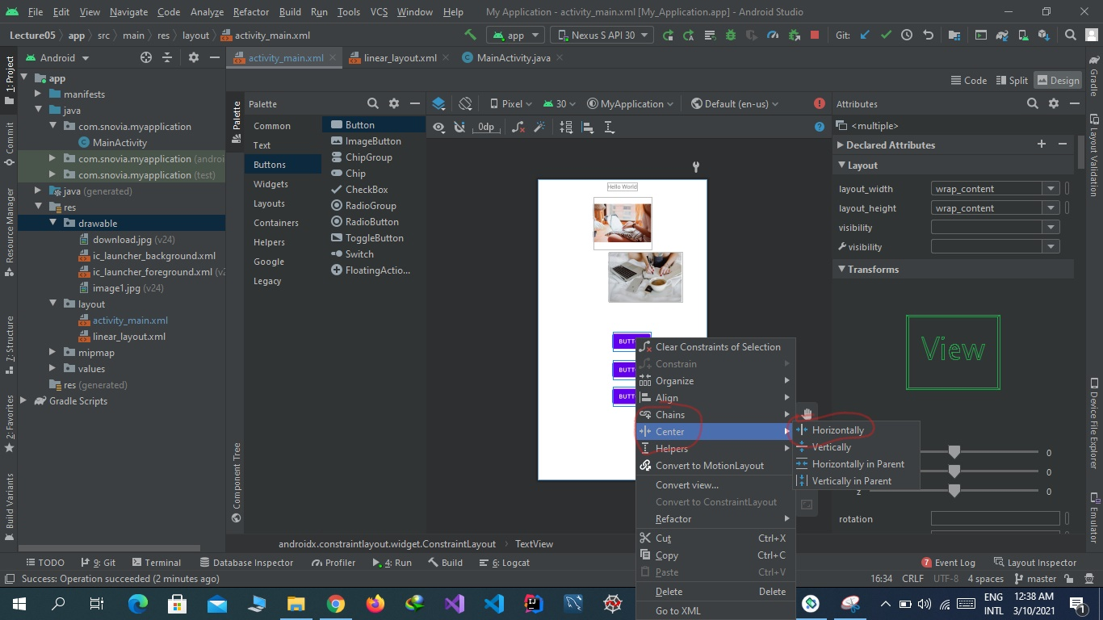

See the results:

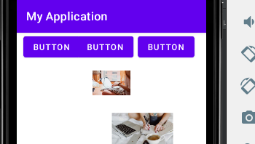

To expand the buttons horizontally select buttons and select expand horizontaaly:

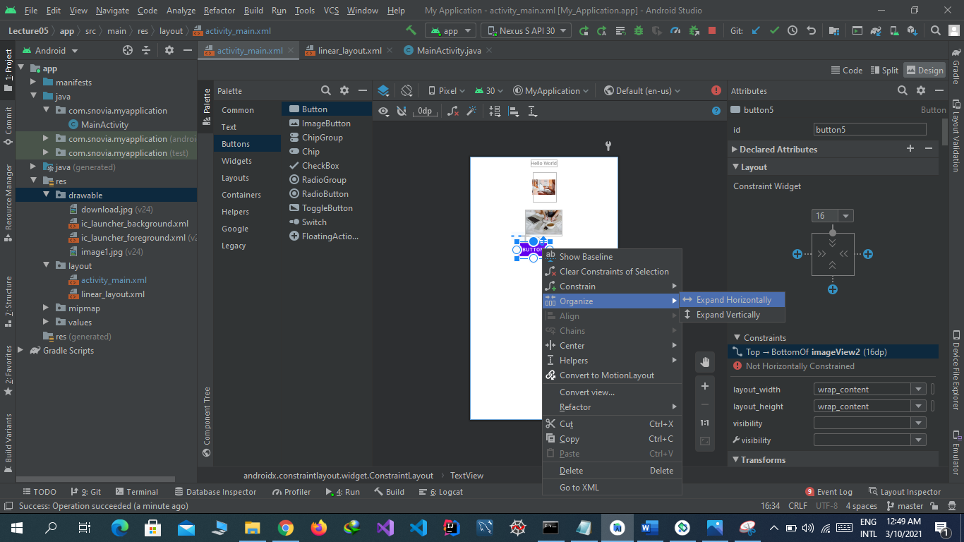

See the result:

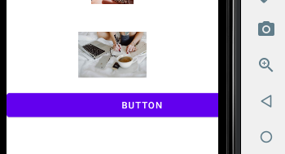

Push this to github:

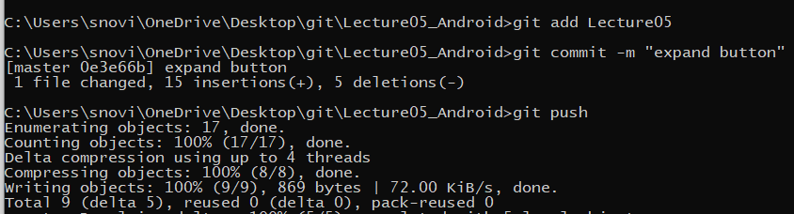

Added:

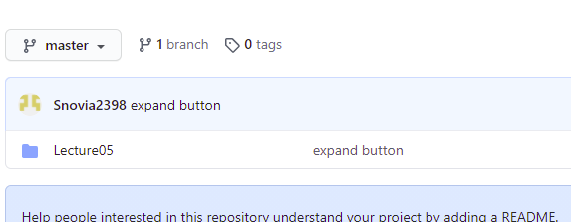

Same in case of vertically expand.

Create a button and a text view by drag and drop, give them names and add springs as :

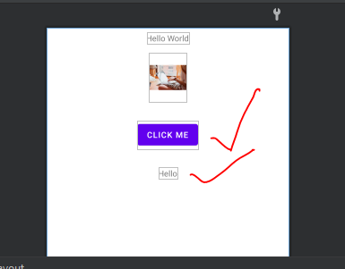

Name the button and text view in code view as :

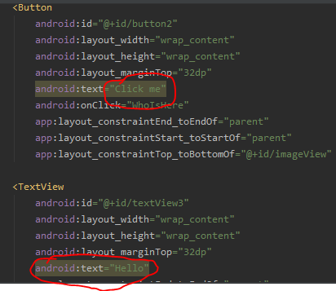

Add onClick event in button that shows that where go after clicking:

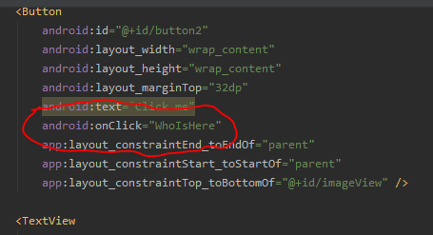

Now in mainActivity.java file import button and text view and create variables for them as:

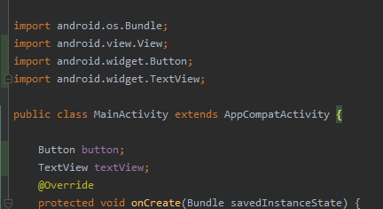

Now get the button and text view from xml file to java file as:

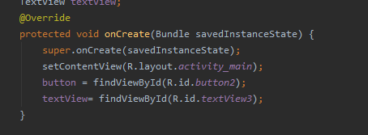

Create a function named whoIsHere and write code to change the text of text view as:

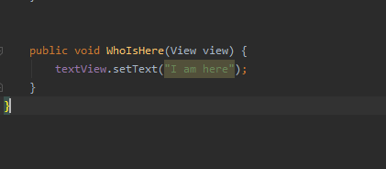

When I click the button text change from hello to I am here. Now see the result:

The text is hello:

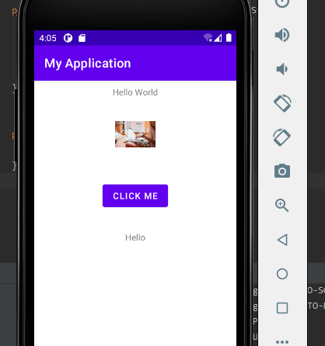

Now click the button and see the change:

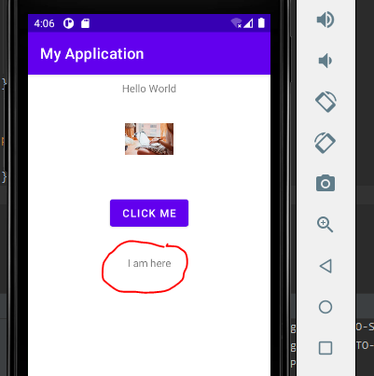

Add this to github as:

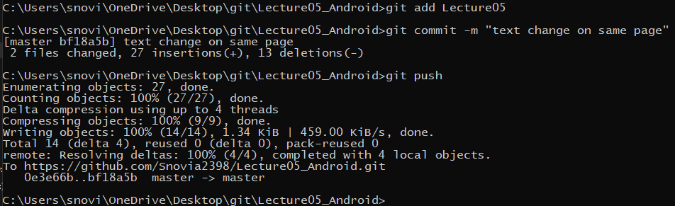

See folder is added::

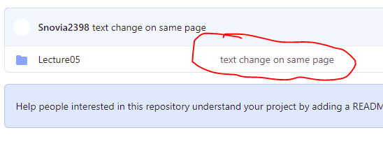

Now got to mobile_computing_progress folder and push the word file to github as:

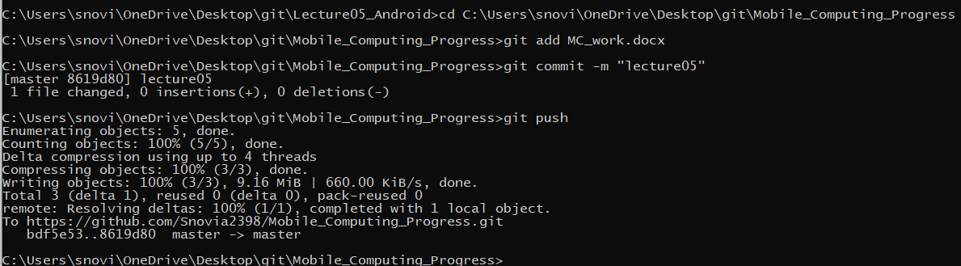

Added:

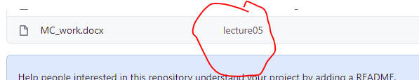

**LECTURE 06**

Create a new repository in github named Lecture06_Android as:

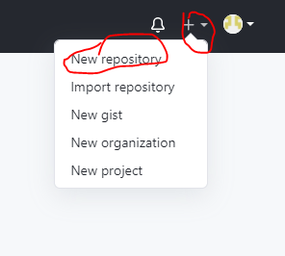

Name this repository as:

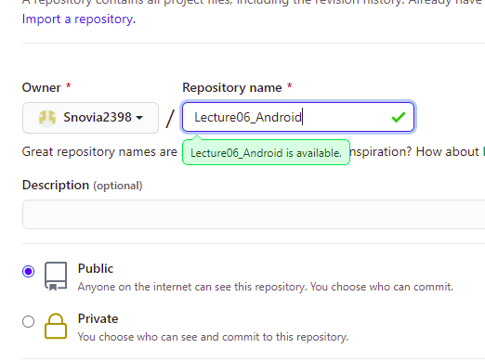

Click on create button as:

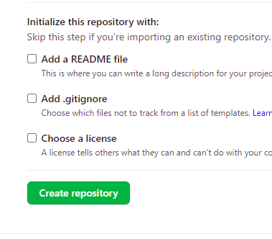

Repository is created:

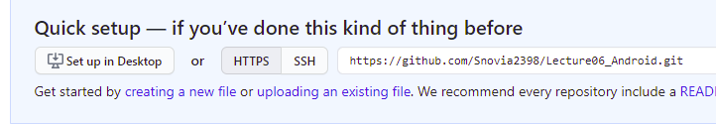

Open command prompt and go to git folder on desktop using command cd as:

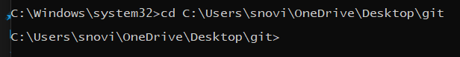

Create a clone of repository by using git clone command as:

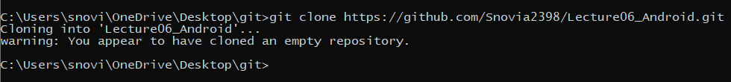

See the clone is created:

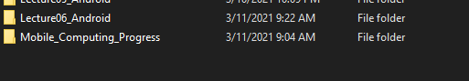

Go to that clone folder as:

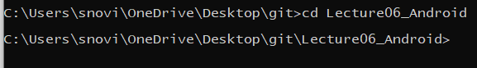

In this folder create a new folder named Lecture06 as:

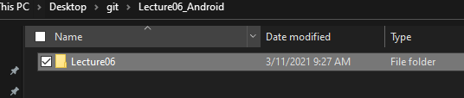

In this create an android project as:

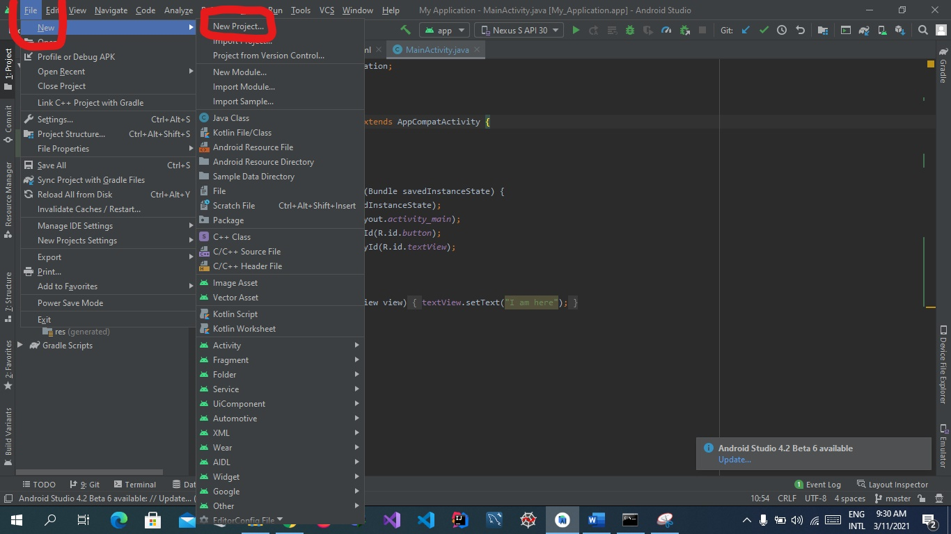

Select template empty as:

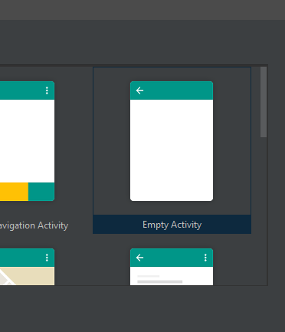

Name this file and select language and location and click on finish button as:

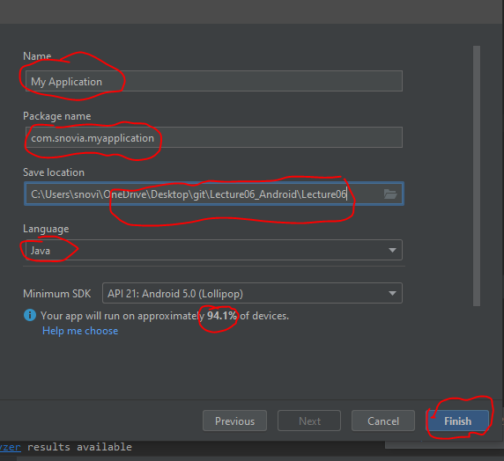

See the project is created:

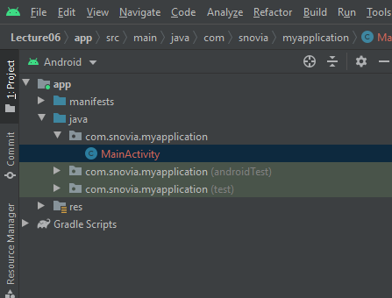

Create new activity by right click on java folder and select new then activity then empty activity as:

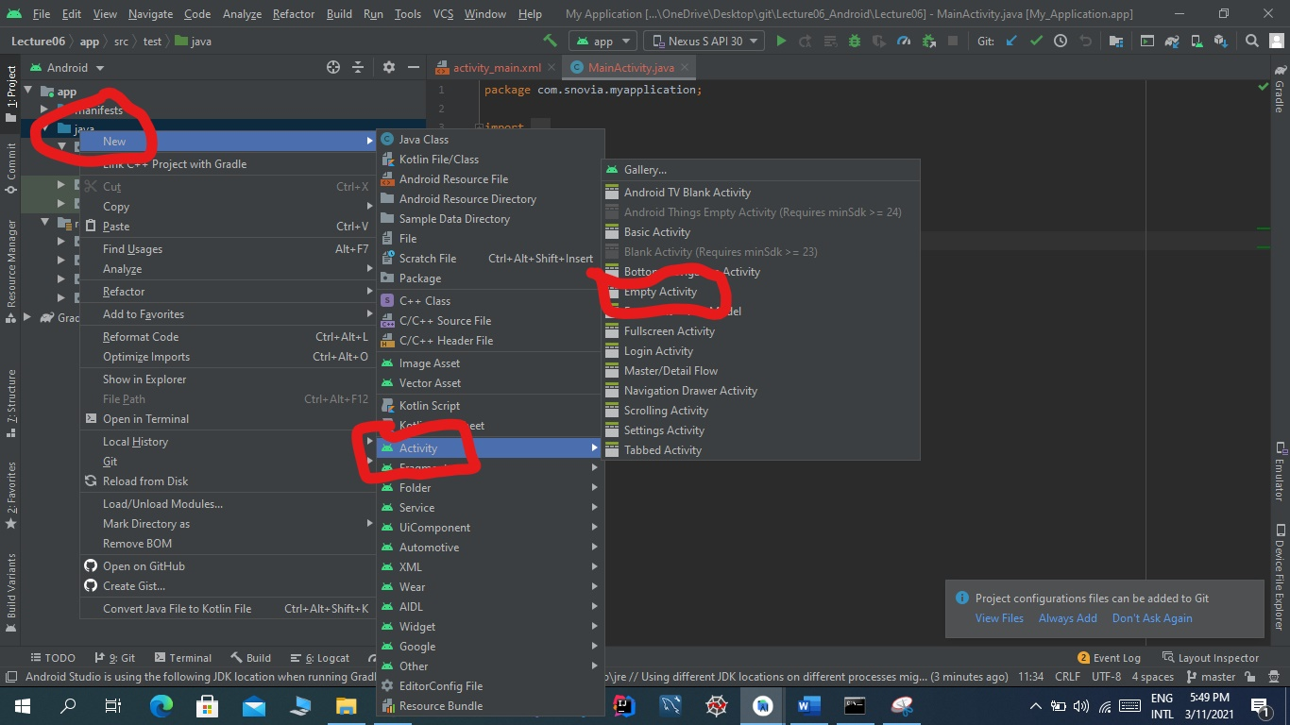

Now name the activity select layout name and language and click on finish button as:

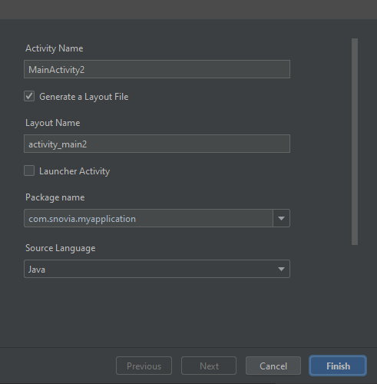

Click on add button :

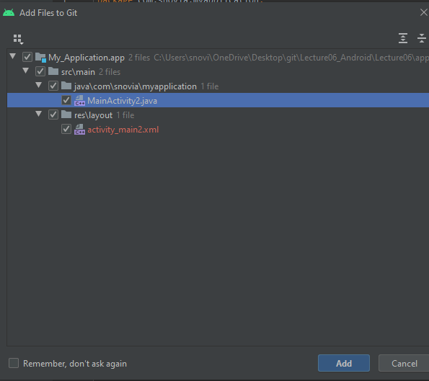

See xml file and java file are created:

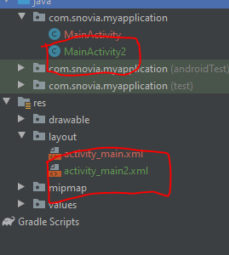

In activity-main.xml create a button by drag and drop and add springs to it:

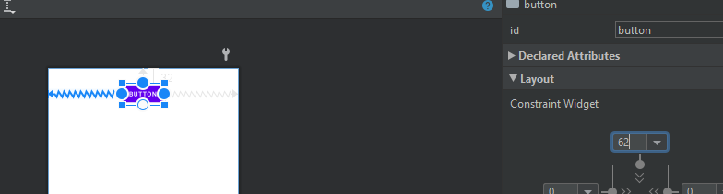

Name the button as Click me and onclick event as:

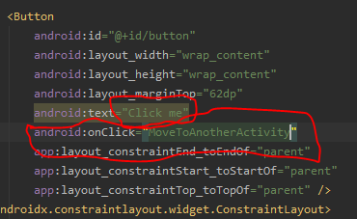

In java file write code to move to main_activity2 as:

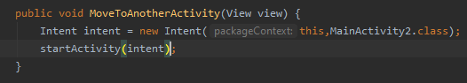

But first get this button by button id and declare the button as:

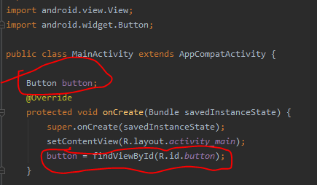

Now run the code and see the output:

Here is button:

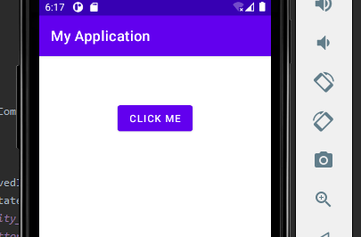

When click on this button it go to another activity:

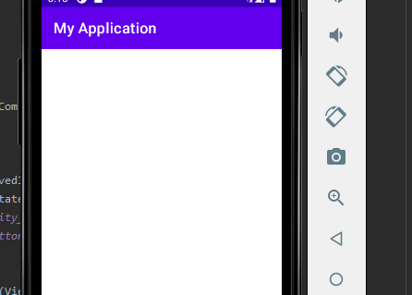

Now in main activity2 create two buttons by drag and drop, add springs:

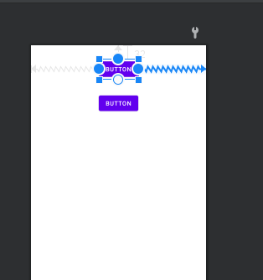

Now give these buttons names and add onClick events/Functions:

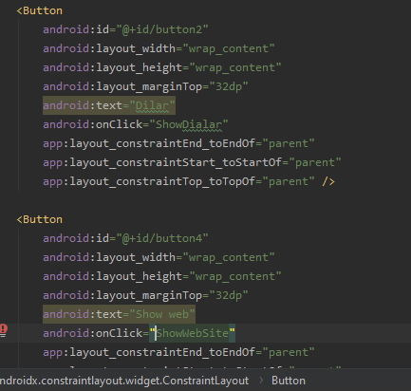

Now in main activity2.java get these buttons by id and declare them:

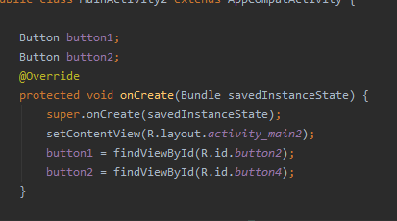

Write code against onClick functions:

In showDialar function write code to go the dialar:

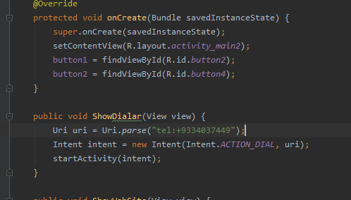

Against showWebSite function write code to go to pucit website:

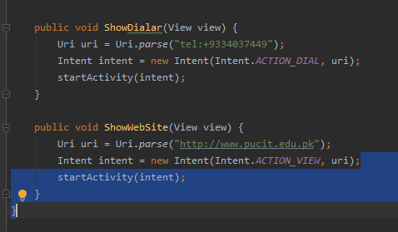

Now run the code:

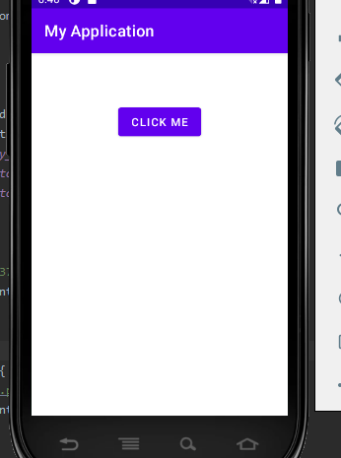

When we click the button we go to main activity2:

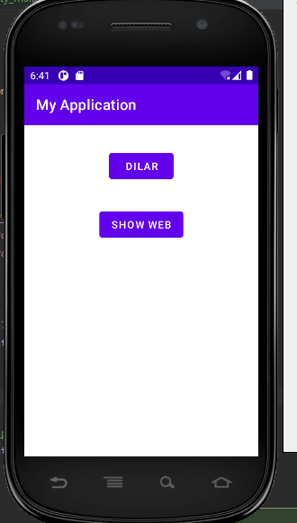

When we click on dialar button we go to dialar of phone:

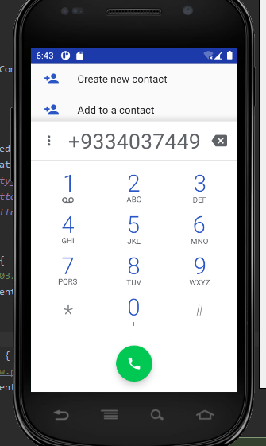

And when we click on show web button, we go to pucit website:

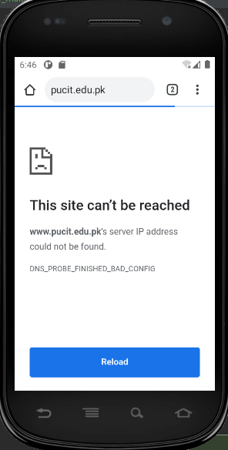

Push this project to github as:

Git add Lecture06

Git commit -m “moving to another activity’

Git push

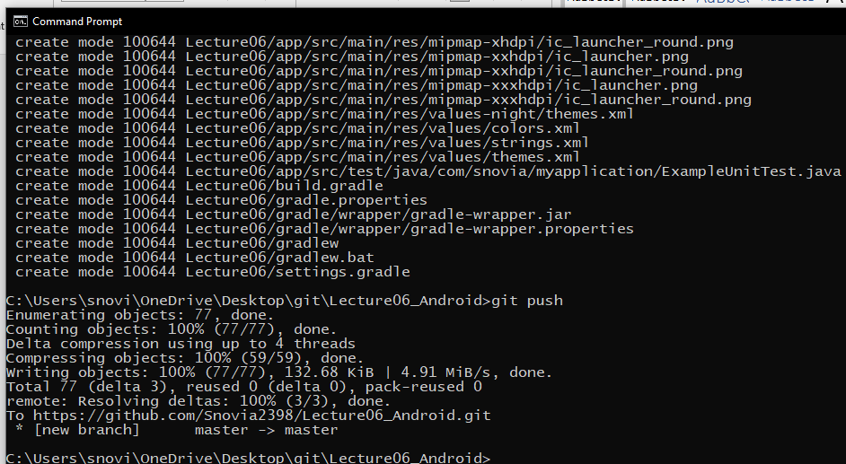

Added:

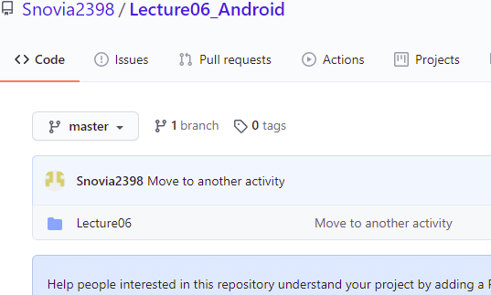

Add word file to github by using commands:

Git add MC_work.docx

Git commit -m “lecture06”

Git push

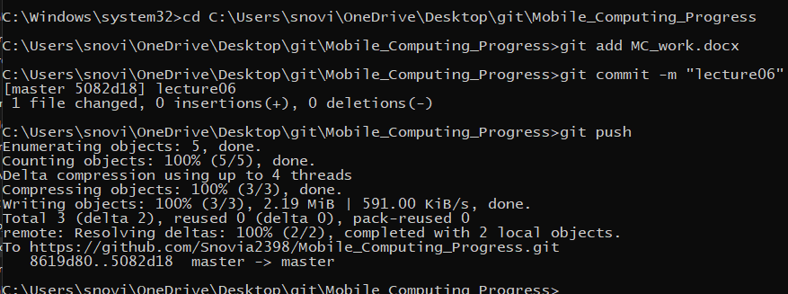

Added:

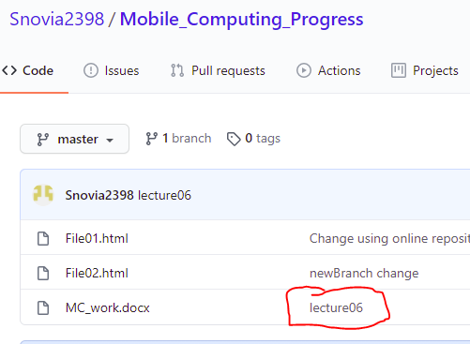

**LECTURE:07**

New repository is created I github named Lecture07_Android by using same steps as above as:

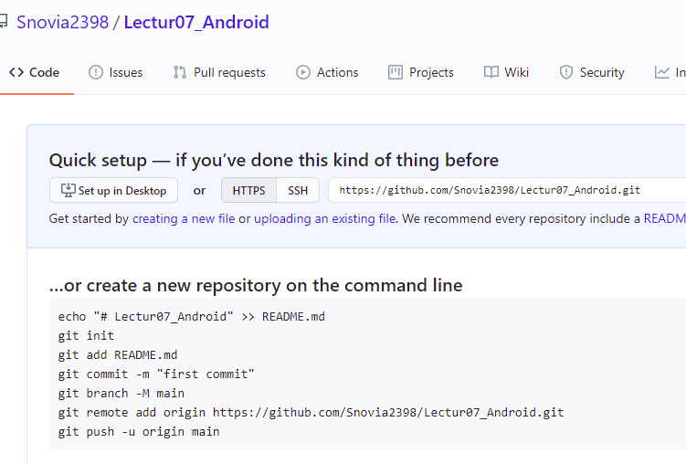

In cmd go to git folder:

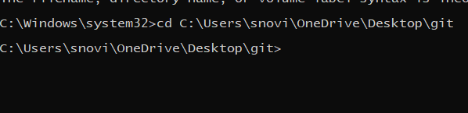

Create a clone of repository as:

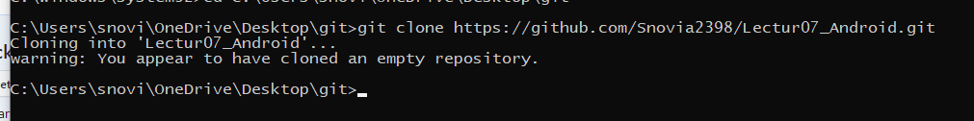

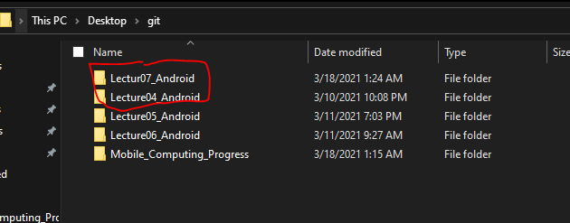

Now go to clone folder and create a folder in it name Lecture 07:

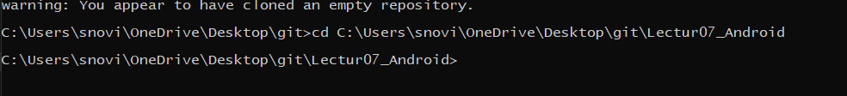

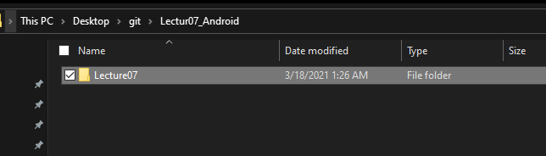

Now create an empty android project in this folder:

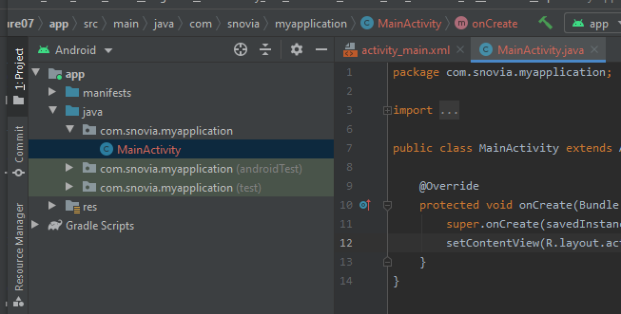

Now start work:

Add a text box by drag and drop as:

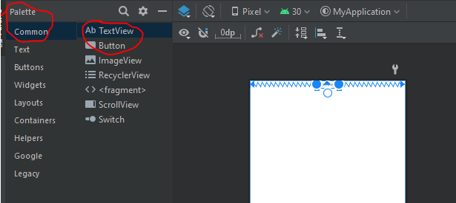

Increase text font size and change its name by using text size and text in code view as:

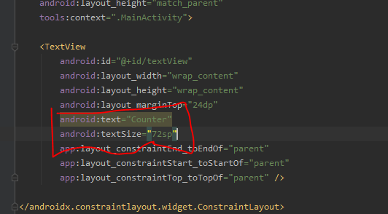

Change the color of text as:

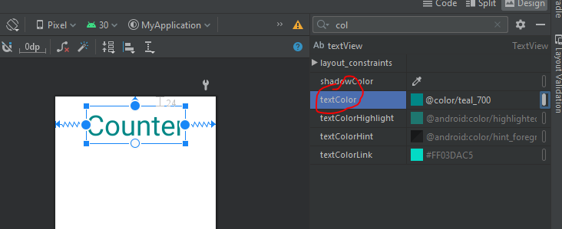

Change the background color as:

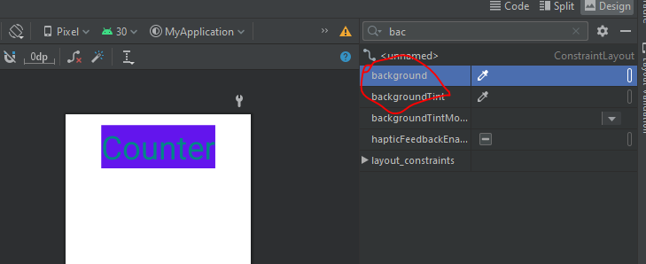

Add again a text box and a button same by drag and drop and add constraints to them as:

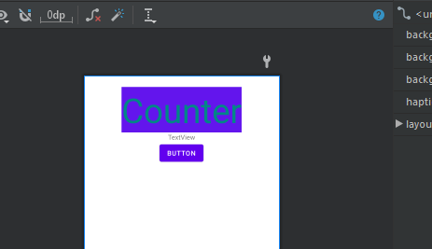

Change the color and size of these two:

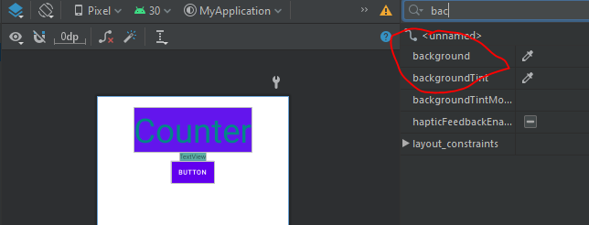

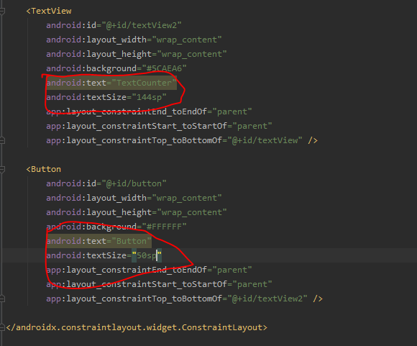

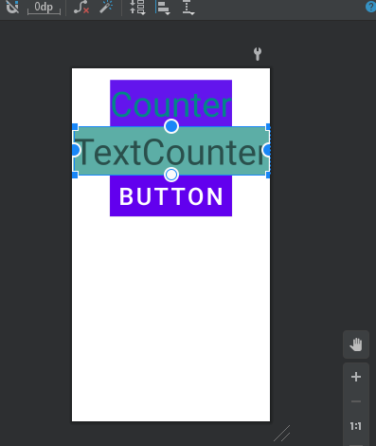

Change text to zero as:

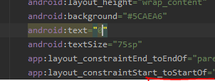

Get the text view and button as:

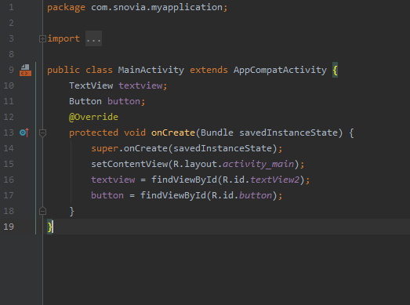

Create onClick event as:

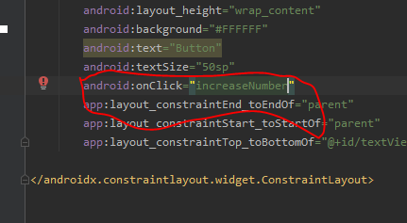

Write a function to increment the counter as:

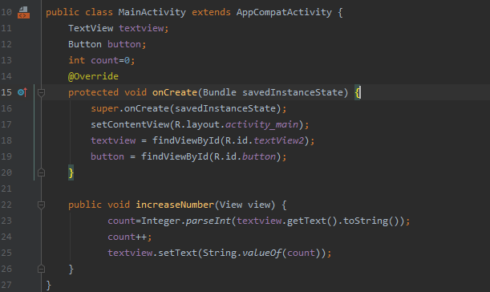

Now run the code and see result:

It work fine by clicking button. Click button 17 times and see the result as: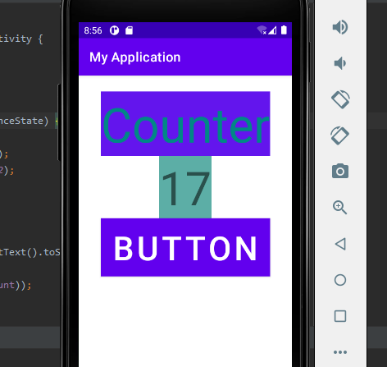

When we rotate the mobile counter start from zero as:

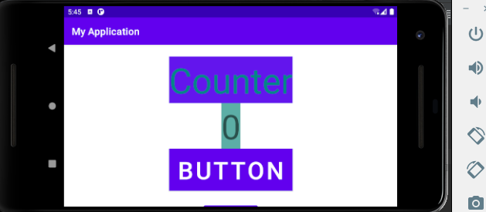

We resolve this issue in some time. Now see the activity life cycle:

Add two buttons by drag and drop to go to other activities and add constraints as:

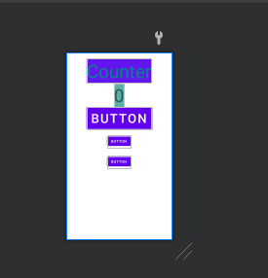

Push to github by using commands:

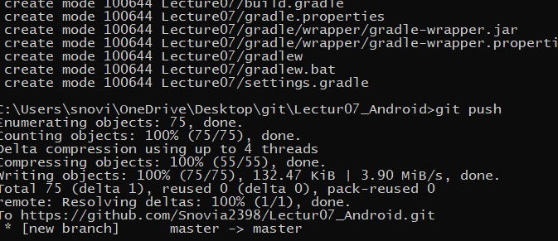

Added:

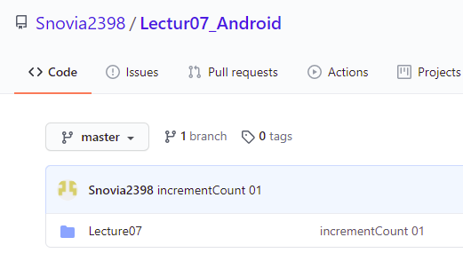

Give new buttons text as activity2 and activity3:

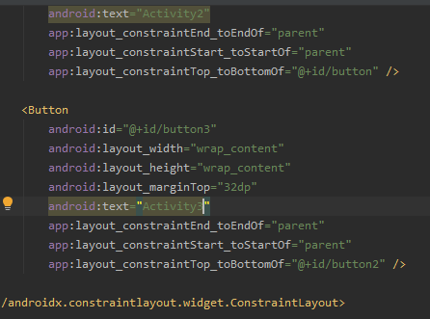

Write log to view the call backs: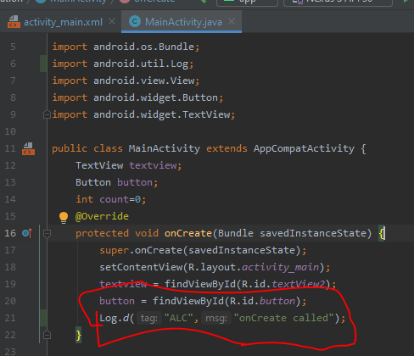

Run the project and in Logcat see the call backs:

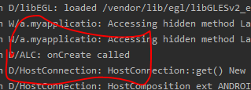

Override other callbacks by right click and then generate and then override methods a:

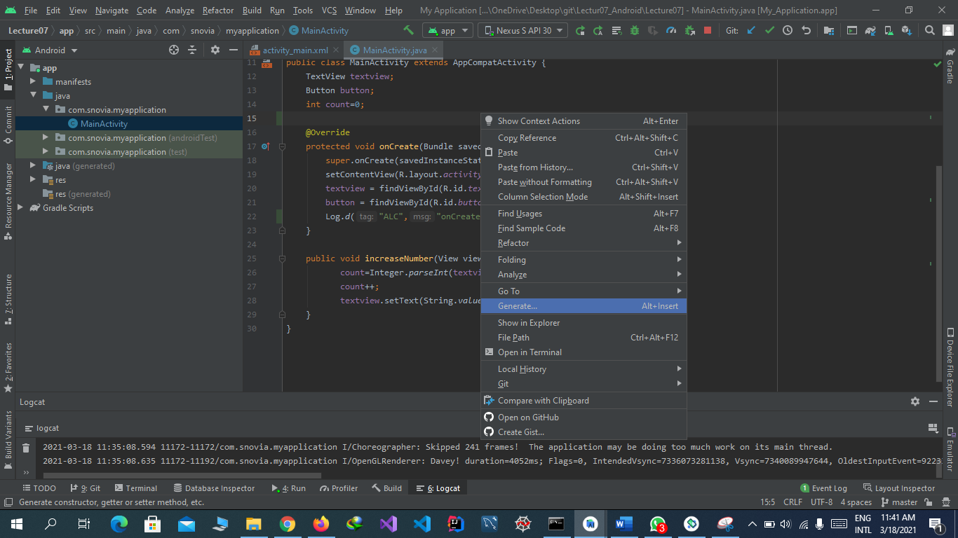

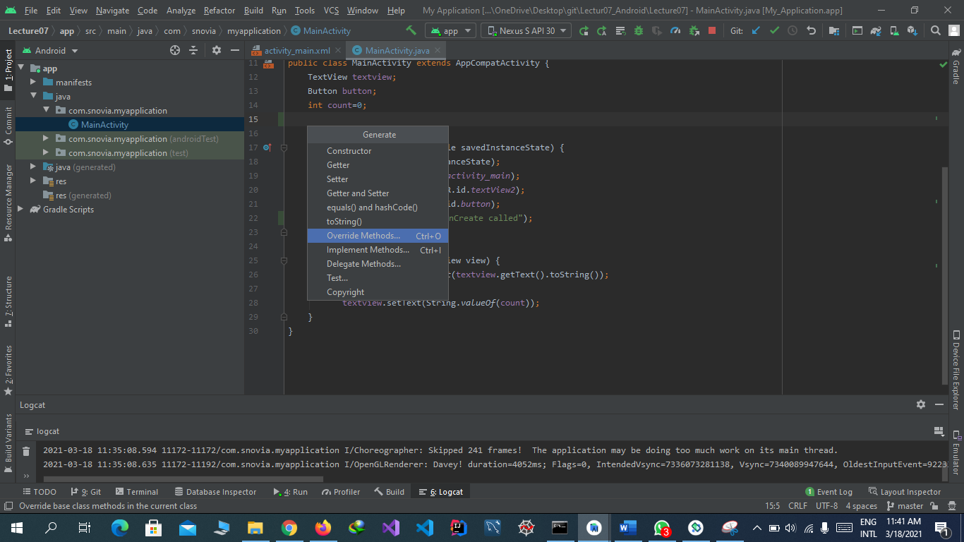

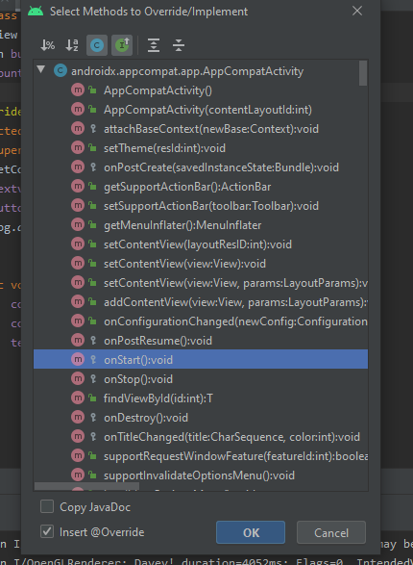

Now override onPause as:

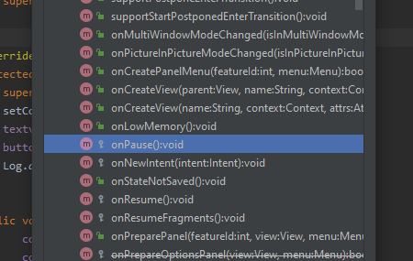

Now add onResume:

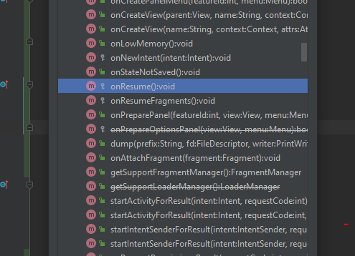

Add onStop:

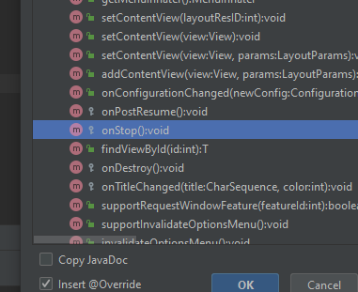

Add onDestroy as:

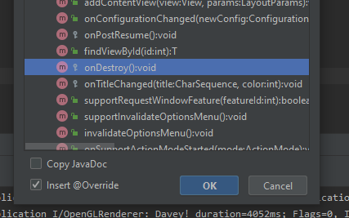

Now add log to these all as:

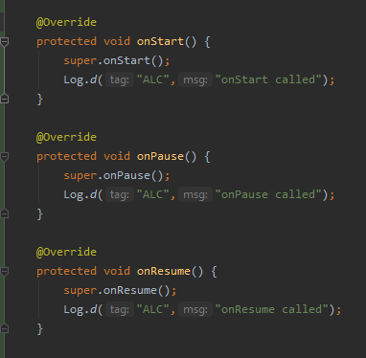

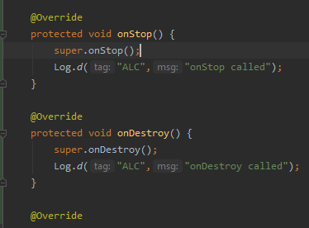

Run the project and see log cat:

When we are in the application the result is:

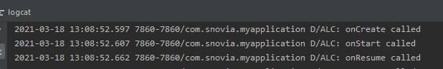

And when we click to go back the output is as follows:

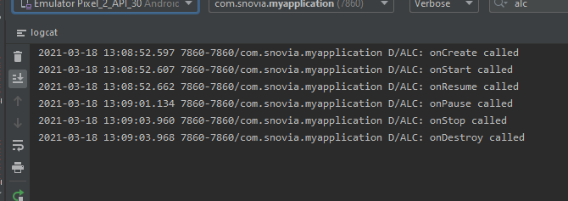

New create two new activities named mainactivity2 and mainactivity3:

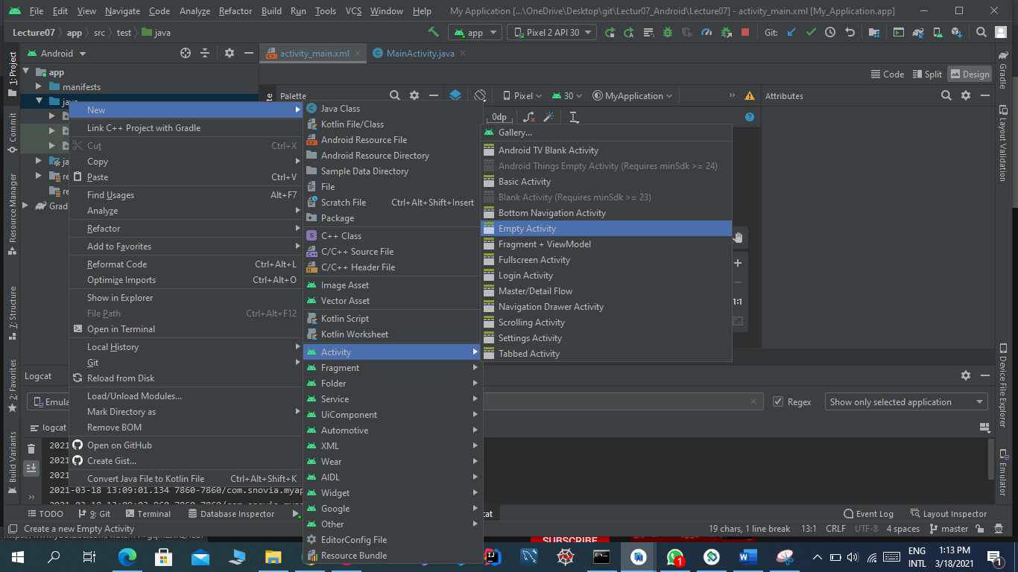

Now add onClick event in both buttons which we added above:

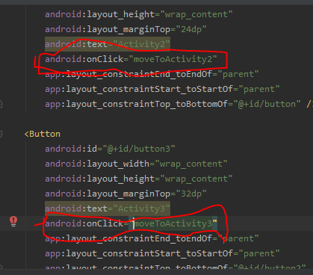

Now in mainactivity.java write functions to move to other activities:

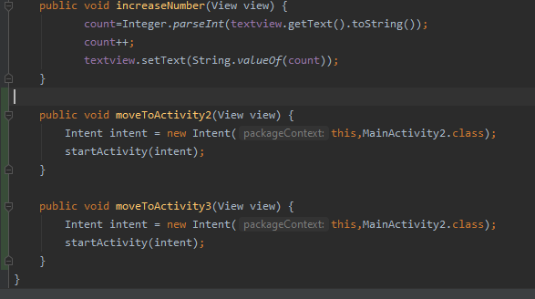

In activity2 create a textbox by drag and drop and add constraints:

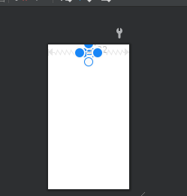

In code view change the text and give text size:

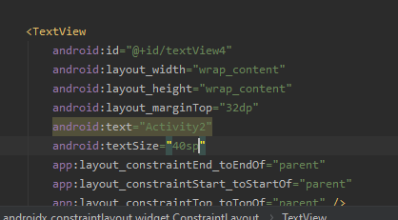

In mainactivity2.java write all call back functions as:

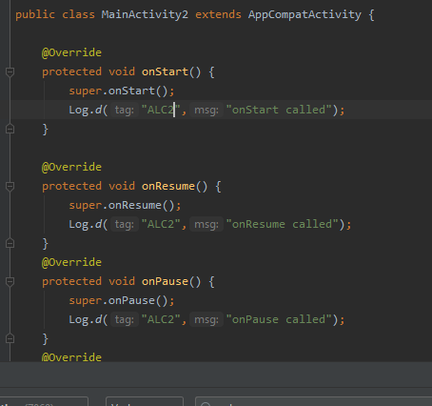

And change alc with alc2:

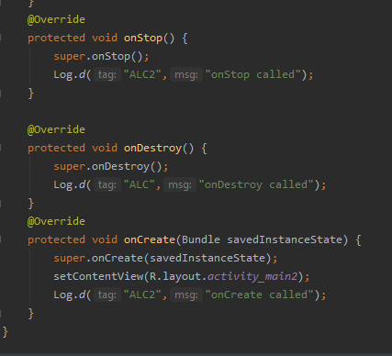

Run the project and see the result:

When we are in main activity result is:

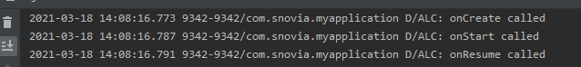

When we go to activity 2 then:

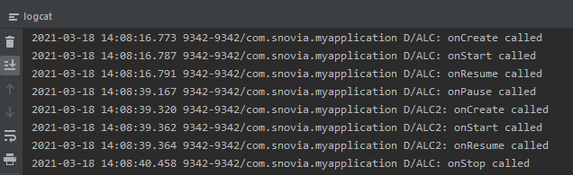

When we go back to main activity result:

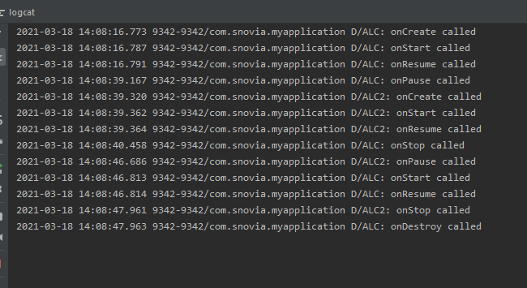

And when we press back from main activity then main activity also destroy:

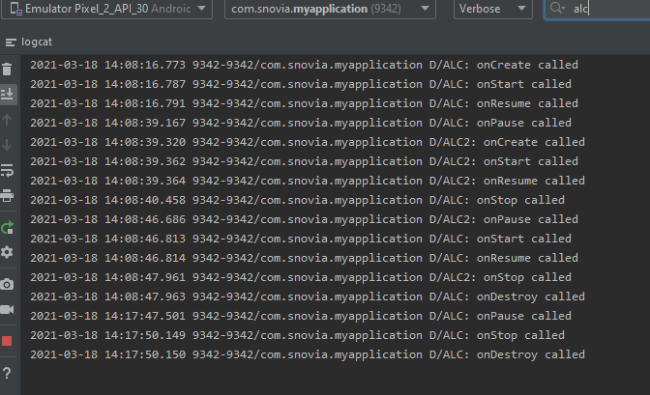

Now when we go to activity2 then:

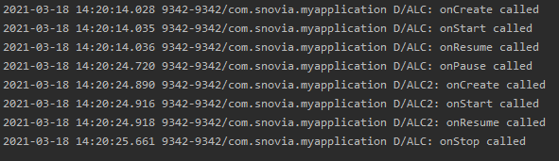

Now press back to go to main activity then activity2 destroy:

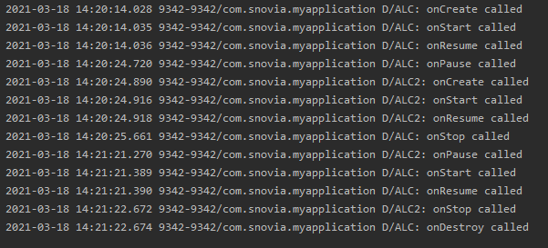

Now from here go to activity3:

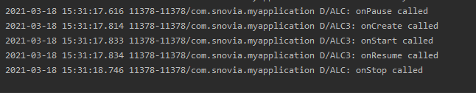

Then back:

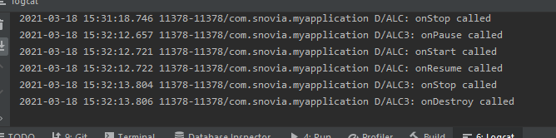

Now create a button in activity2 by drag and drop and add constraints:

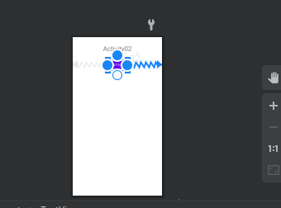

Now change the text and increase size:

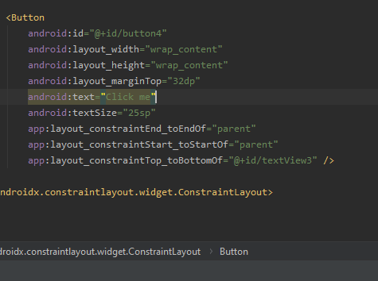

Add onClick event in it to go to activity3:

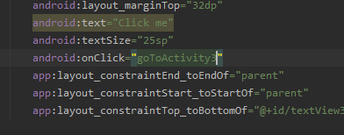

In java file write function to go to activity3:

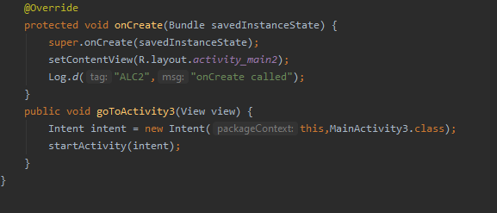

Run the program and see result:

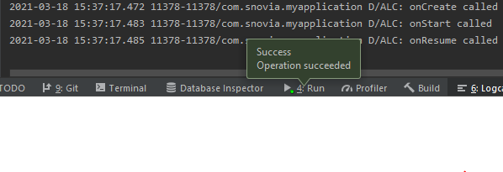

Now got to activity2:

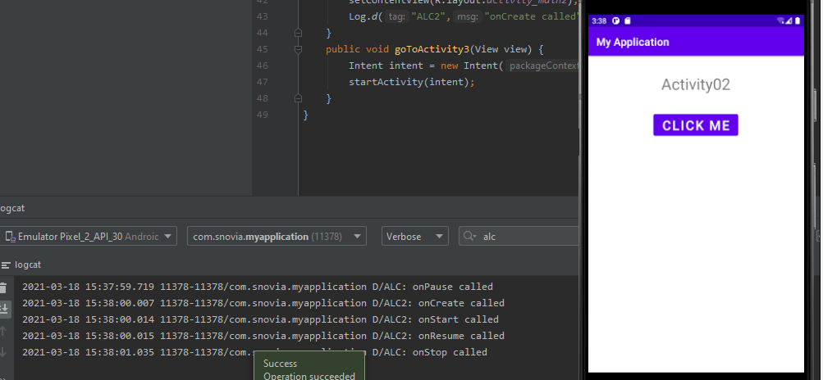

Now click the button and go to activity3:

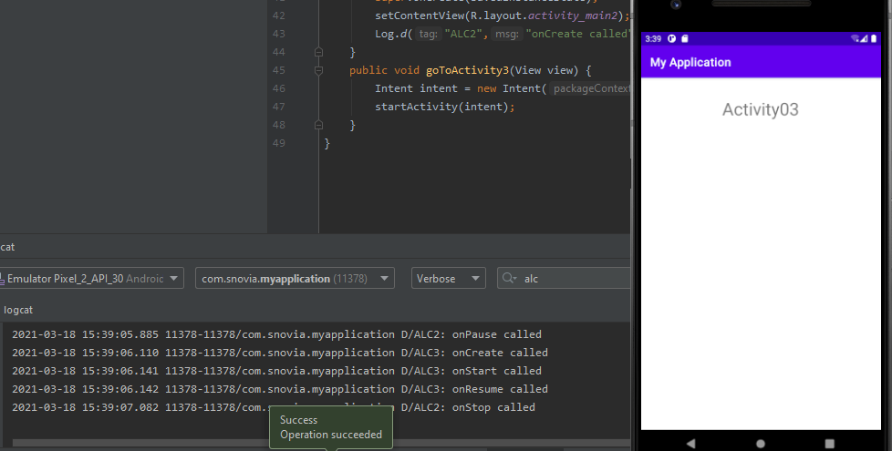

Go back to activity2:

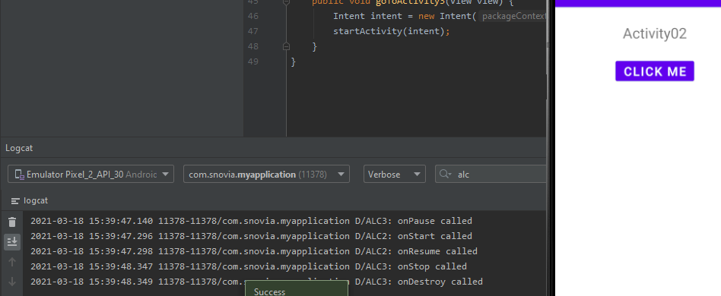

Now go back to main activity:

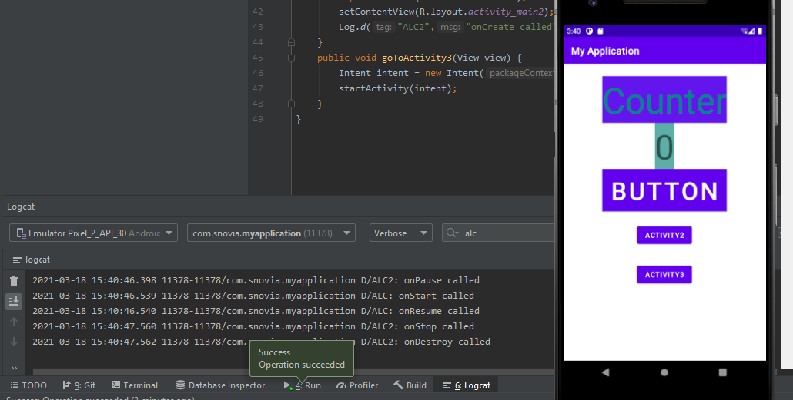

You see the call back functions.

Now add this to github:

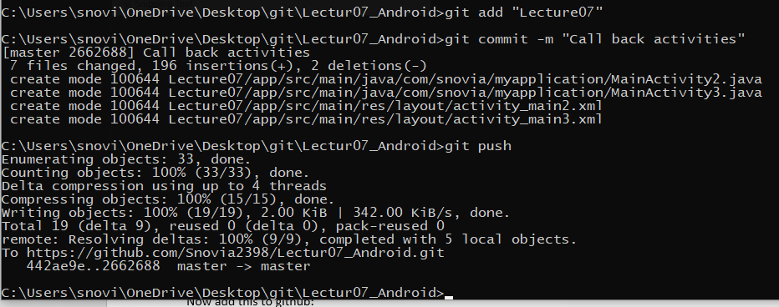

When we run the increment code the call back is like:

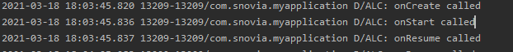

But when we rotate the screen it destroyed then again create:

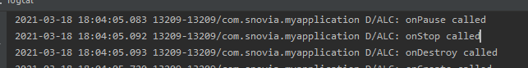

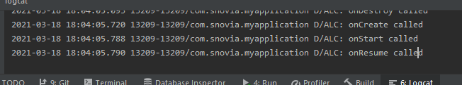

So we have to save values before destroying and call them after create. For this we override function onSaveInstanceState().

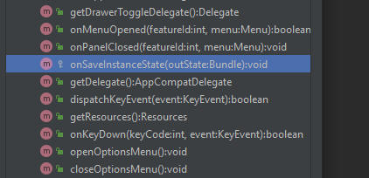

We save our values in bundle in onStop function and call them in create

Save value in bundle onState as:

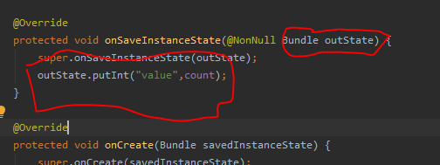

Retrieve value in onCreate as:

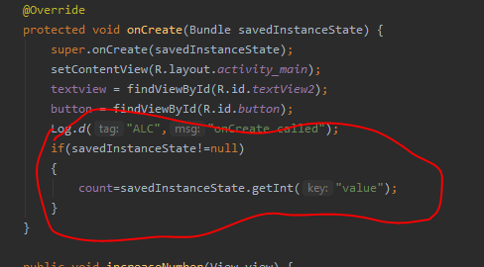

Now run the code and see output:

Before rotation result is:

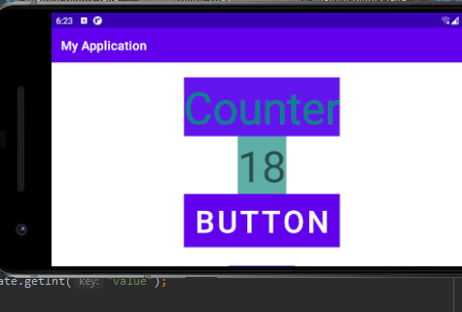

After rotation it again become zero not 18:

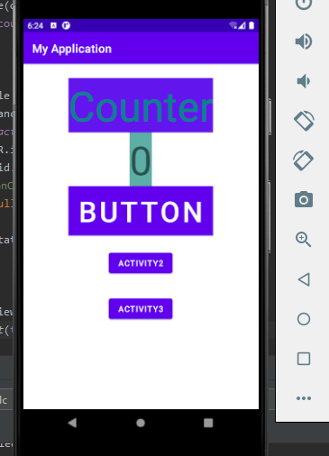

The reason Is that we retrieve the data but not display anywhere so for this:

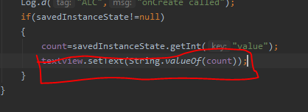

Now see by running code:

Before rotation:

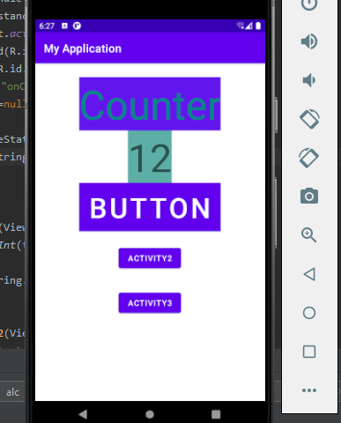

After rotation result is same:

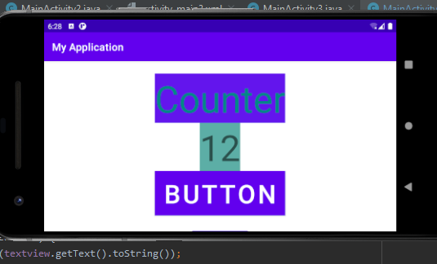

So problem is solved.

Now add this to github:

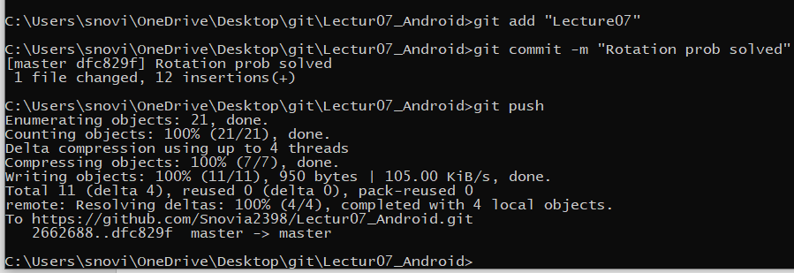

Added:

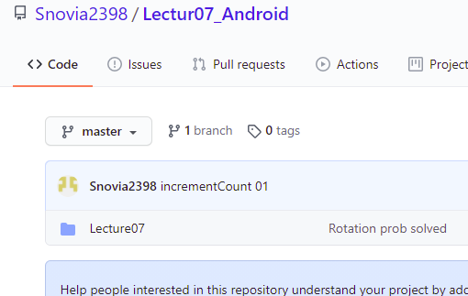

Now add word file to git hub:

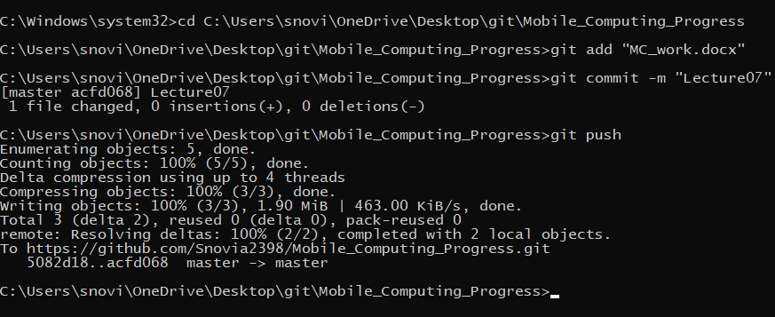

Added:

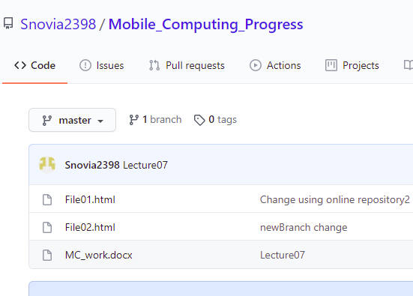

**LECTURE:08**

Create repository in github named Lecture08_Android:

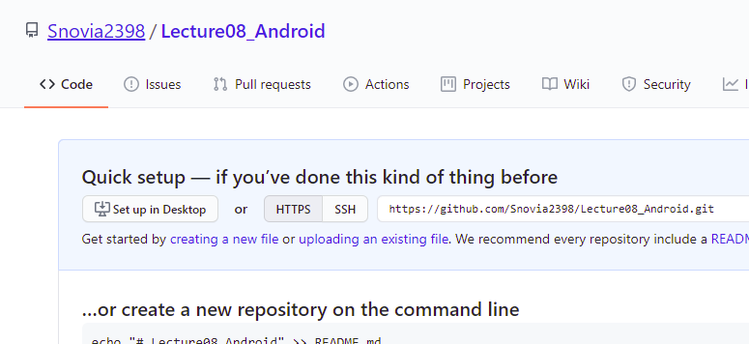

Now go to git folder:

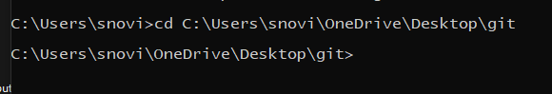

Create a clone of repository in this:

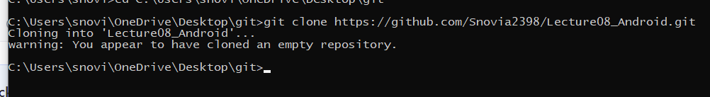

Go to clone folder and create a folder named lecture08:

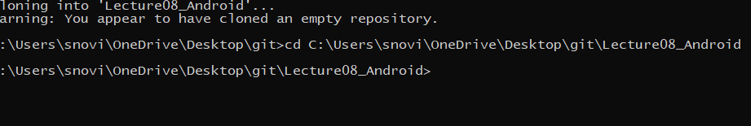

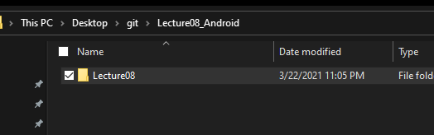

In this folder create android project:

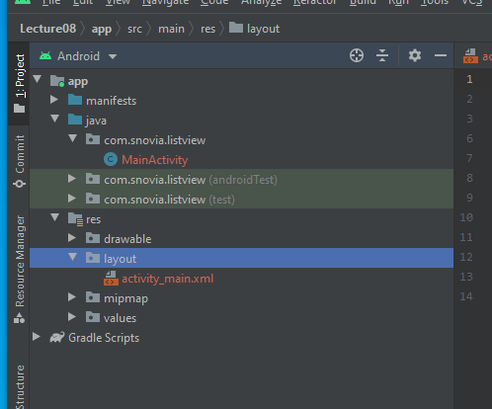

Now start work:

In main activity.xml create list view by drag and drop from legacy:

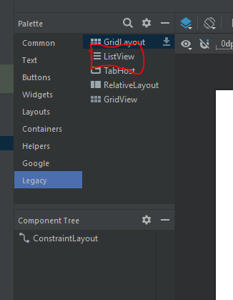

Add constraints to it:

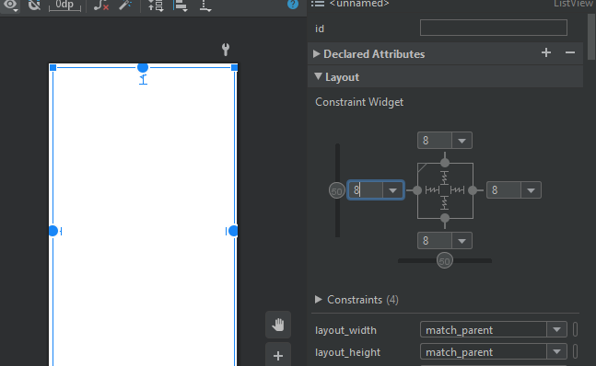

Create instance of list view and get that view list by id:

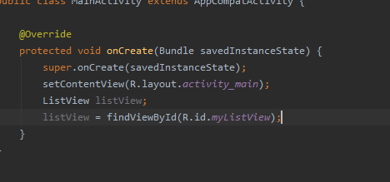

Create string list and array list and add some name as data to it:

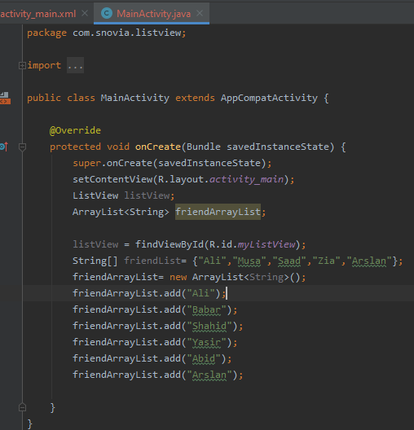

Now create array adopter and set adopter of list view that we created and pass it array adopter:

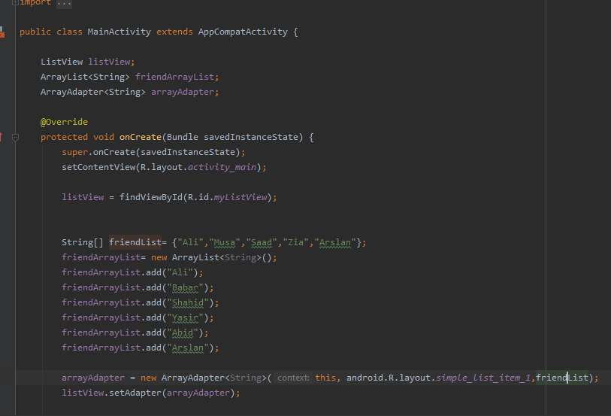

Now run this code and see output:

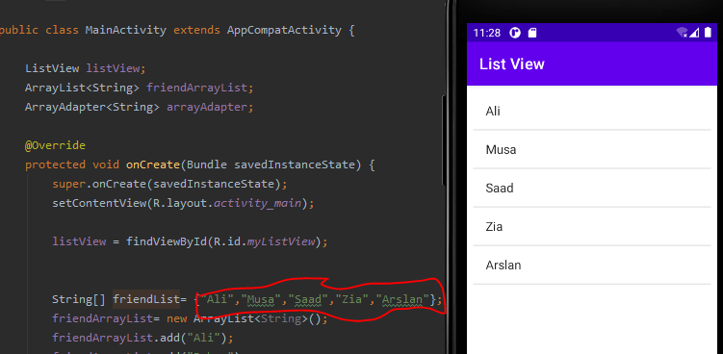

Now push this to github:

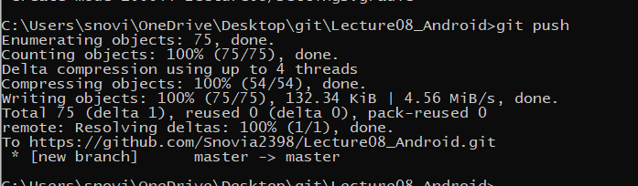

Added:

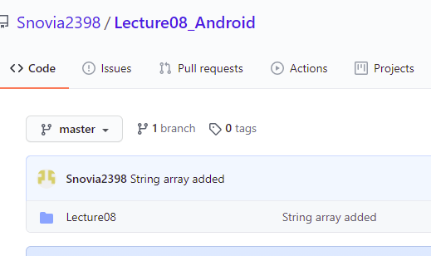

Now show list view of array list as: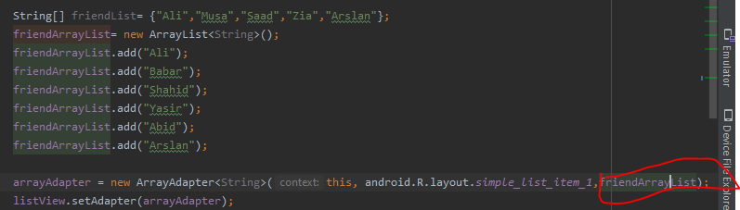

See the output:

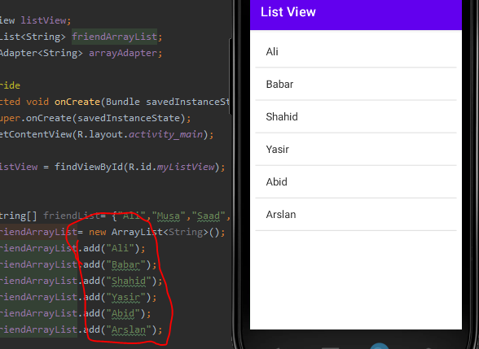

Push this to github:

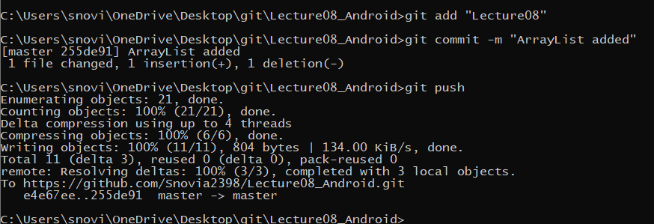

Added:

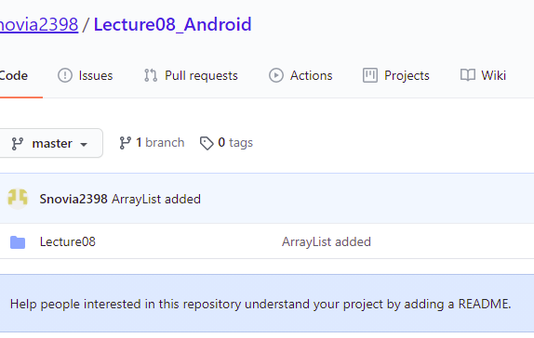

To add names at runtime we have to take input from user and show that in the list. For this create a button and a plain text enter text in plain text and click the button that name added in list view:

Drag and drop the button and plain text as:

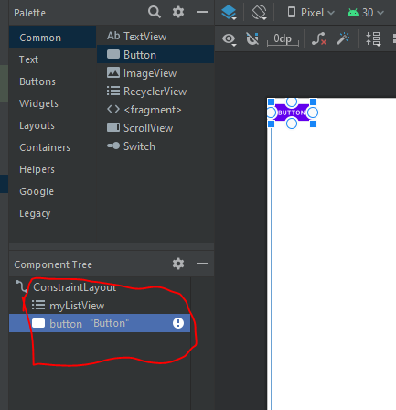

Now plain text:

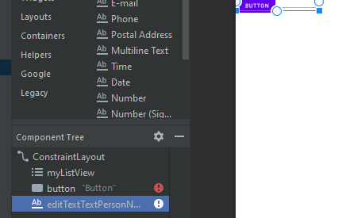

Give them id and add constraints:

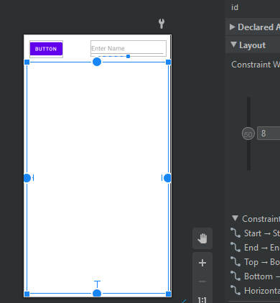

Now in button add onClick event:

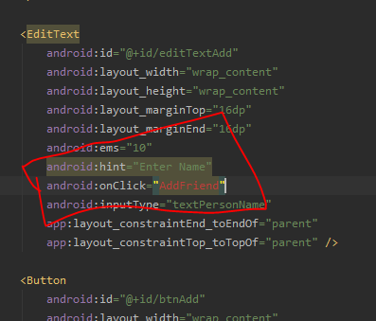

In main activity java create instance of button and edit text and a function and add code to it to take input from user and add to list view:

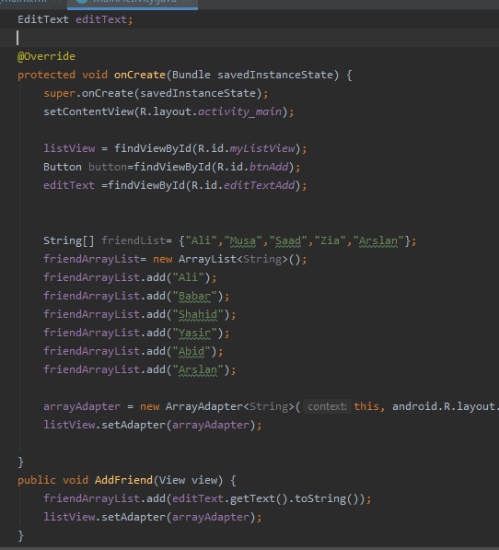

Run code and see output:

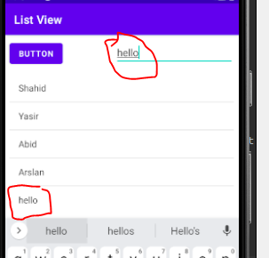

Push this to github:

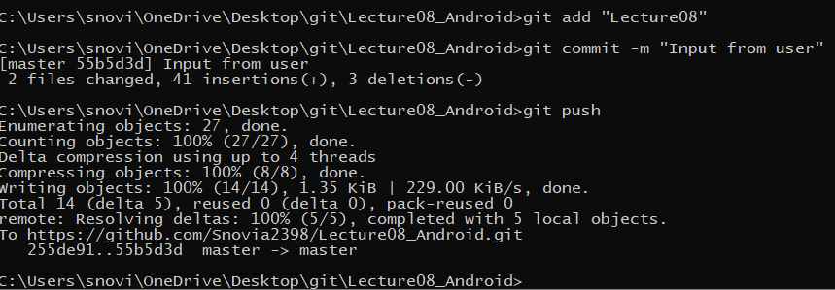

Now add overload function for updating and sorting:

First see the logcat and you see which name we clicked it shows that we click that name:

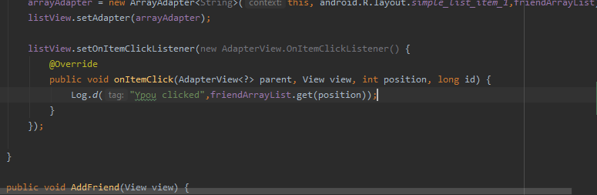

Run and see the output:

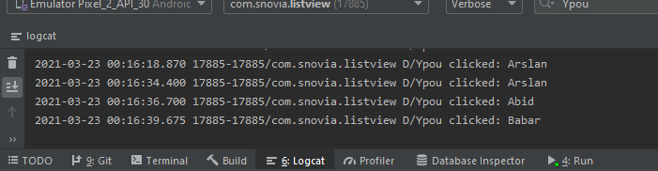

Now to edit use this:

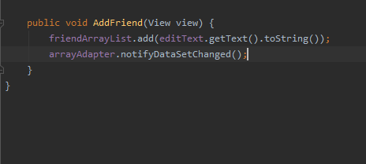

See the output:

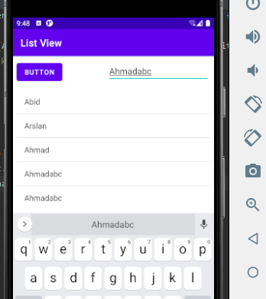

To sort the list use this:

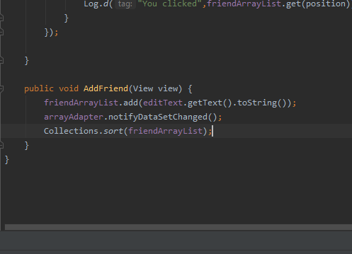

See the output:

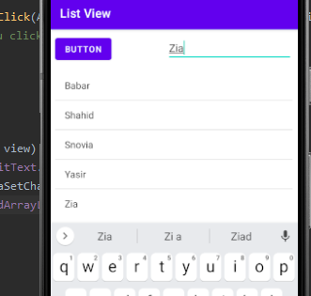

Add to github:

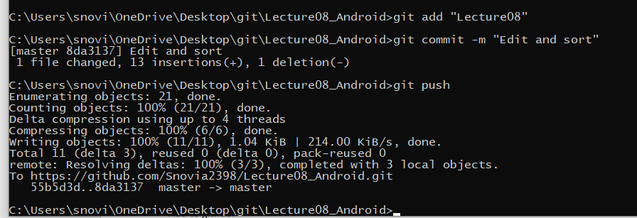

Added:

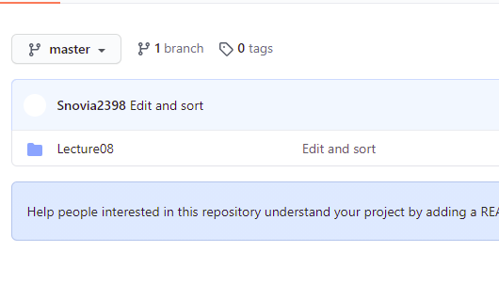

Now to move data from one to another activity create an empty activity:

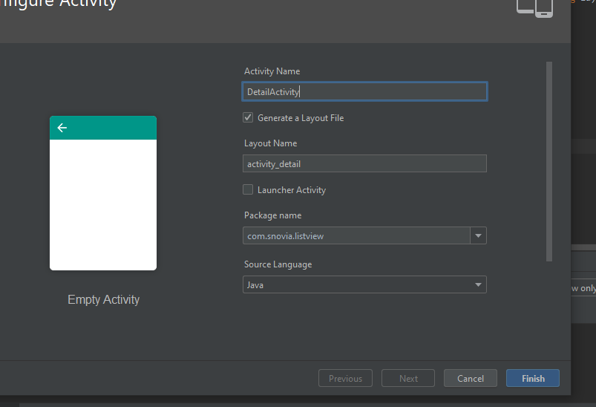

Created:

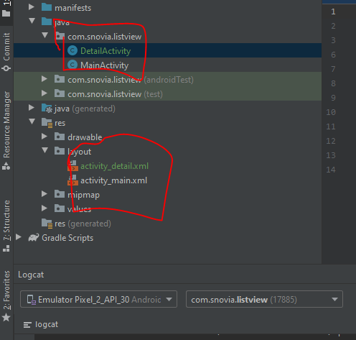

Create a text box in detail activity xml and add constraints to it, give id and increase font size:

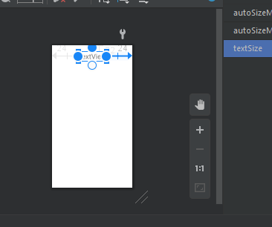

Now in main activity java create intent to move to another activity and also save data to it:

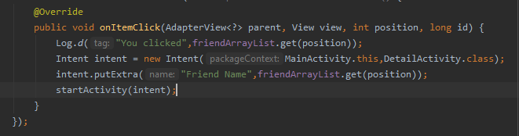

In detail activity java create instance if text box and get the intent and data from main activity:

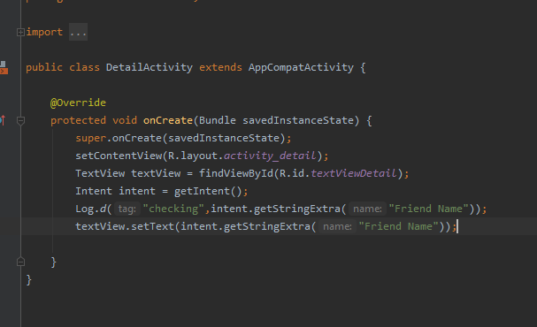

Run the code and see output:

First you are in main activity:

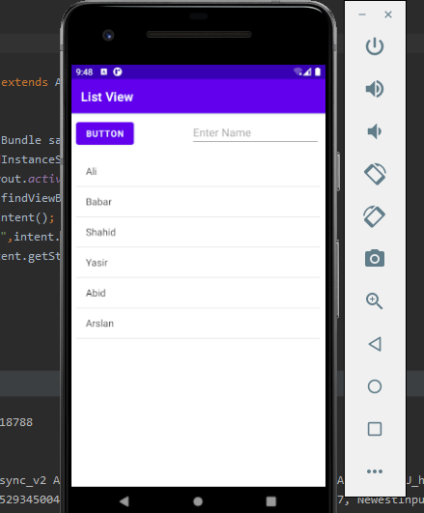

When click on name for example babar then in detail activity that name shows:

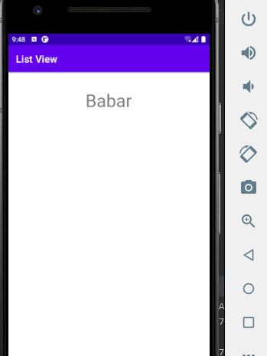

Push to github:

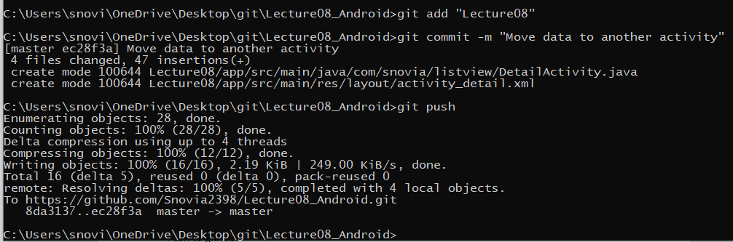

Added:

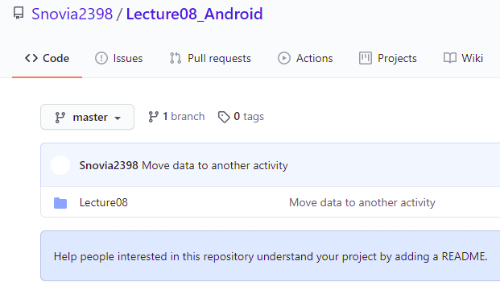

Now push word file to github

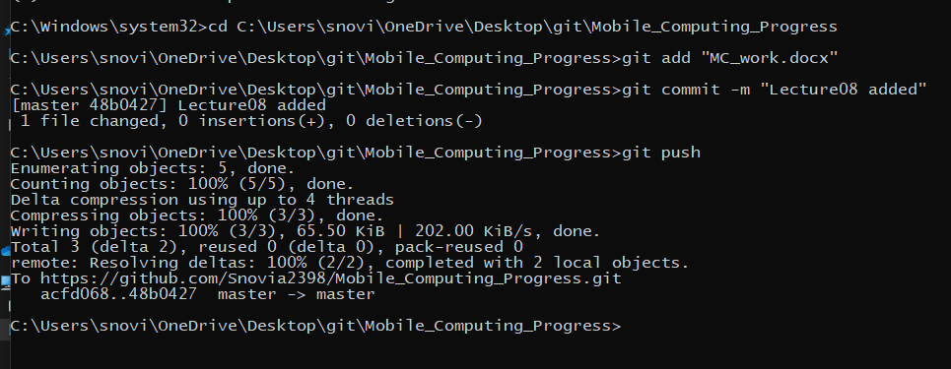

Added:

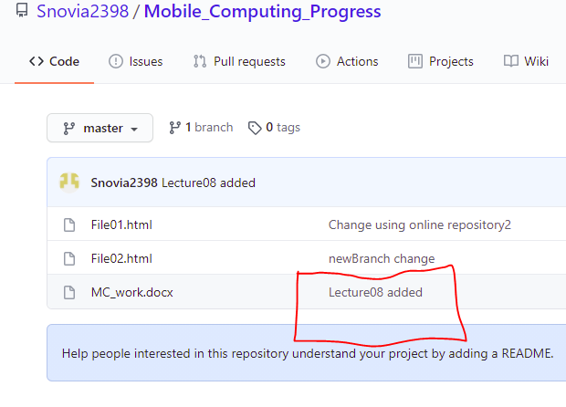**LECTURE: 09**

Create a repository in GitHub named Lecture09_Android:

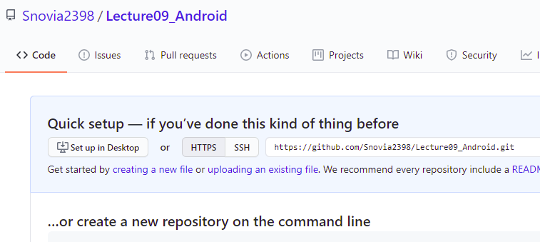

Now got to git folder and create a clone of this repository:

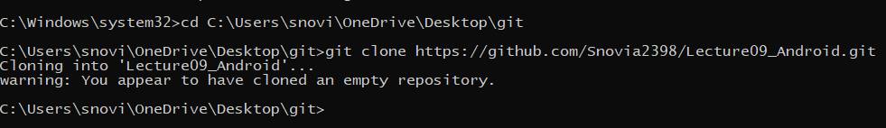

Create a folder in this clone and go to that folder:

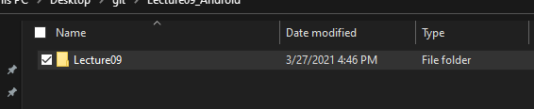

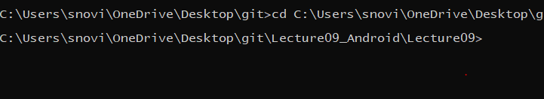

Now create android project in this folder named android_animation:

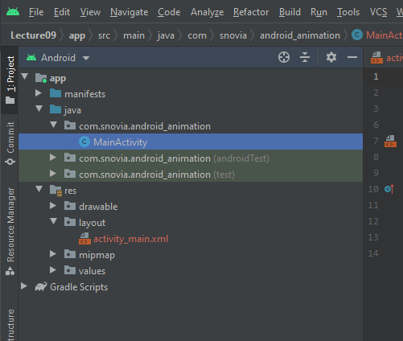

Create a seekbar by drag and drop:

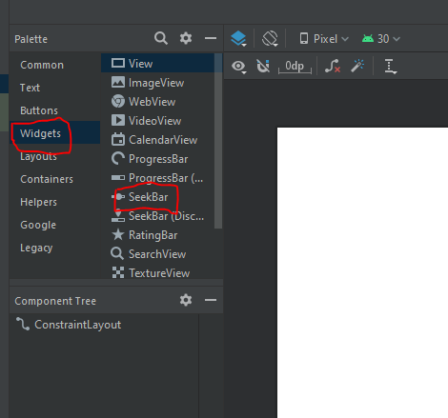

After drag and drop add constraints to it:

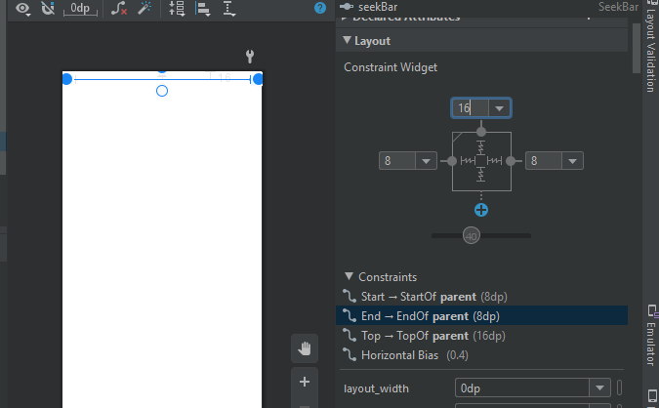

Run it and see the output:

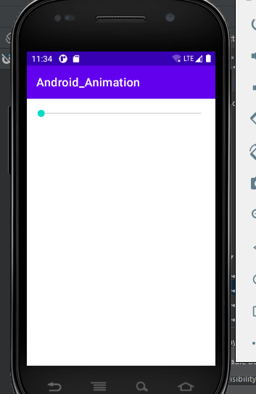

Set the maximum value and try to read that in log:

Create object of seekbar in java file, set its maximum value and create call function and in progress part write code to read the value:

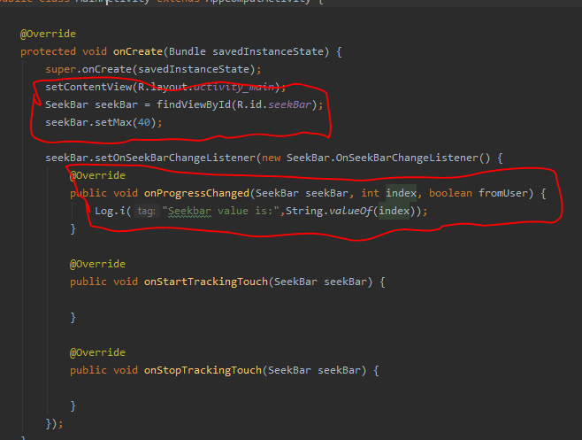

Now run this and see results:

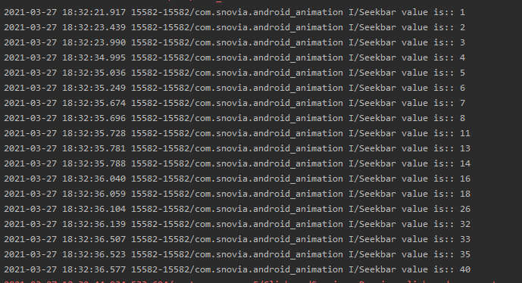

Increase the maximum to 100.

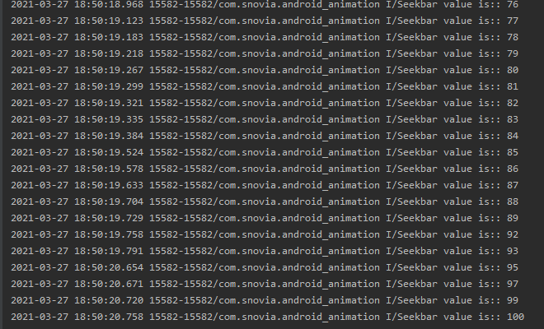

Add this to repository:

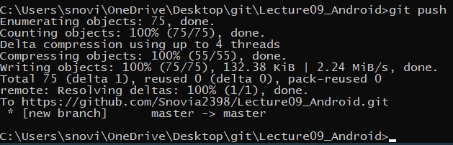

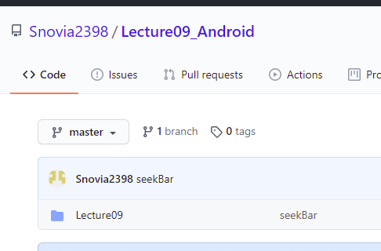

Now create a list view below the seekbar, give id and add constraints to it:

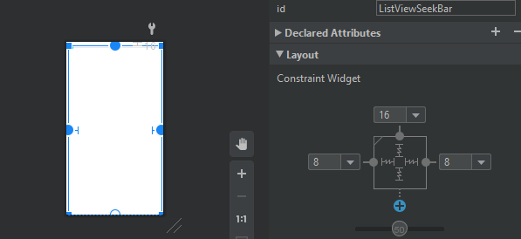

Now try to create table according to changed value in seekbar:

For this get listView and write code to display table:

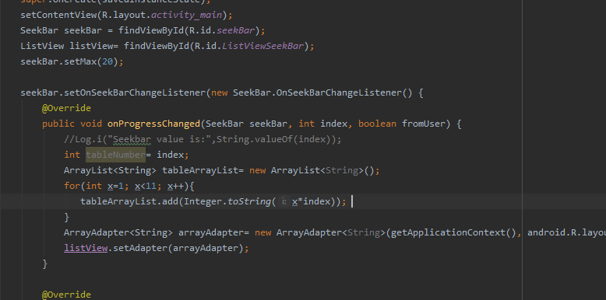

Run the code and see results:

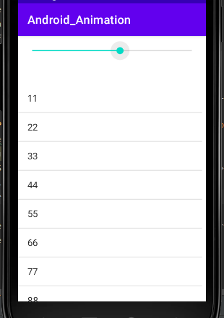

Increase the maximum to 50 :

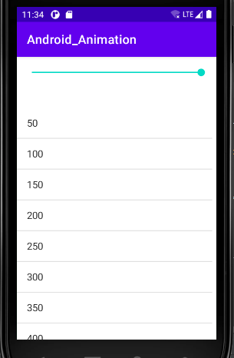

Push this to GitHub:

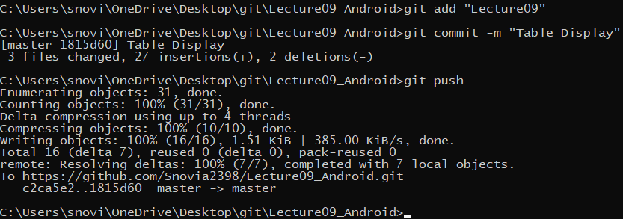

Added:

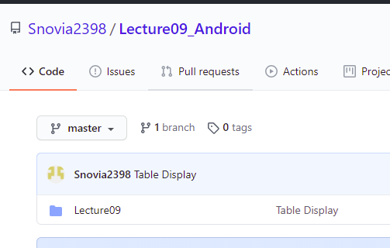

Now go to animations:

First of all copy 2 images football and cricket_bat from pc and paste them in drawable:

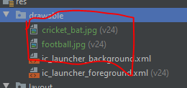

Create imageView by drag and drop and select image of cricket_bat and add constraints to it:

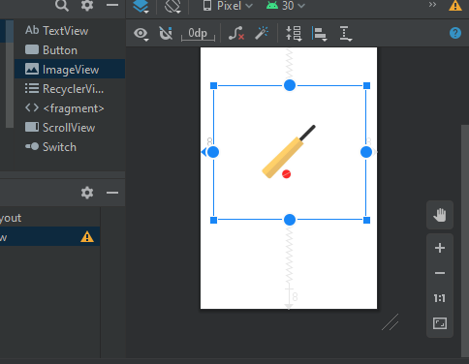

Run the code and see results:

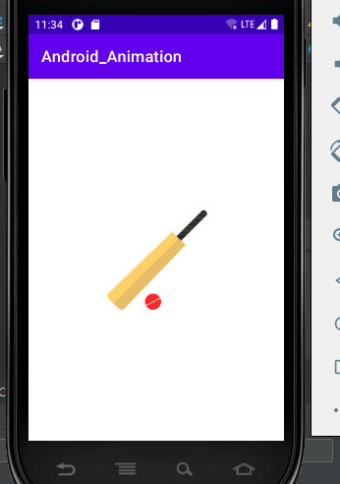

Now add onClick function to image:

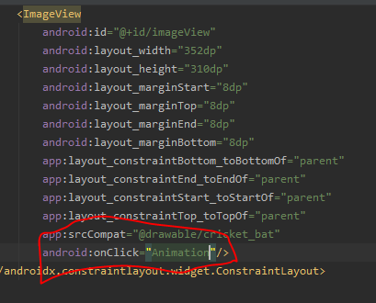

In java file write function Animation and write code to fade the image on click the image:

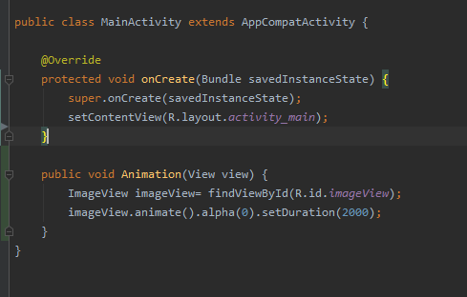

Run the code and see output:

Before:

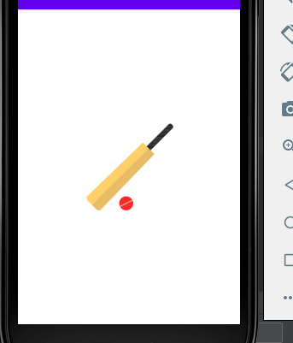

After:

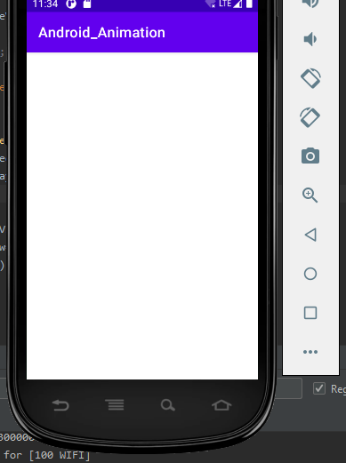

Push to GitHub:

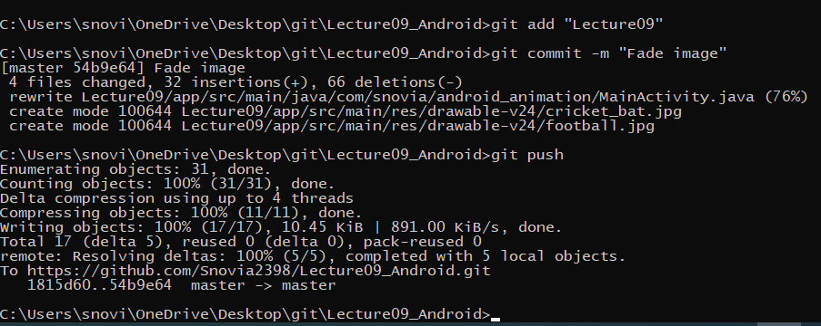

Added:

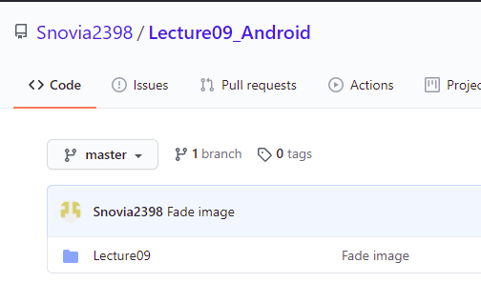

Now move image to y-axis:

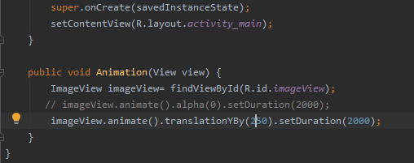

Run code and see results after click image:

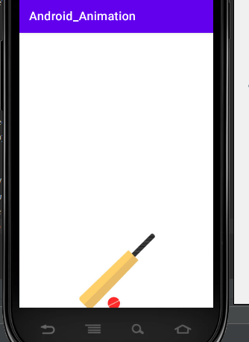

Push to GitHub:

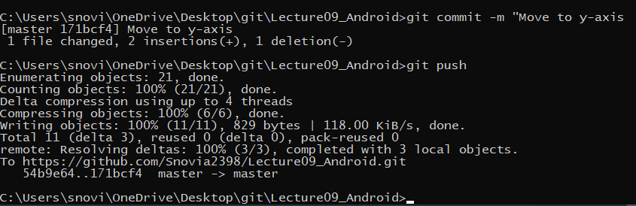

Added:

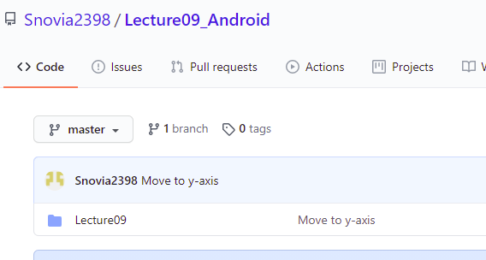

Now move to x-axis:

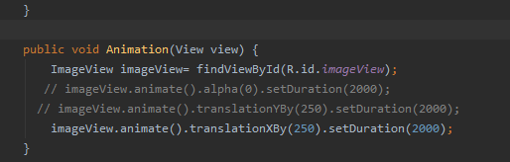

See results:

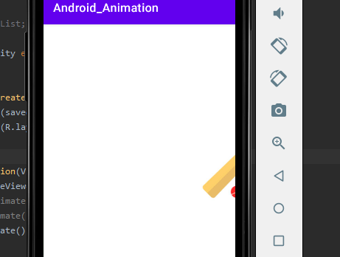

Add to GitHub:

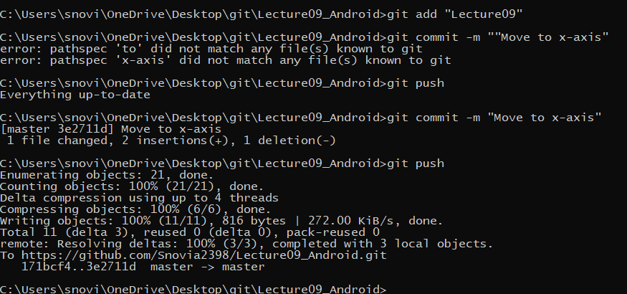

Added:

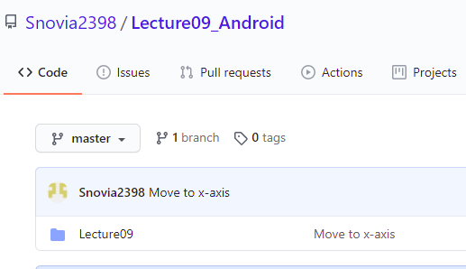

Now rotate the image:

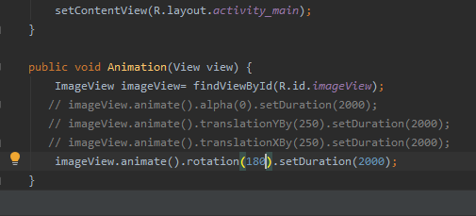

See results:

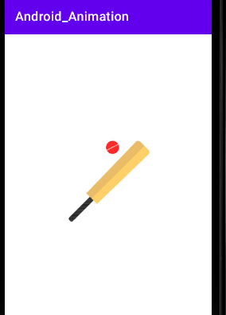

Add to GitHub:

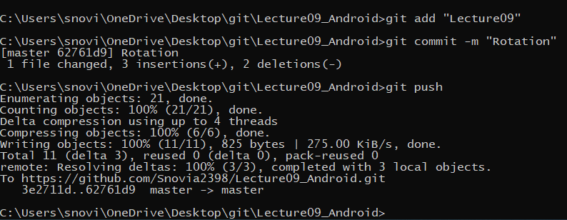

Added:

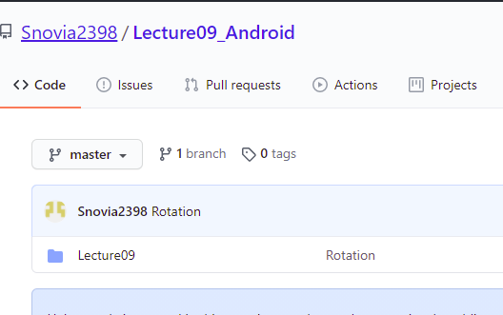

Now apply rotation and alpha simultaneously:

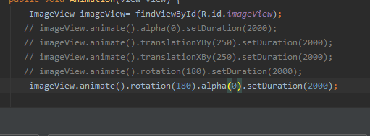

It rotate and after rotation disappears:

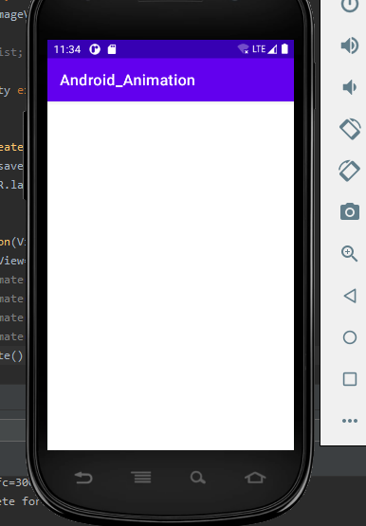

Push to GitHub:

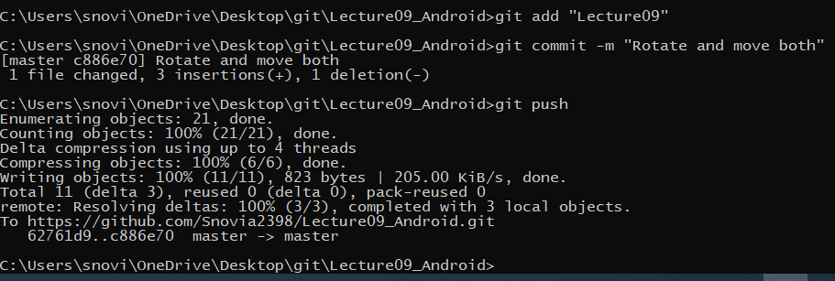

Added:

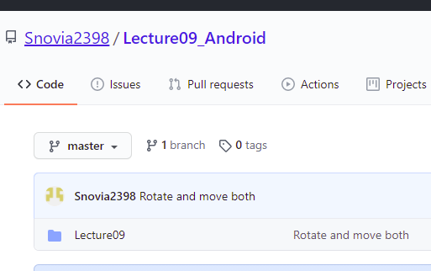

Now scale the image along x-axis:

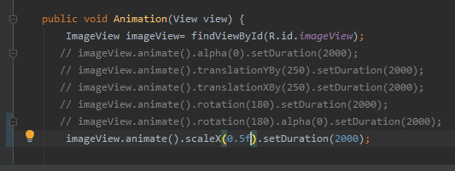

See the results:

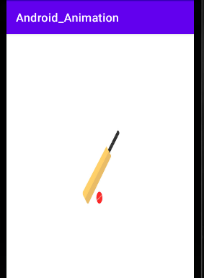

Now scale along y-axis:

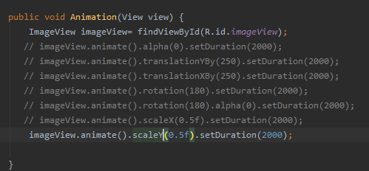

See results:

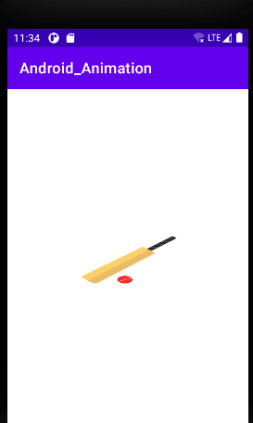

Add to GitHub:

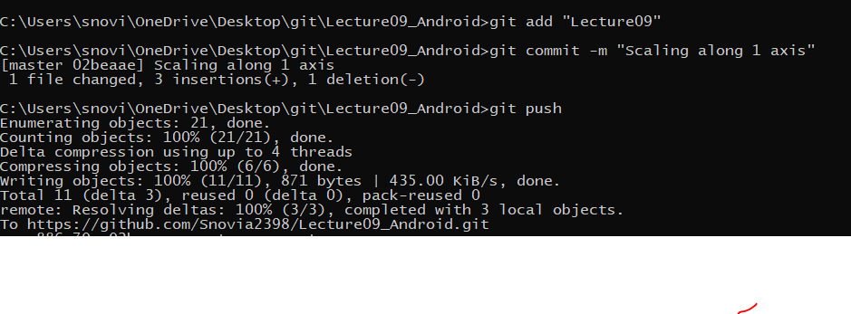

Added:

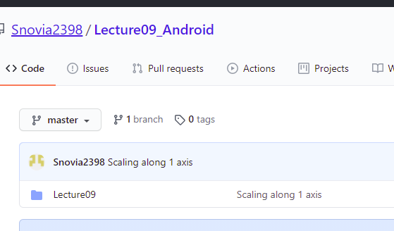

Now move along both axis:

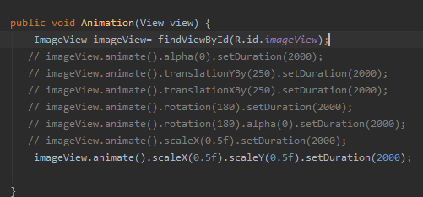

See results:

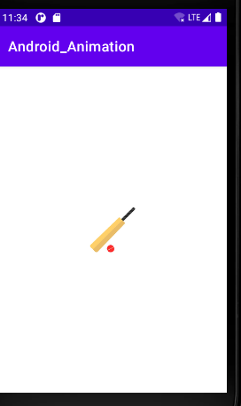

Now apply scaling with rotation:

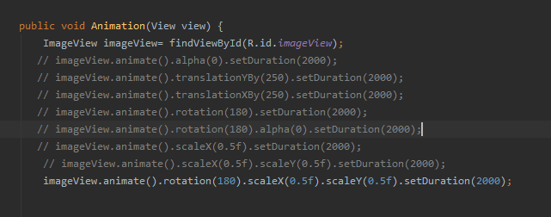

See results:

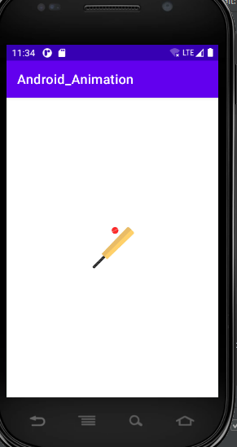

Push to GitHub:

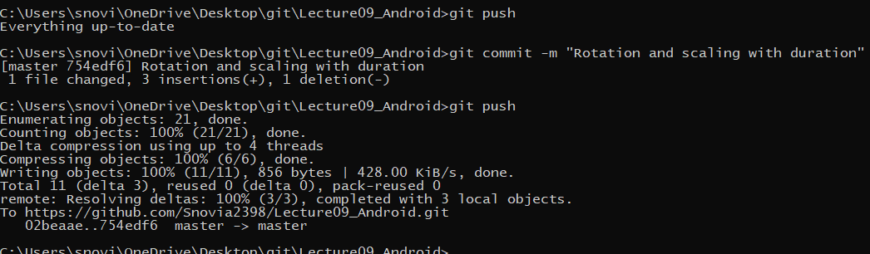

Added:

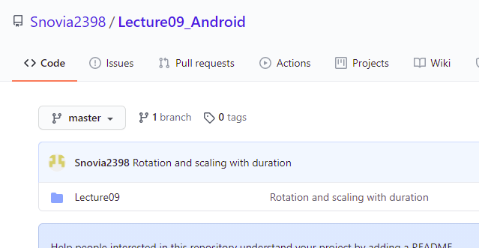

Now create a new activity and tick the launcher activity so that program run on this activity.

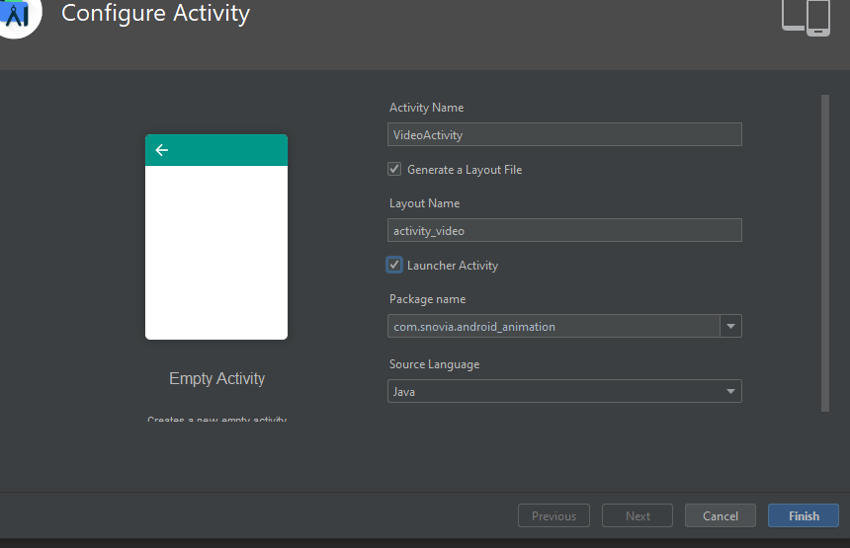

Here the activity is created:

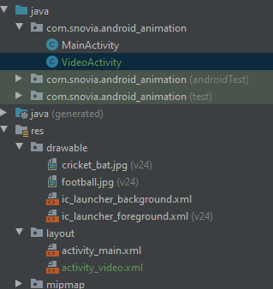

Create videoView by drag and drop and add constraints to it:

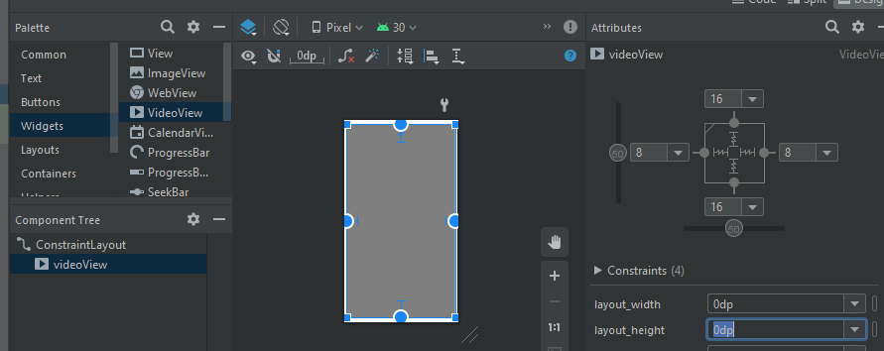

In java file create object of this:

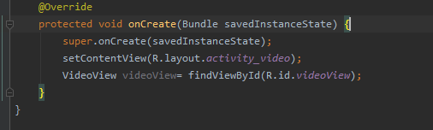

Now copy video from pc and paste to raw:

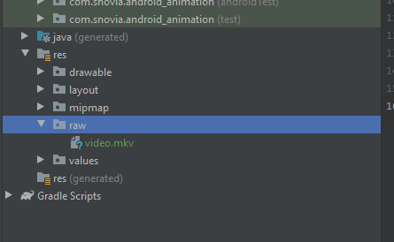

Write a code in java file to run video:

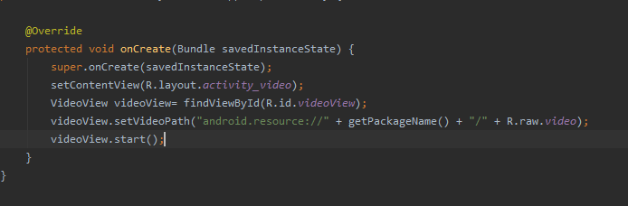

Run and see results:

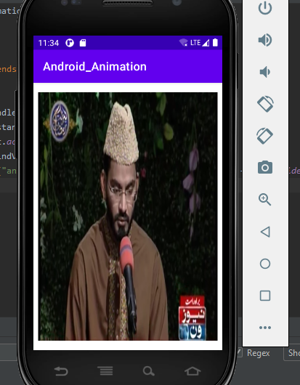

Add this to GitHub:

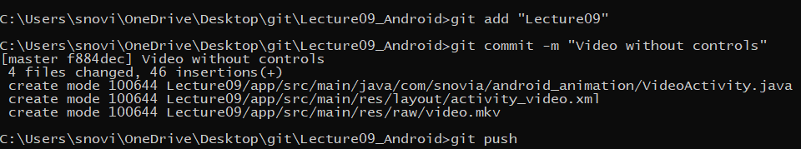

Added:

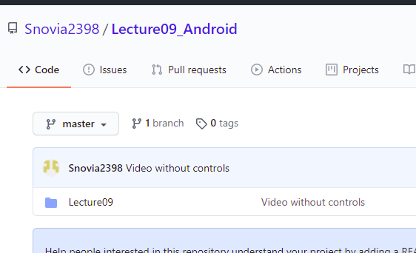

Now add controls:

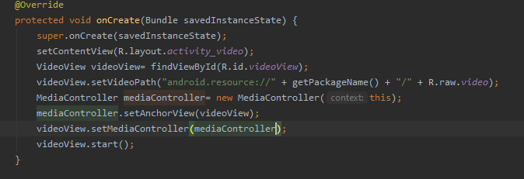

Run and see results:



Add this to GitHub:

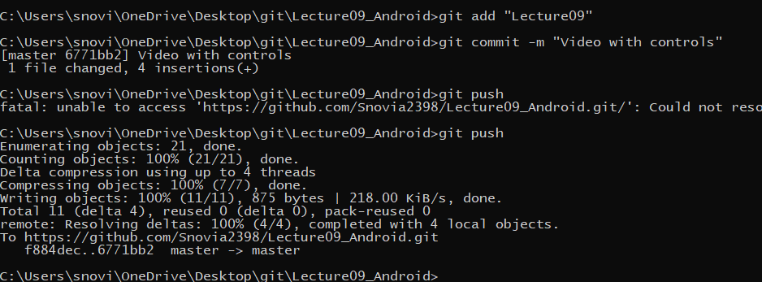

Added:

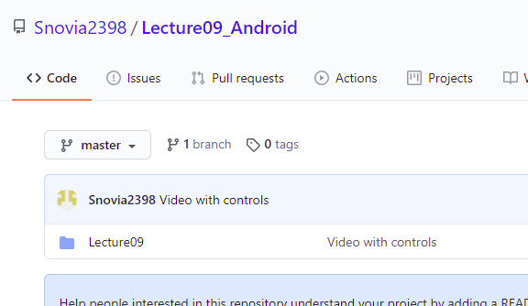

Now see how to add audio:

For this create new activity named audio activity and make it launcher activity:

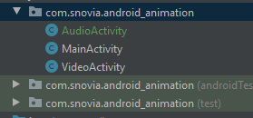

Copy audio file from pc and paste in raw folder:

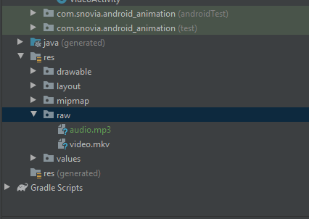

Write code to start the audio:

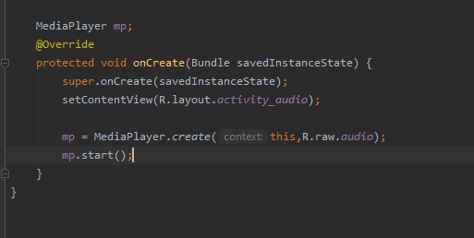

Run and see results:

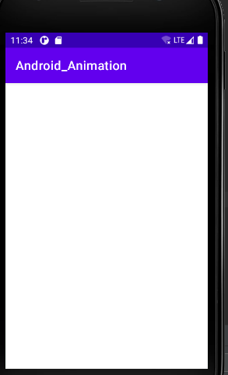

Audio is playing.

Add to GitHub:

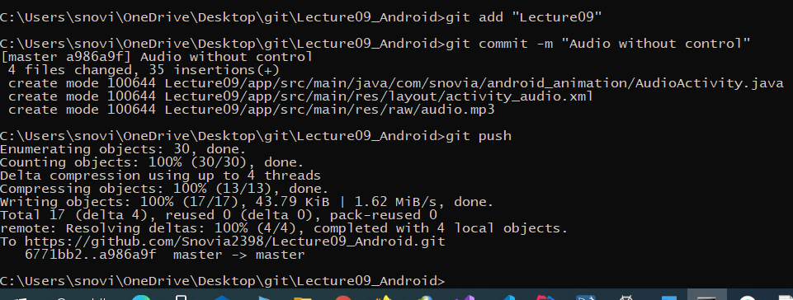

Added:

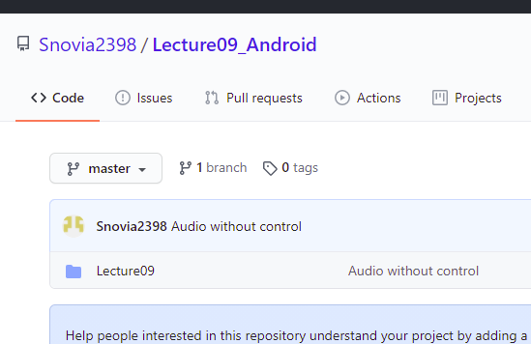

Now add buttons in design view and add constraints to them.

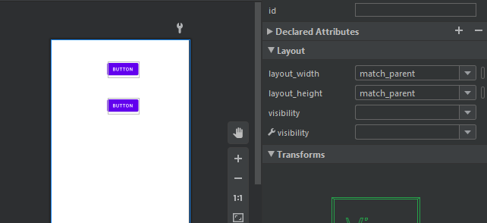

Now add onClick event:

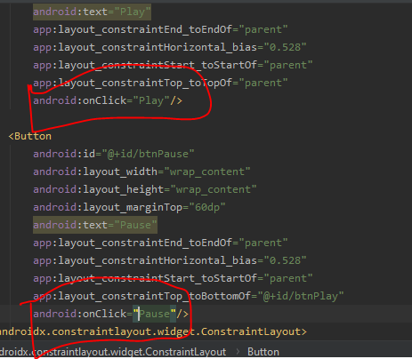

In java file create play and pause functions and write code to play and pause the audio:

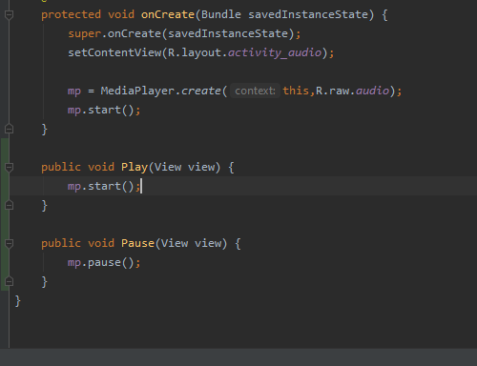

Run the code and see results:

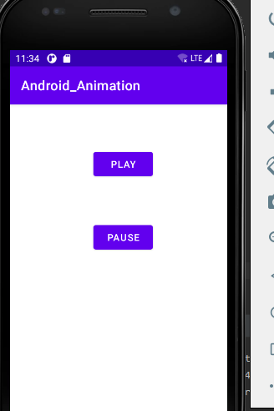

It is working fine.

Push to GitHub:

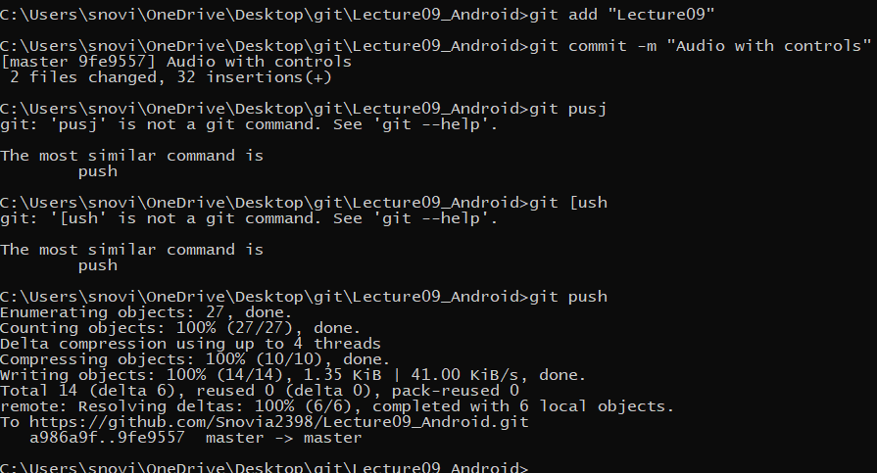

Added:

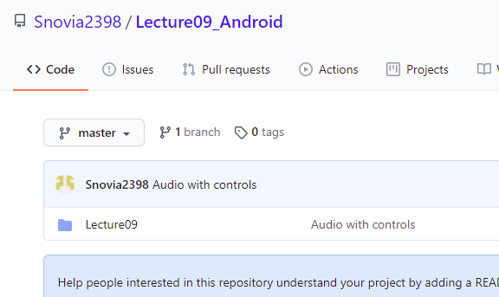

Add word file to GitHub:

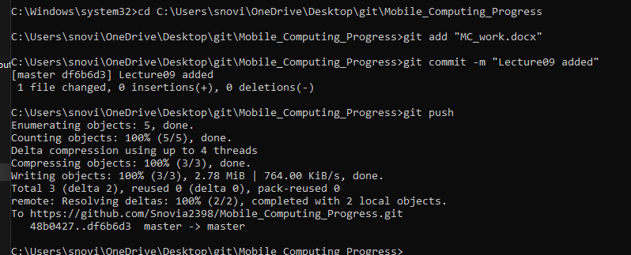

Added:

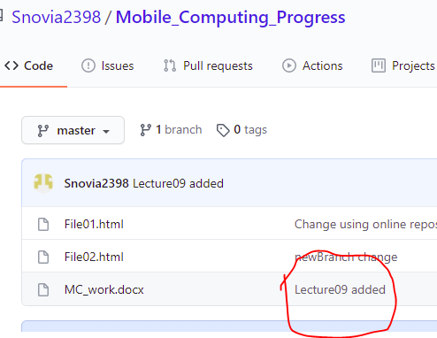

**ASSIGNMENT:01**

Create a repository in GitHub named Assignmentt01:

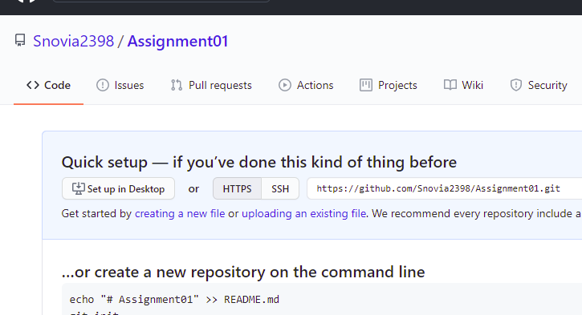

In git folder create a clone of repository:

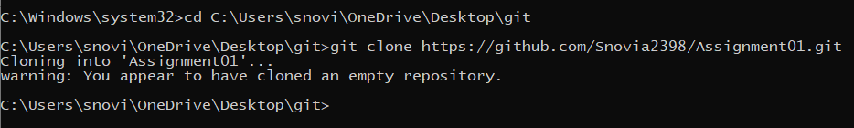

Go to this clone folder and create android project named “Alphabets Learning”:

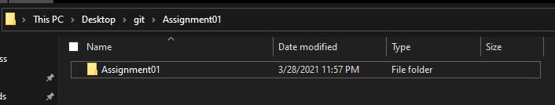

Project is created:

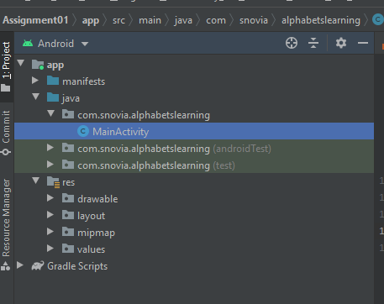

Change the background color:

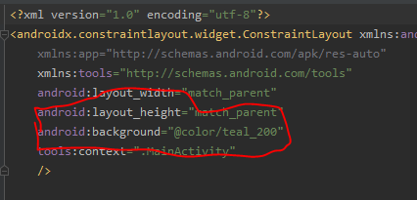

Copy image from pc and paste in drawable folder:

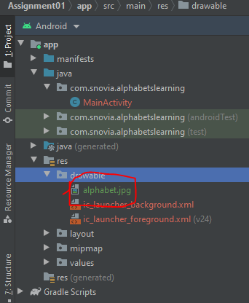

Create a textView give it id, change width to match_constraints, give background color, text color, text style and add constraints:

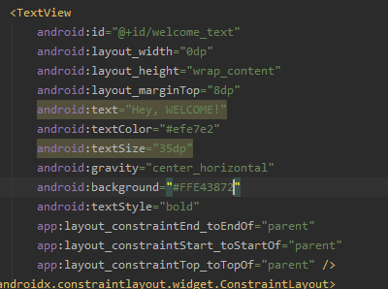

Run the code and see results:

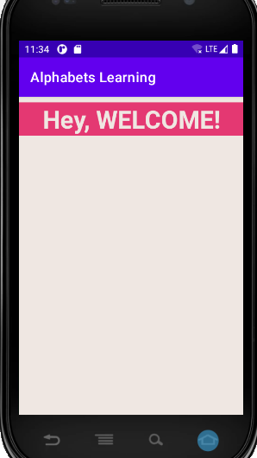

Now create imageView by drag and drop and add constraints and set height and width:

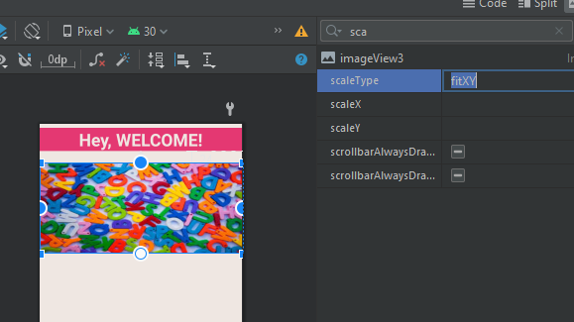

Run the code and see output:

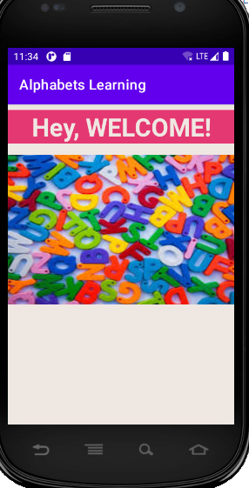

Now add buttons by drag and drop and add constraints and styles:

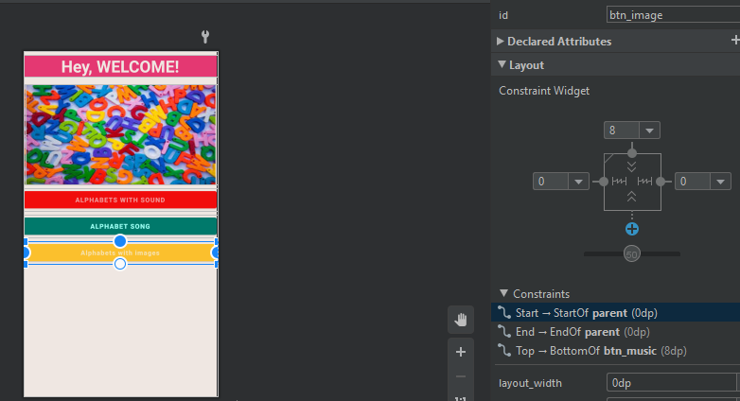

Push to GitHub:

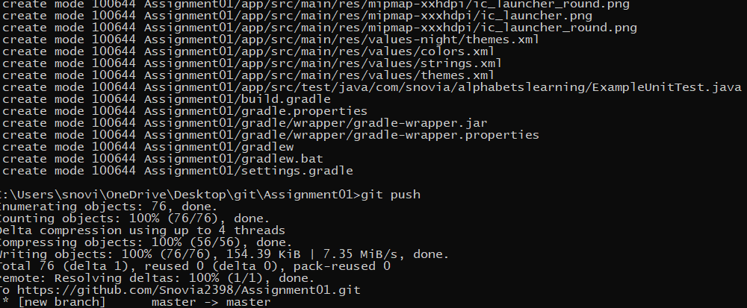

Added:

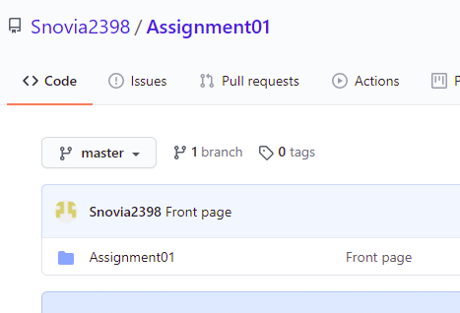

Now create an activity for alphabets with sound:

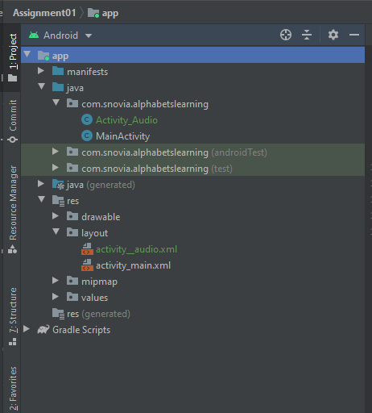

Add onClick event for button Alphabets with audio to move to Activity_audio:

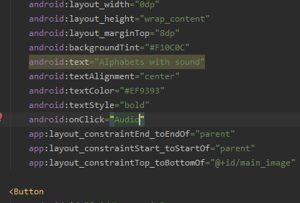

Now in main activity java class write function to move to Activity_audio:

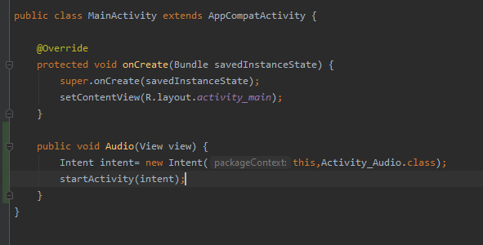

In Activity_audio create gridView by drag and drop and add constraints to it:

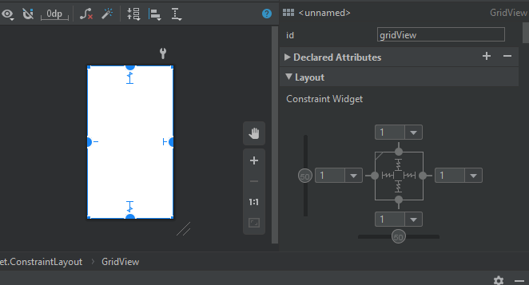

In java class make array of alphabet letters and create object of gridView:

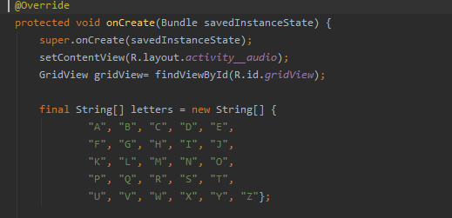

Write adopter to display the gridView items and give grid columns 4:

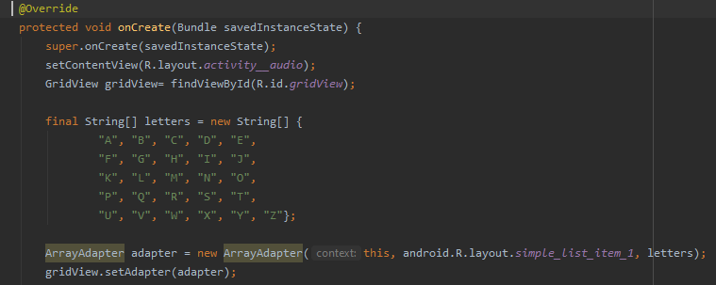

Run the code and see output:

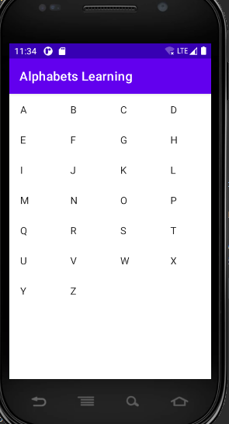

Give background color to the screen:

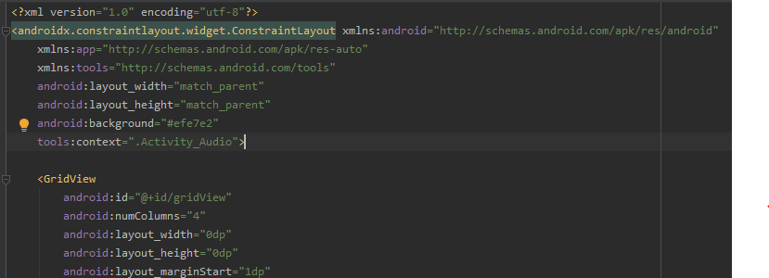

Run code and see output:

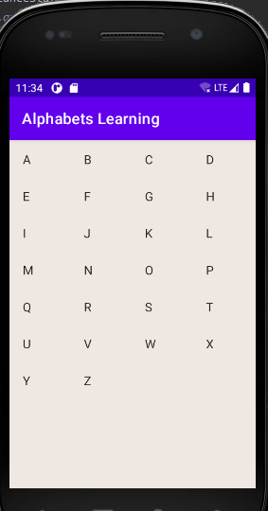

Now add mp3 files to raw folder from pc:

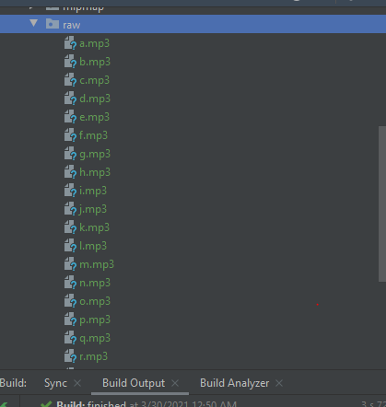

Now write code to add sound on click each item:

For this use switch statement on every position add sound according to position:

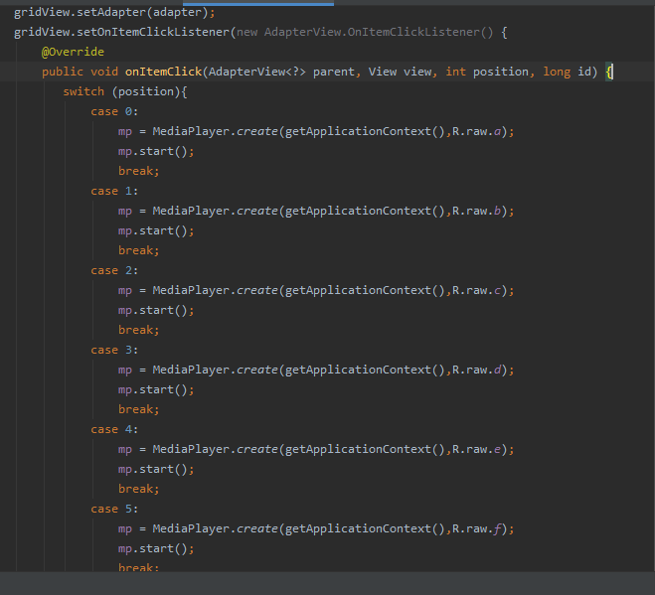

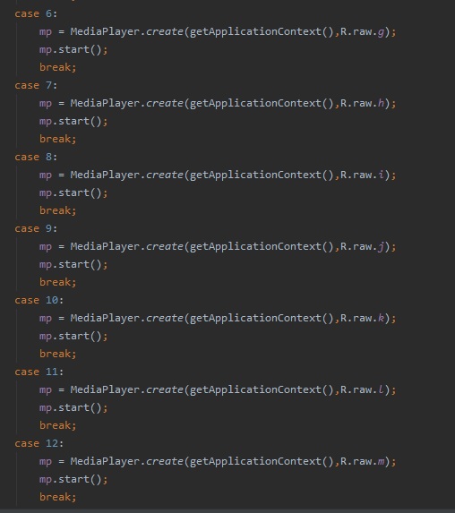

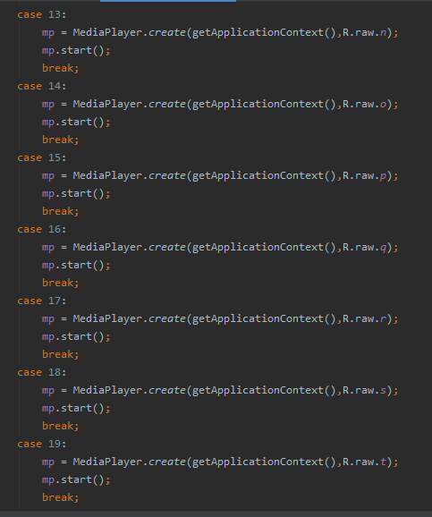

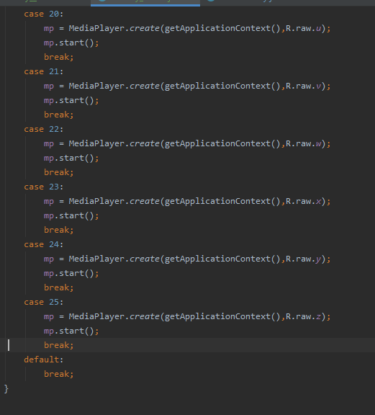

Now run code and see output:

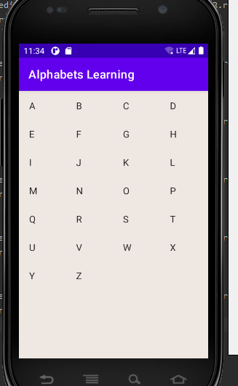

It works fine.

Add this to GitHub:

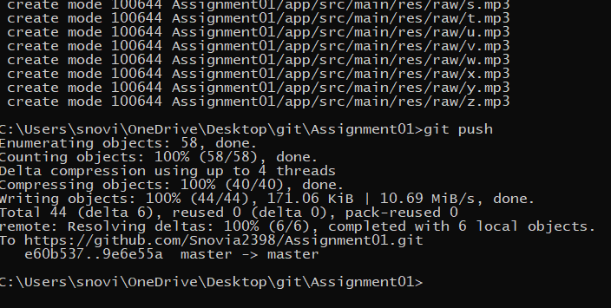

Added:

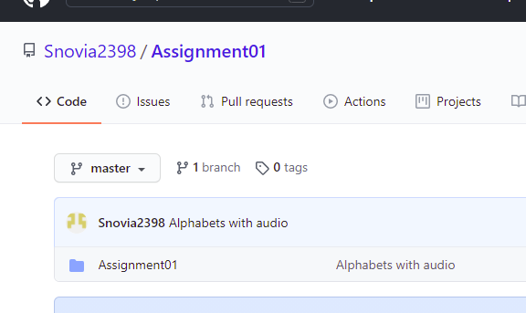

Now add onClick event on second button which is used to go to another activity:

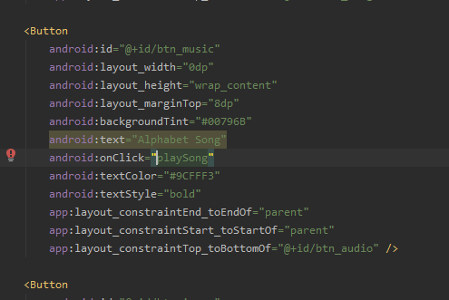

In java class create function playSong and write code in it to go to other Activity:

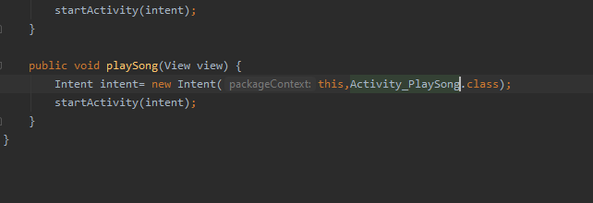

Now create new activity Activity_PlaySong:

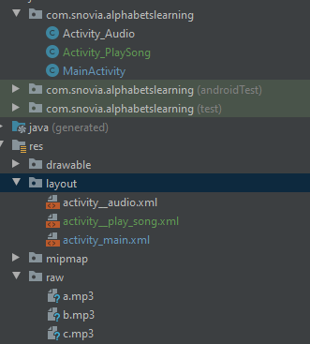

Now in Activity_PlaySong xml file create videoView by drag and drop and add constraints to it:

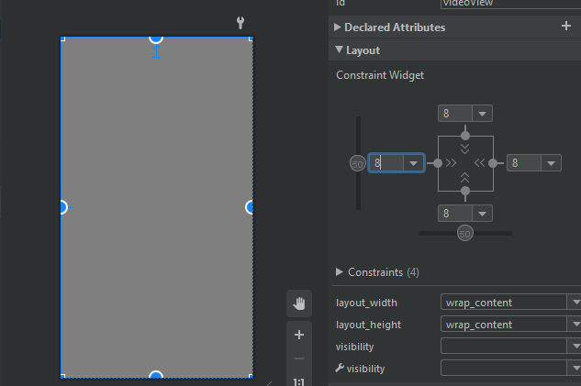

In java file create instance of videoView and get by id:

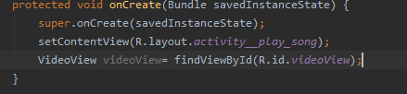

Copy video from pc and paste into raw folder:

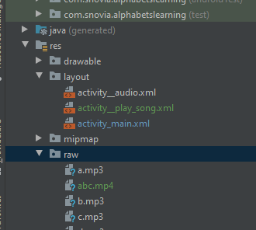

Set path for this and add media player for controls:

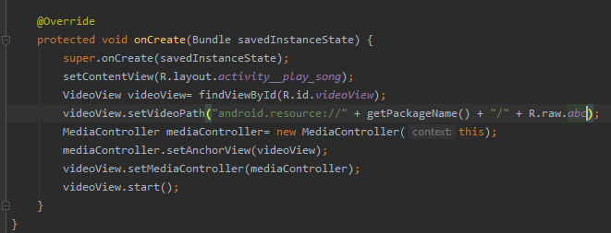

Run the code and see results:

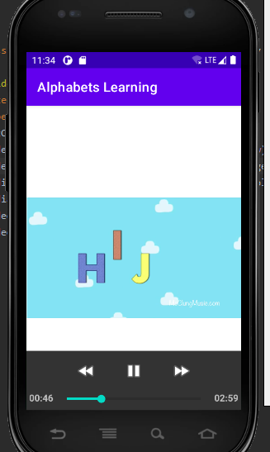

Change the background color of screen:

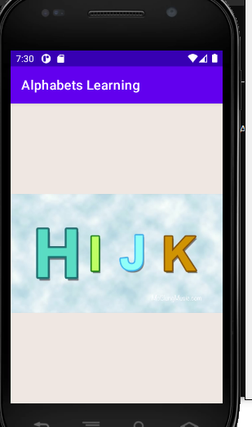

Add this to GitHub:

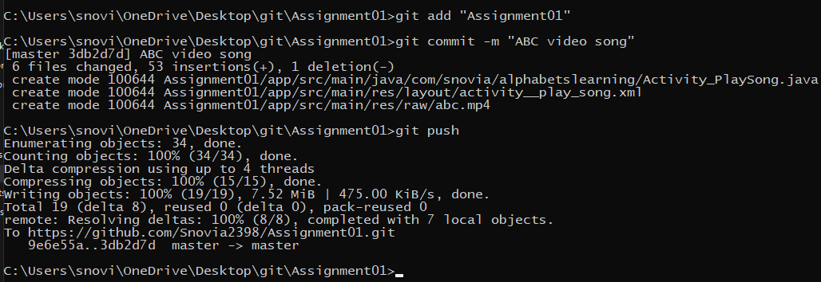

Added:

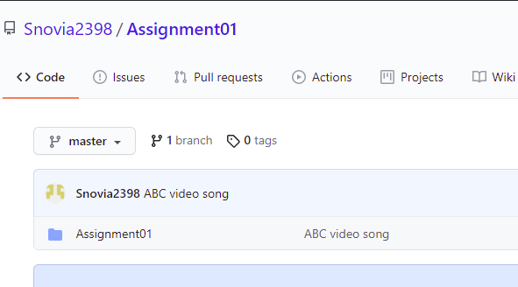

In main activity on last button add onClick event and write function to move it to activity_a:

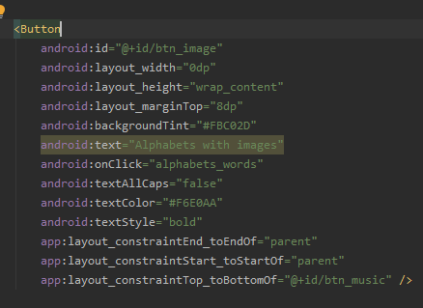

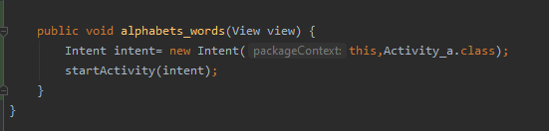

Create 26 new activities for alphabets learning with image and audio and two new buttons for backward and forward movement, add constraints and give background colors to them like activity for a:

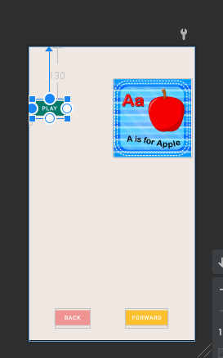

Activity a java class:

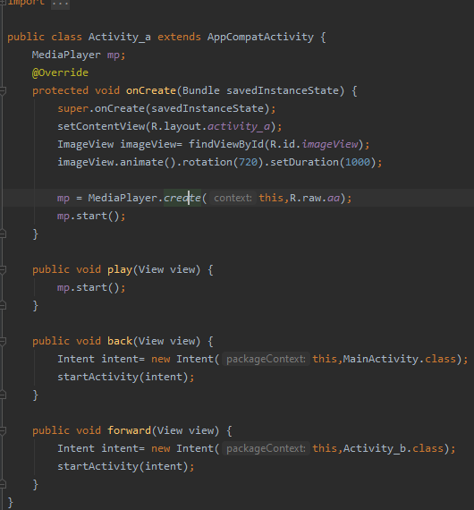

Activities are:

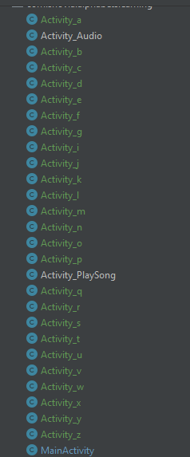

See output for alphabet a activity:

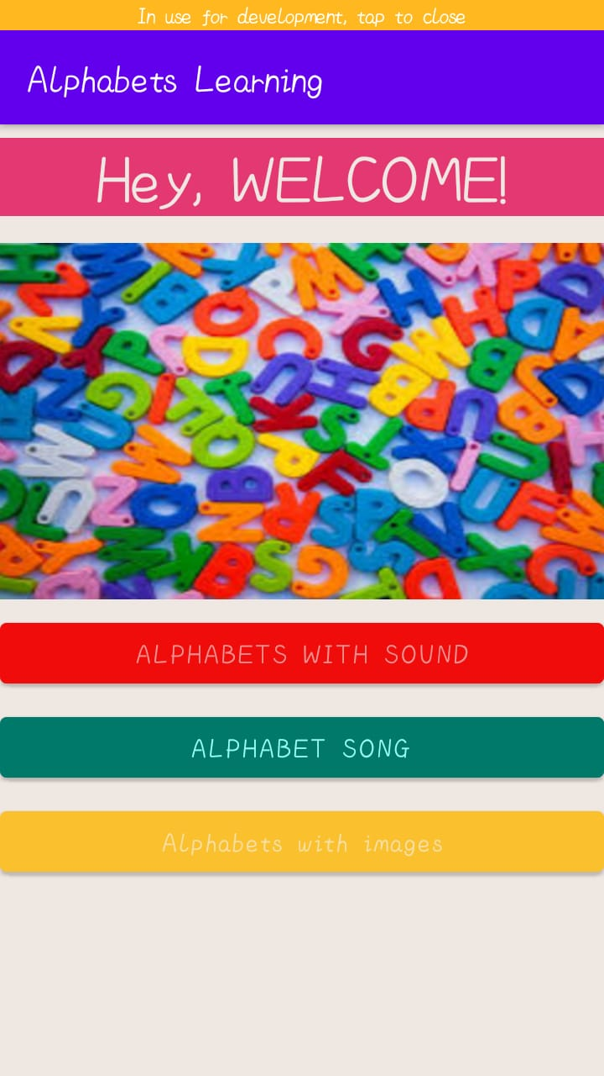

When we click on last button output:

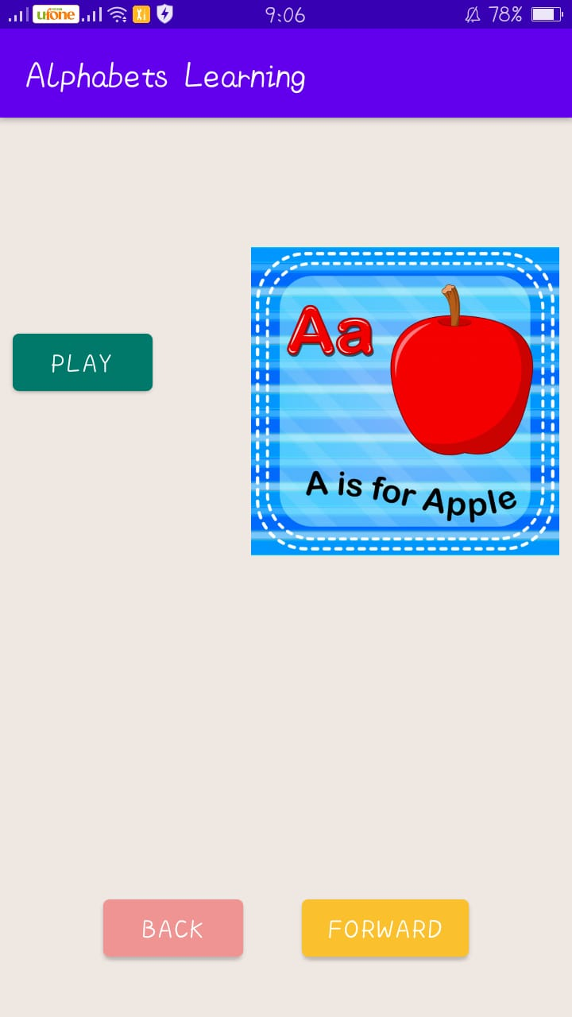

When click on back button:



When click on forward button output:

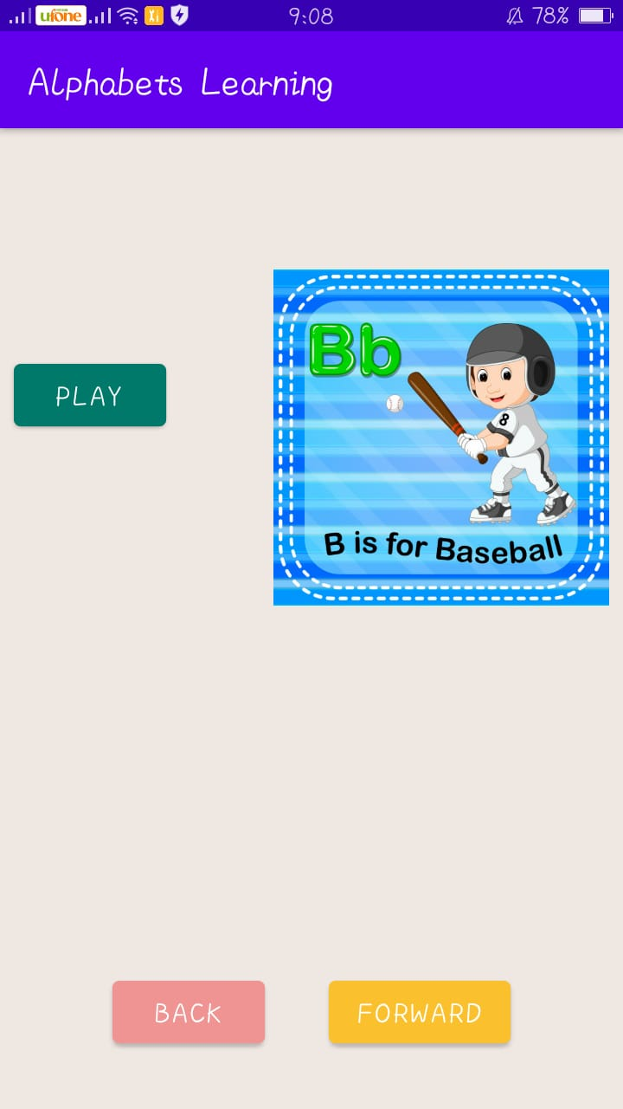

Same procedure with other 25 activities.

Push to GitHub:

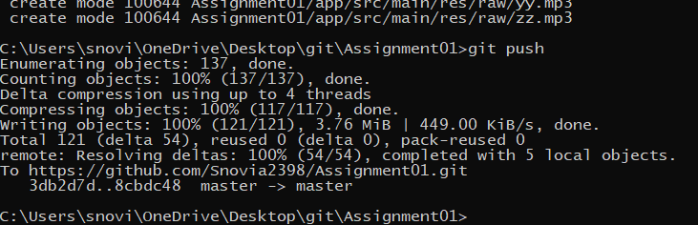

Added:

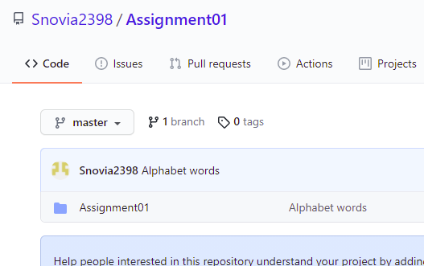

Now add 1 new activity for main page/loading page:

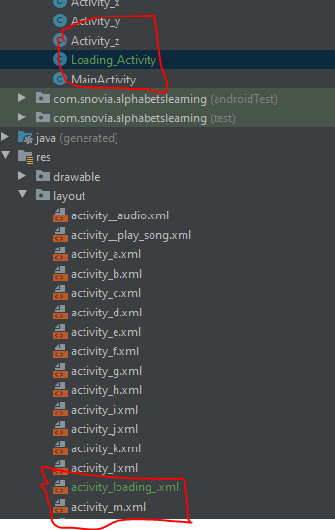

In this xml file add image at background and a progress bar and in java write code to give time to go to other activity:

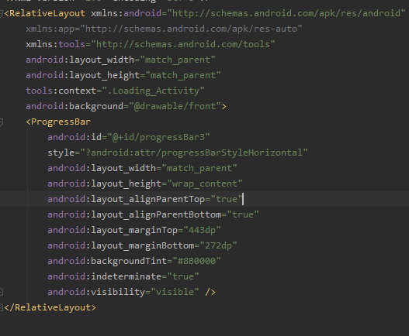

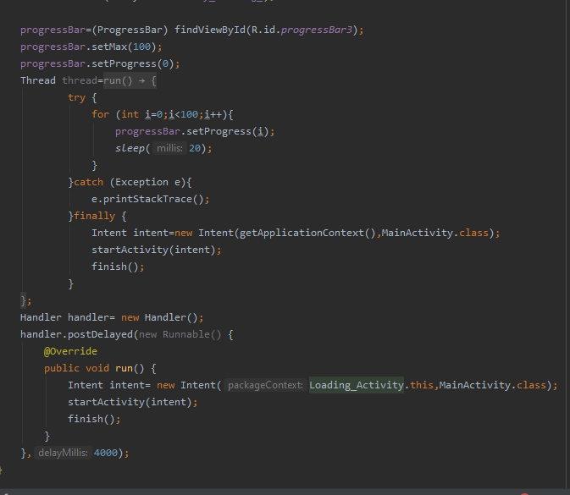

Change background color, add icons and also in main buttons rounded and many other changes like rounded buttons, increase font size of grid view images etc.

See the final result:

Front loading page:



Home page:

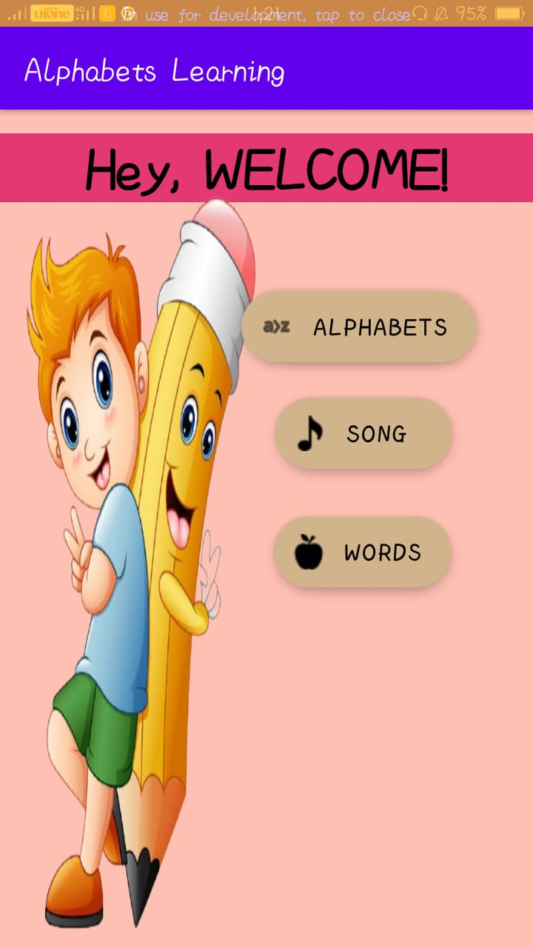

Alphabet page:

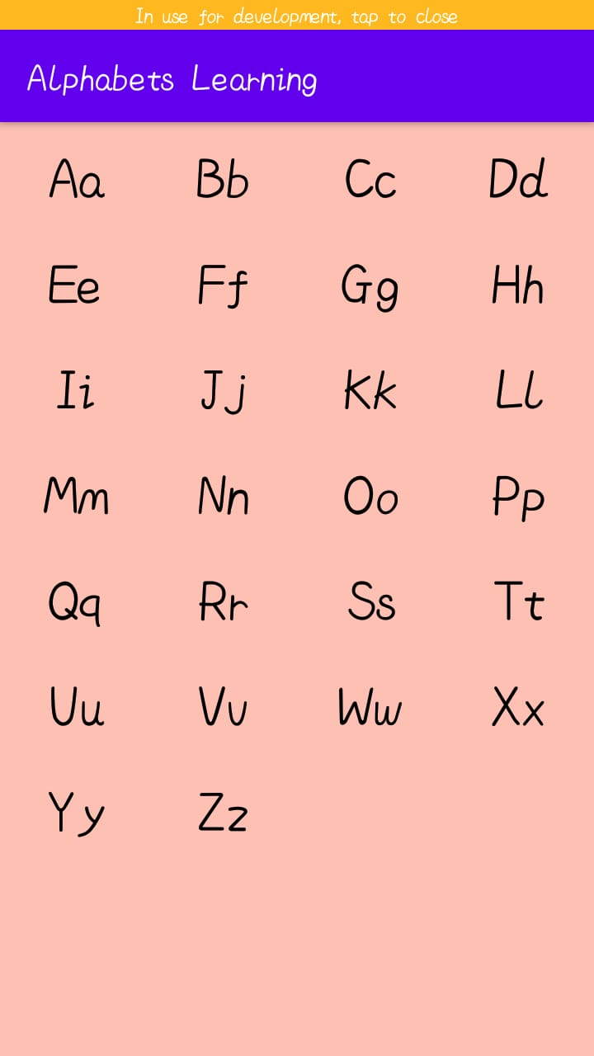

Song page:

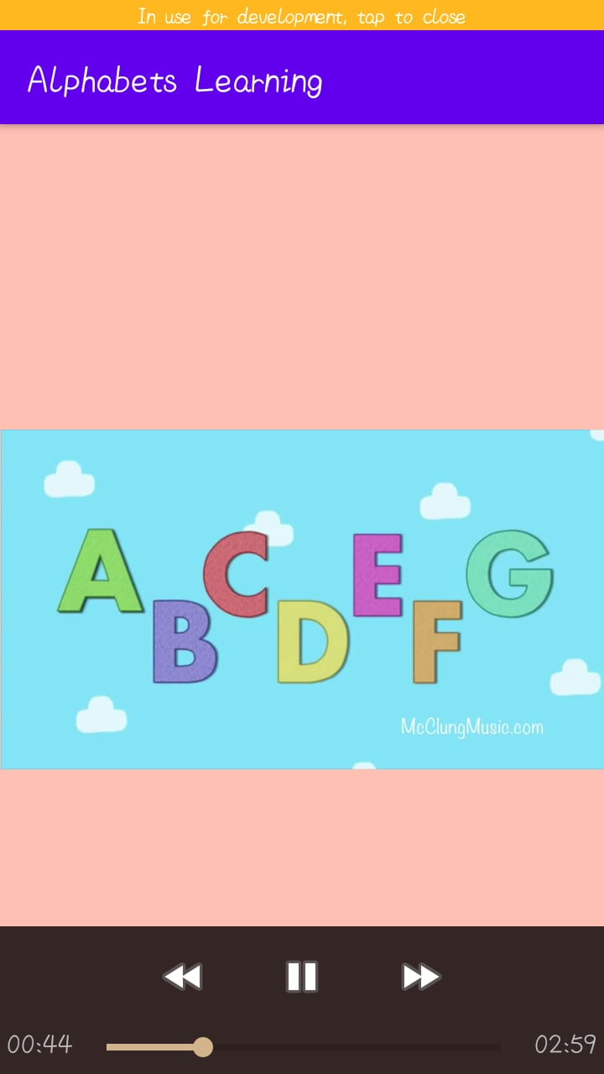

Words page:

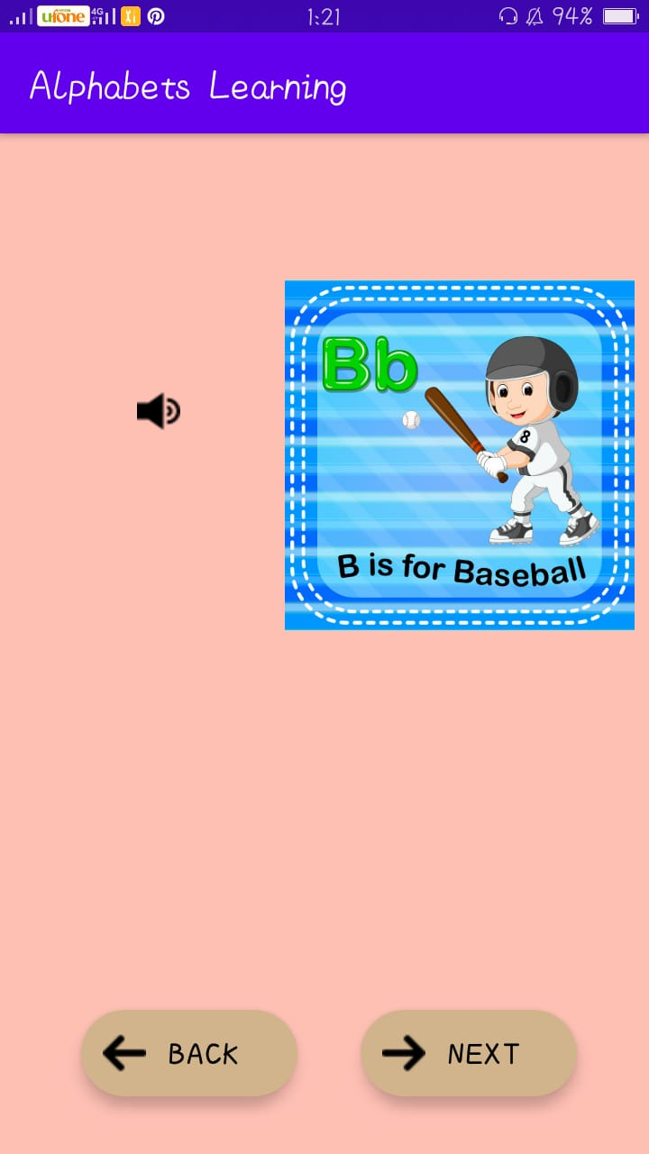

Words last page:

When we click on home button it goes back to homepage

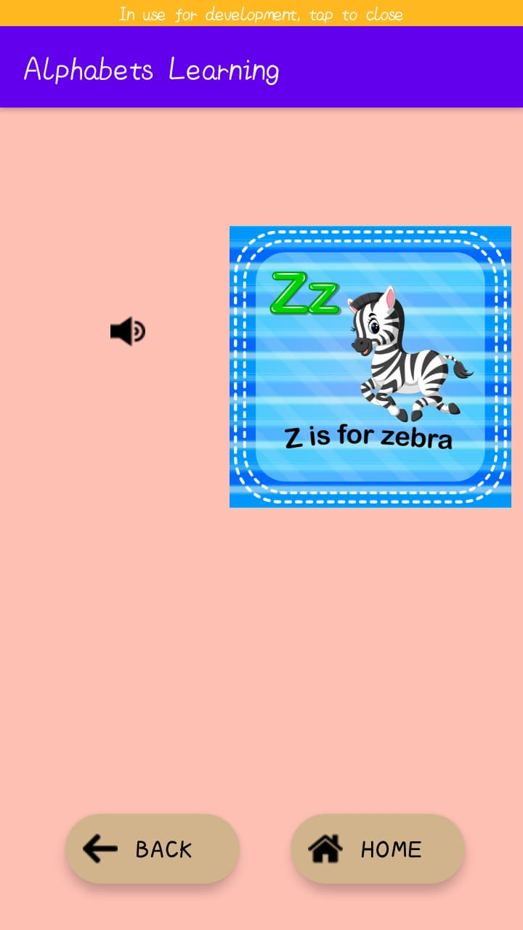

Push to GitHub:

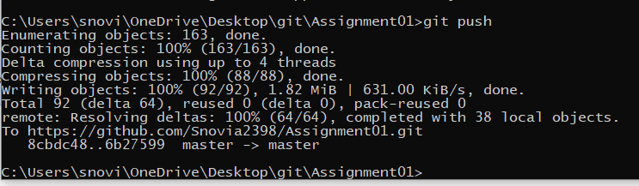

Added:

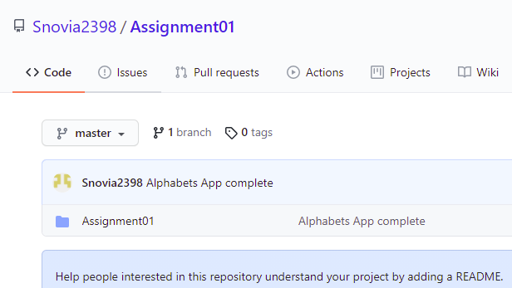

**LECTURE:10**

Create a new repository in GitHub named Lecture10_Android:

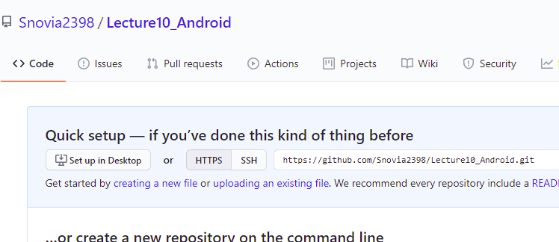

Go to git folder and create clone of this repository:

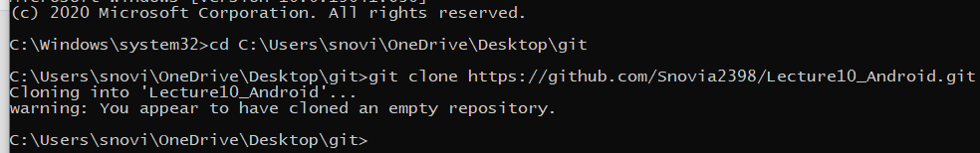

Go to this clone and create a folder named Lecture10:

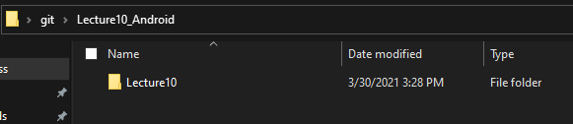

In this folder create an android project named Sqlite:

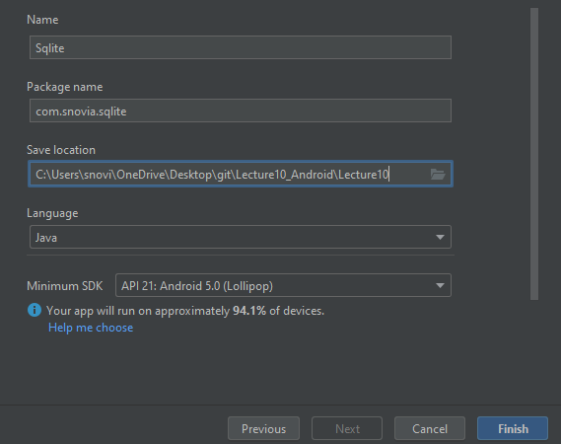

Project is created:

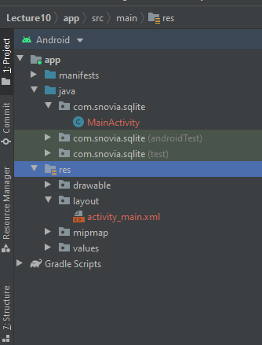

Enter a text by drag and drop and add constraints:

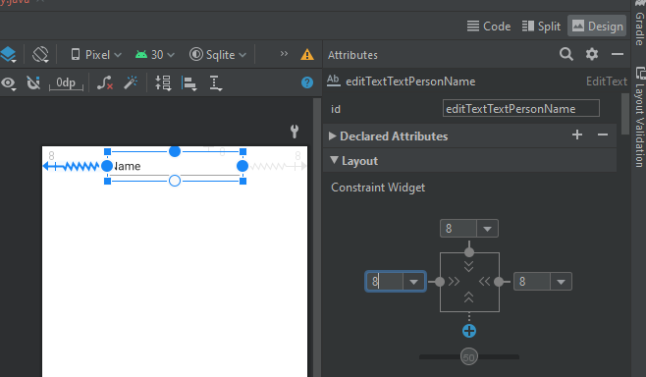

Remove text and add placeholder:

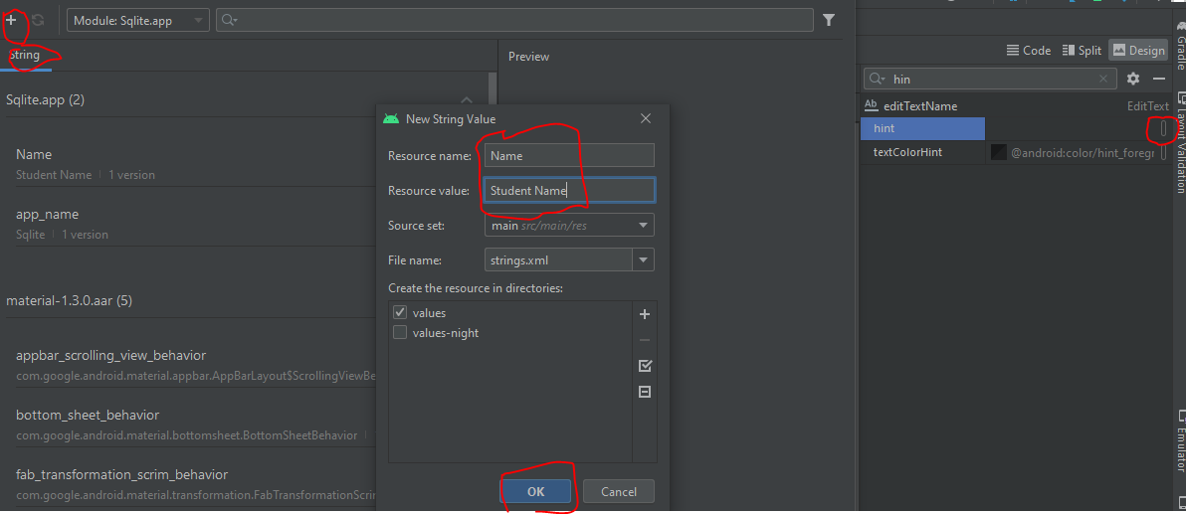

Change width to match_constraints and see results:

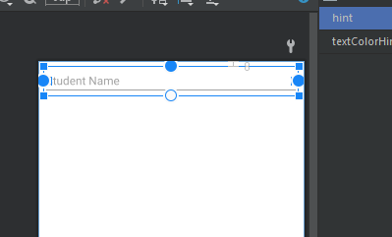

Add a number field and add constraints and give place holder to it as above:

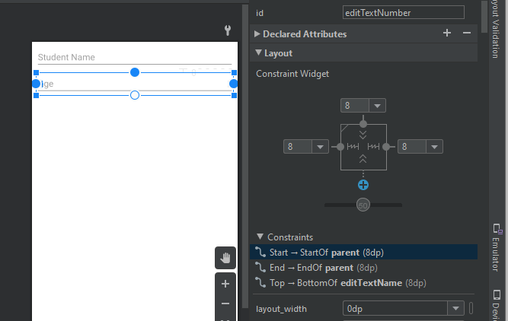

Now add switch by drag and drop and add constraints to it and give text:

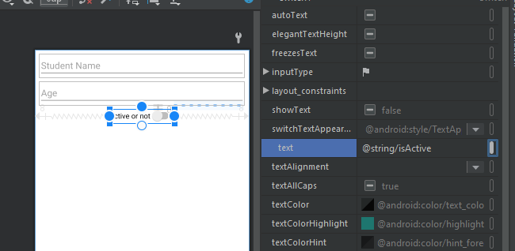

Now add two buttons and add constraints to them:

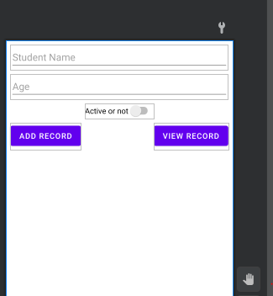

Now add listView and add constraints to it:

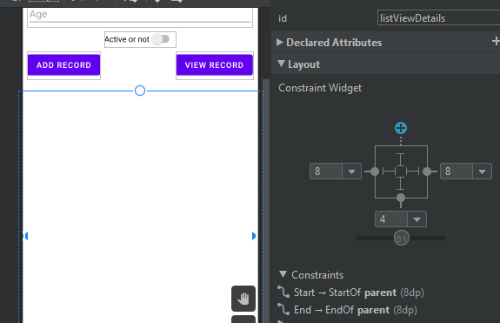

Run the code and see output:

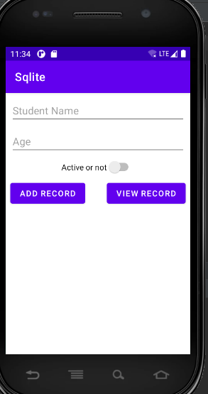

Add instances of each view we use and get them by id:

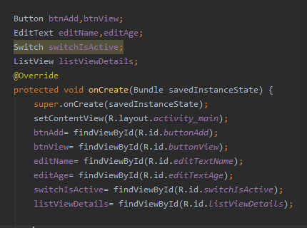

Add click listener to buttons:

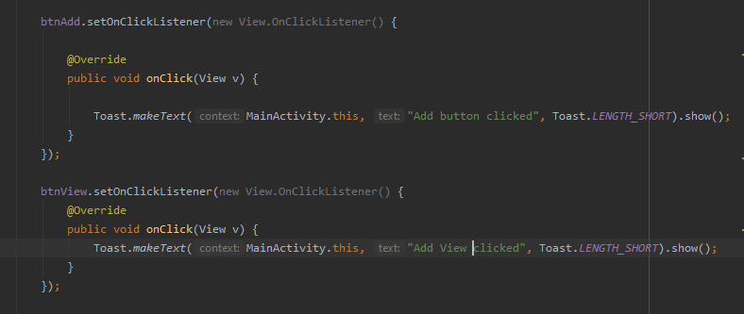

Now run code and see output:

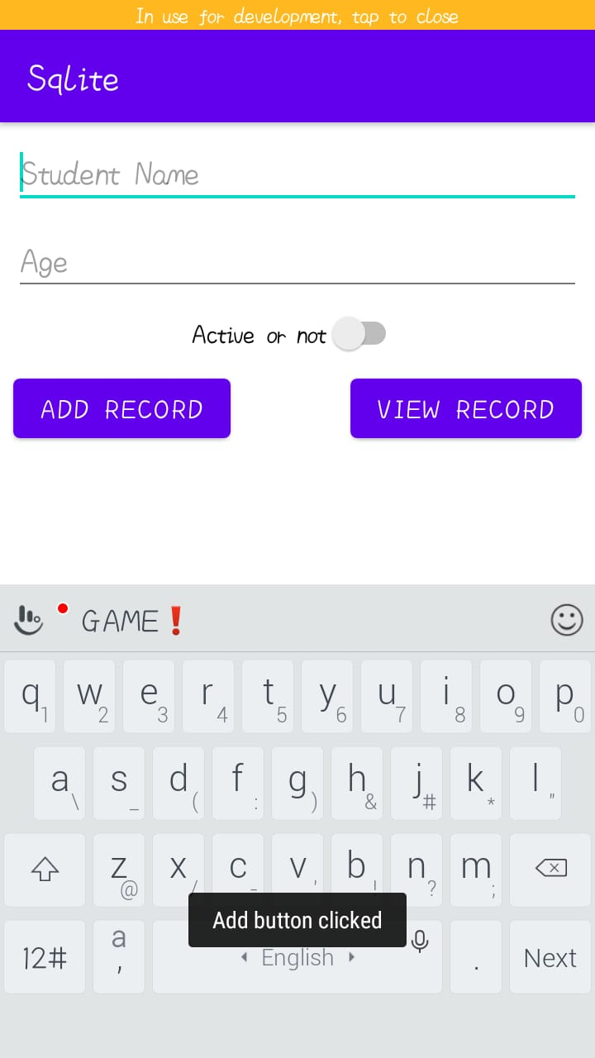

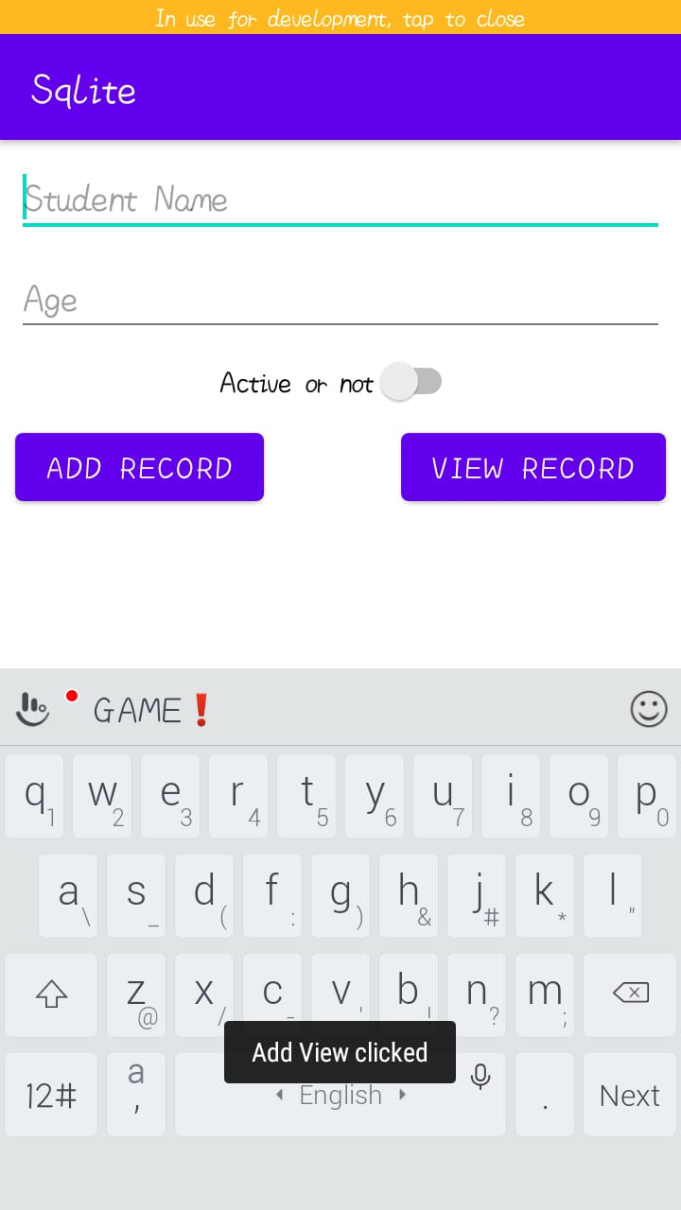

Now add new java class named CustomerModel:

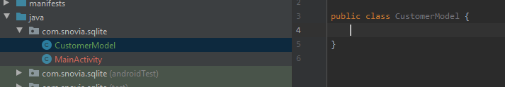

New declare variables and then add constructor and setter getters and also toString override method:

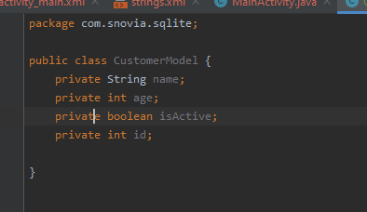

In next line right click and select generate and then select all variables with constructor:

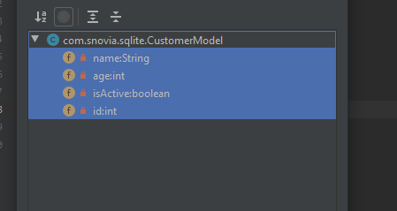

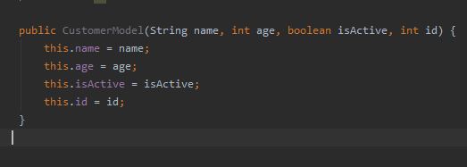

Now setter and getters:

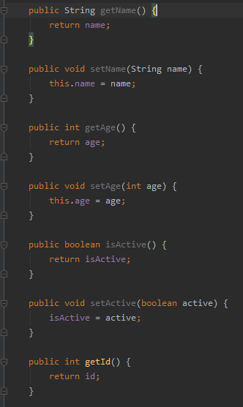

Now toString:

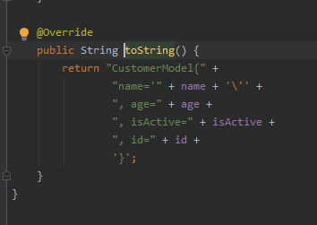

Now in add button click listener method make object of customer model and then write code to display the data given to it:

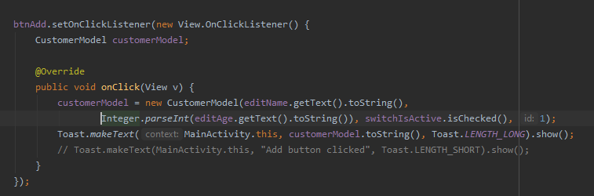

Run code and see results:

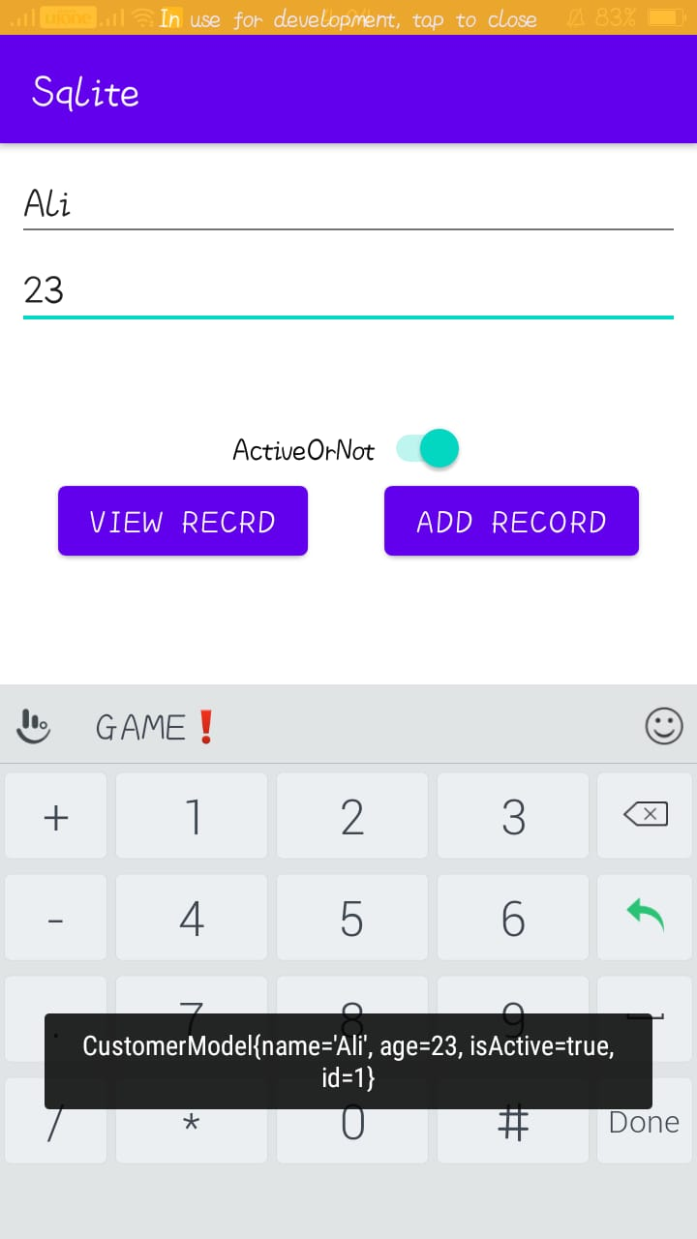

Push to GitHub:

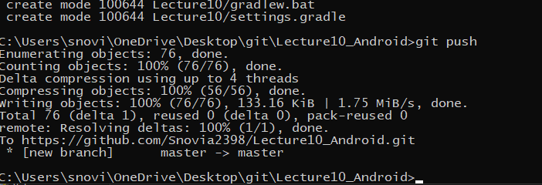

Added:

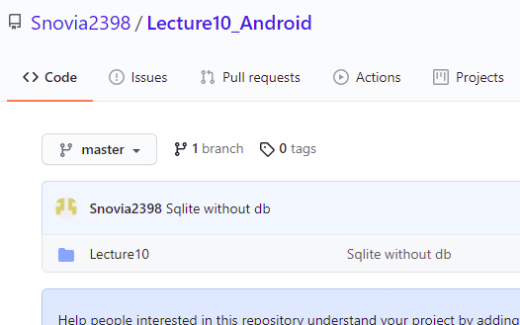

Now add database:

For this create a new java class named DBHelper and a class DBHelperOne:

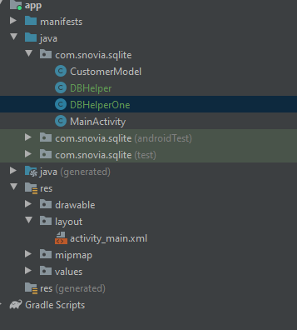

Now in DBHelperOne create class with extend database and write code:

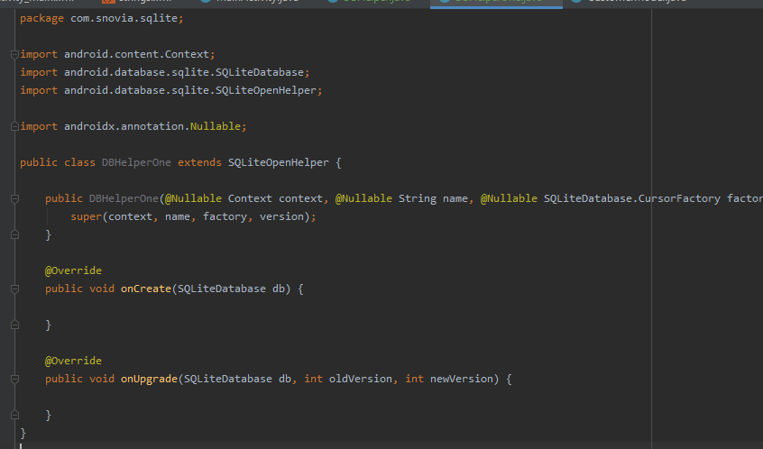

In DBHelper write code to create table and then insert method and write insert query:

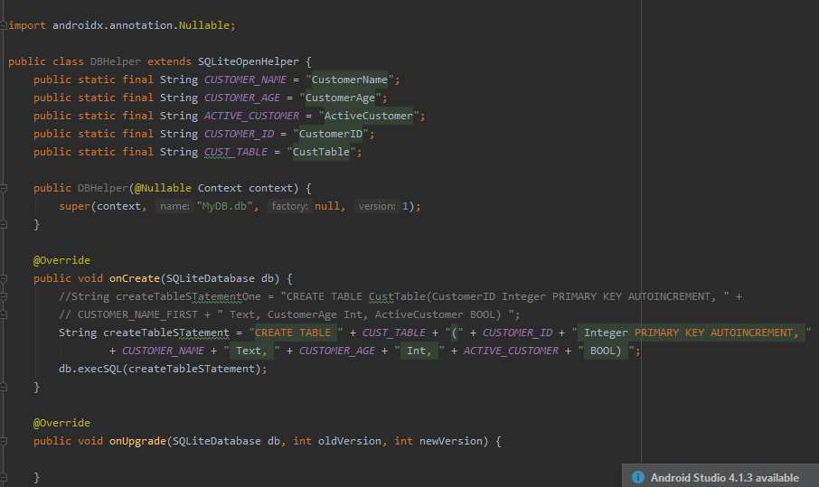

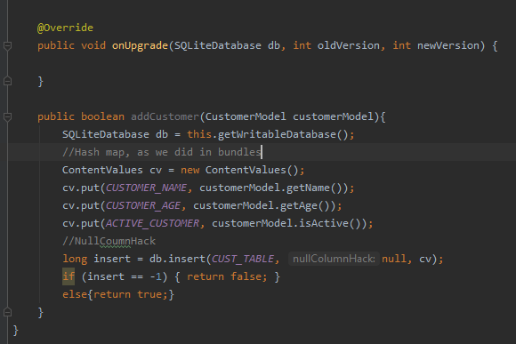

In main activity java class make changes:

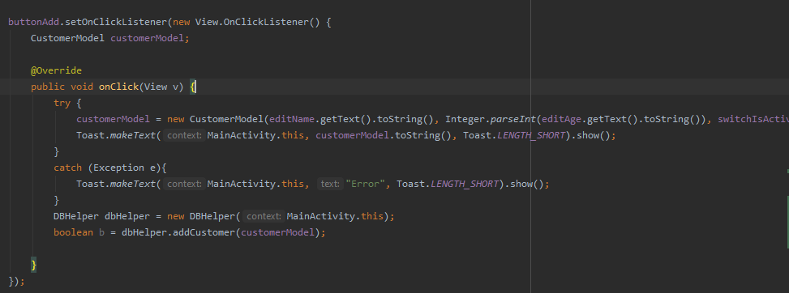

Run the code and see output:

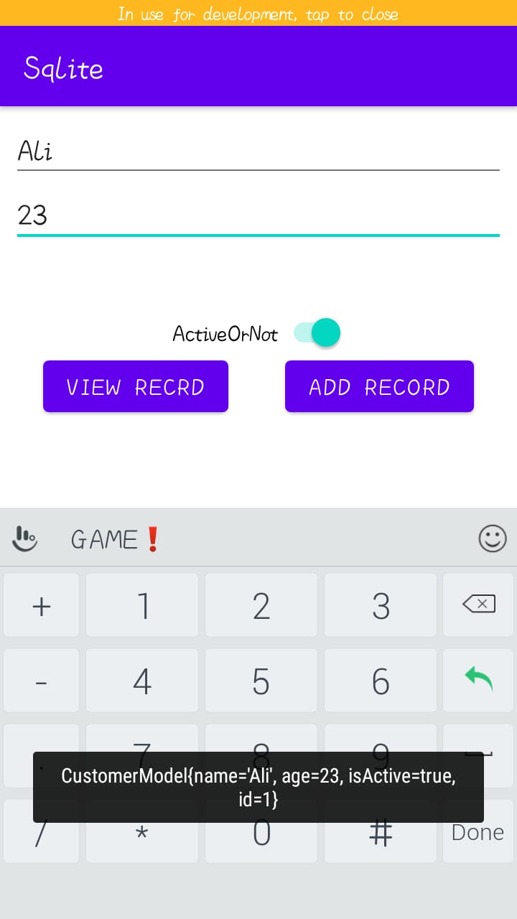

If age is not given then it gives error:

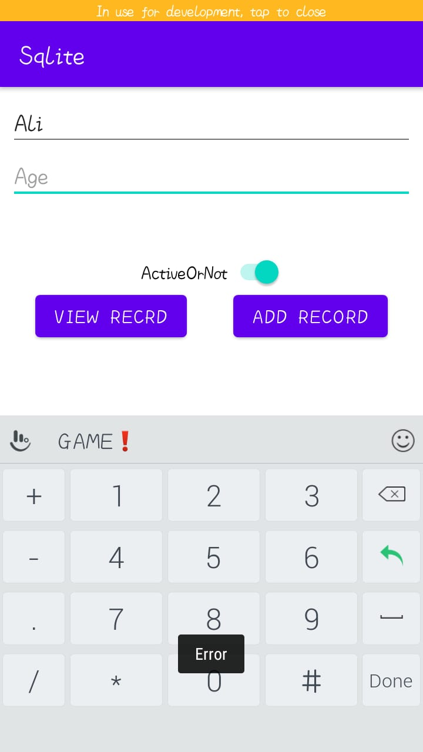

Push to GitHub:

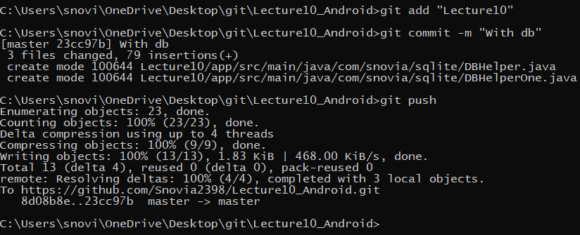

Added:

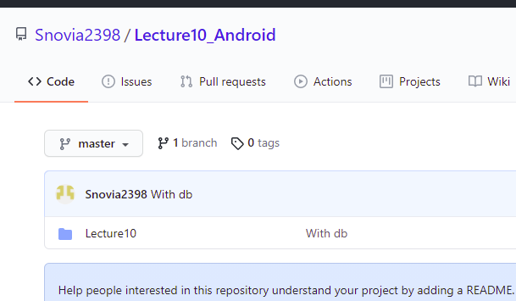

**LECTURE:11**

Create a new repository in GitHub named Lecture11_Android:

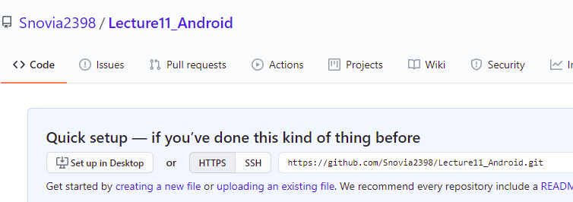

Go to git folder and create a clone of this repository:

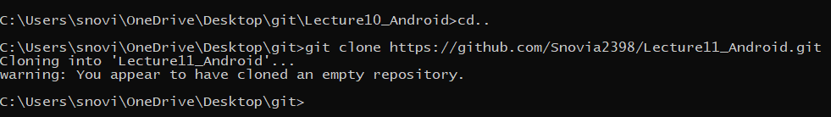

In clone folder create a new folder named Lecture11 and in this create android project named sqlite_Application:

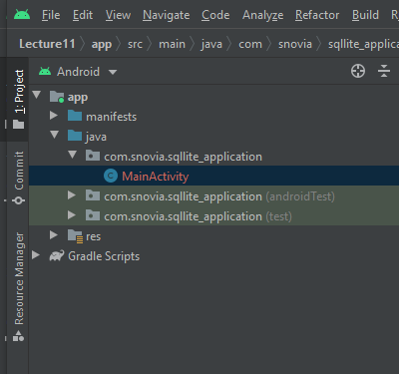

Do all work that we have done in lecture 10. Now we see how to add data in listView by retrieving from database:

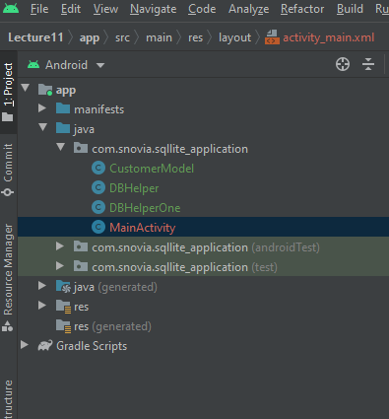

Create function getAll which return a list that we create as CustomerModel:

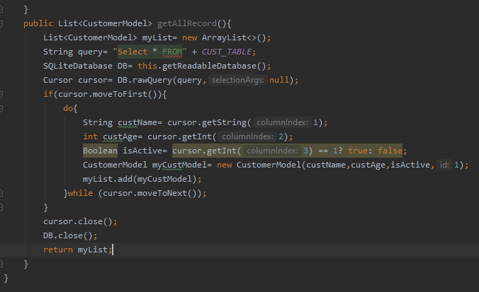

In java file in viewAll function use this data:

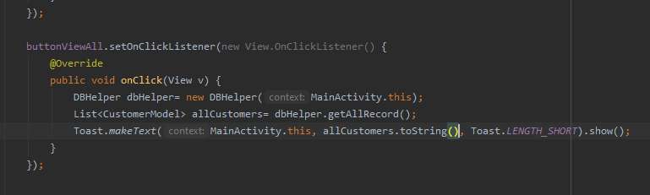

Now run code and see results:

Now write code to show how to add in listView:

For this, create array adapter and use this is view function:

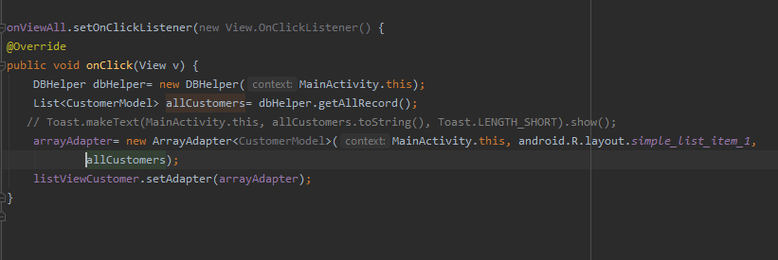

Run code and see output:

To resolve this issue change edit text name height to match-parent and adjust constraints of listView.

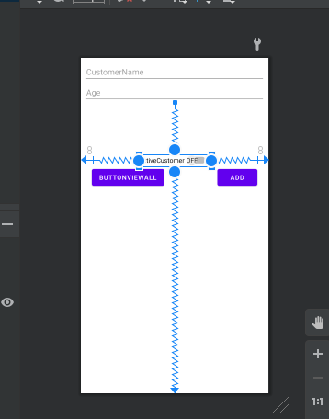

Now run code and see output:

Now create a function refreshData that display data list and call this in viewAll button click listener and in add listener after adding data and on create method:



Then:



Then:



And then:

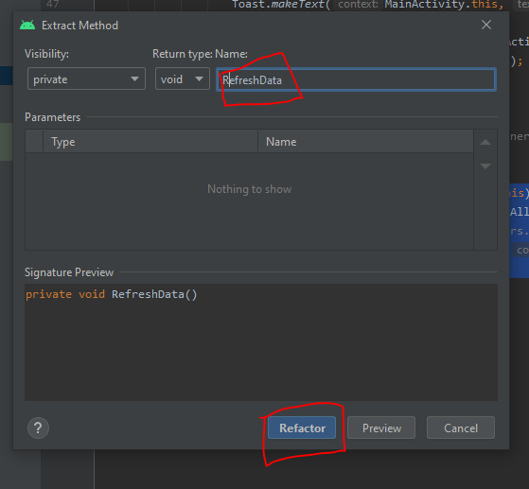

See private function is created:

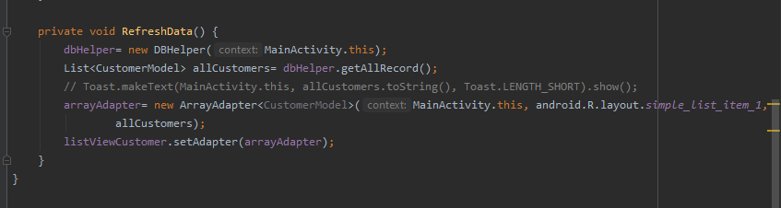

Call them:

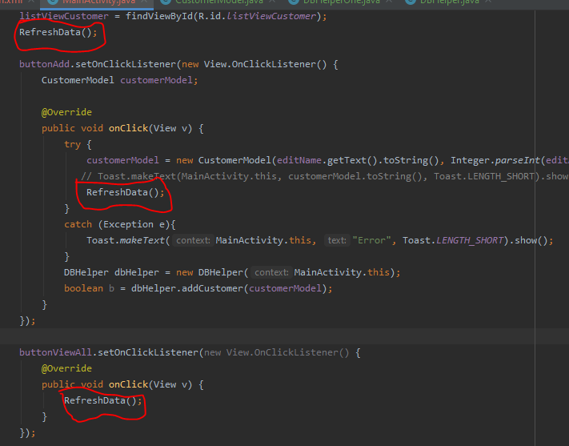

Run and see output:

When we add data it not automatically displayed. For this we have to call refreshData function at the of add listener function.

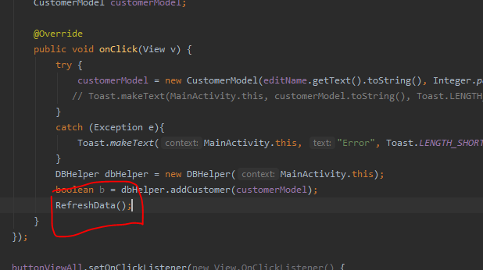

Run and see result:

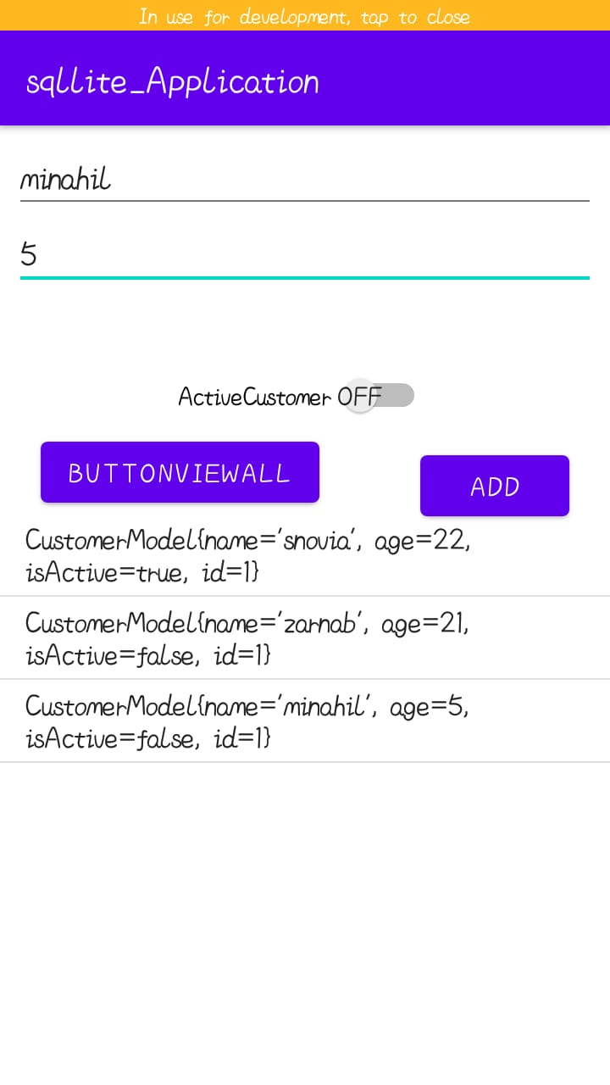

Push to GitHub:

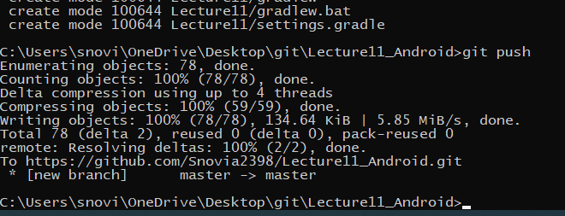

Added:

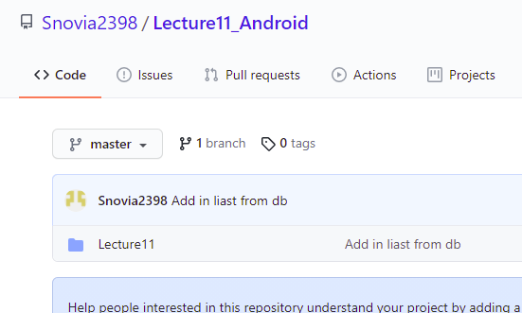

Now add delete function in dbHelper class:

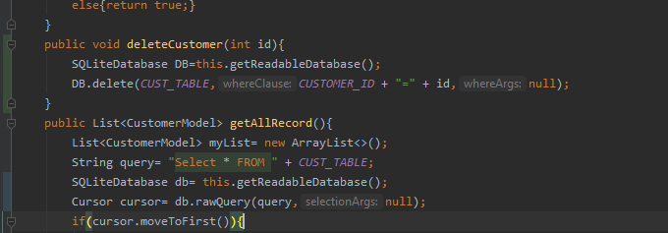

Then add code in java class:

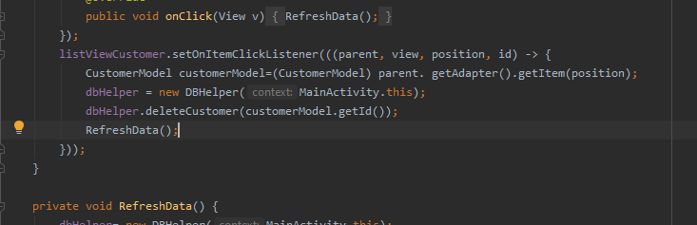

Add code for id auto increment:

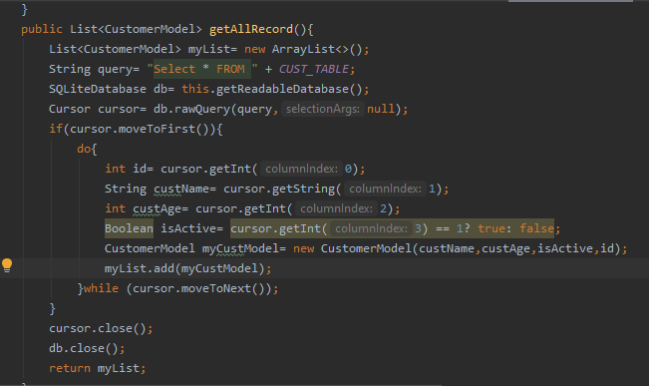

Run code and see result:

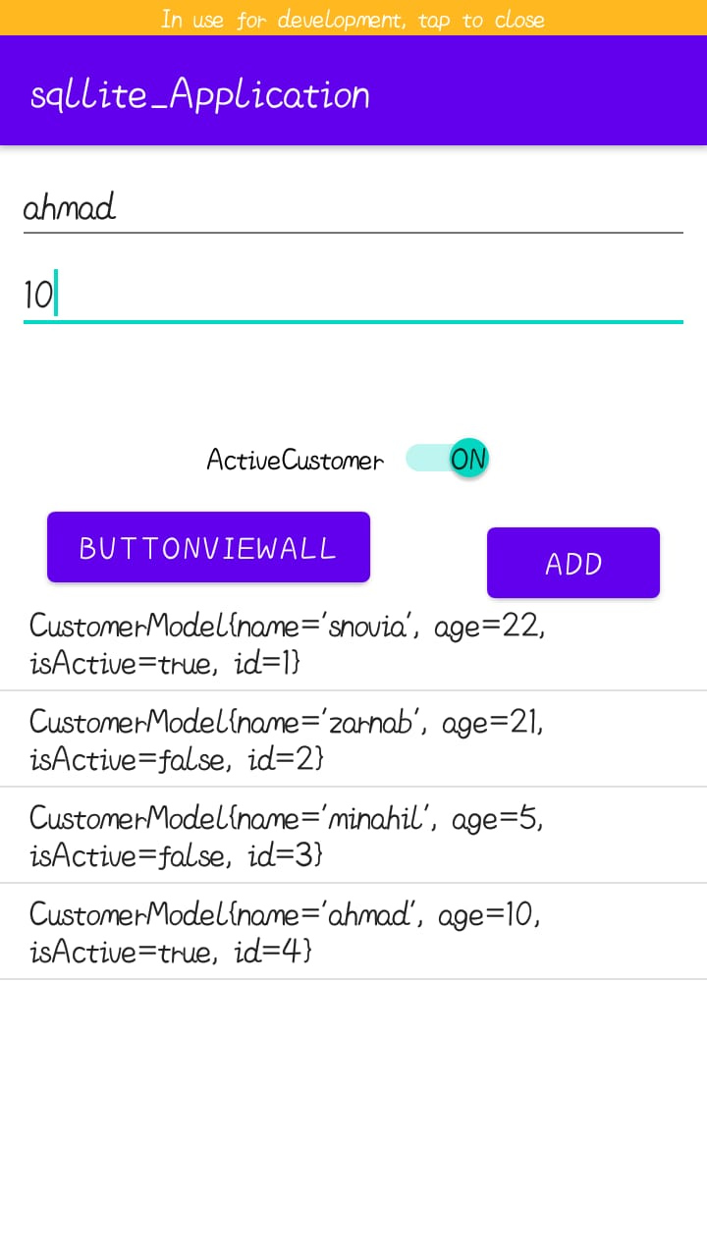

See id is auto incremented. Now delete minahil:

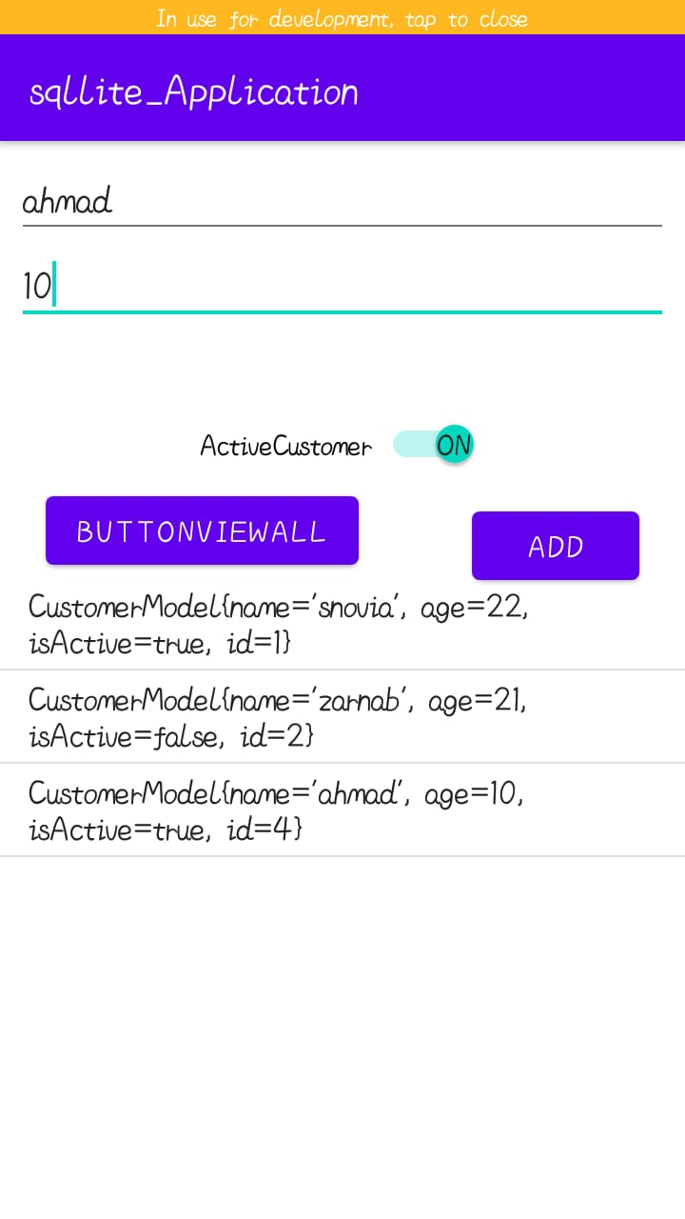

Now delete Zarrab:

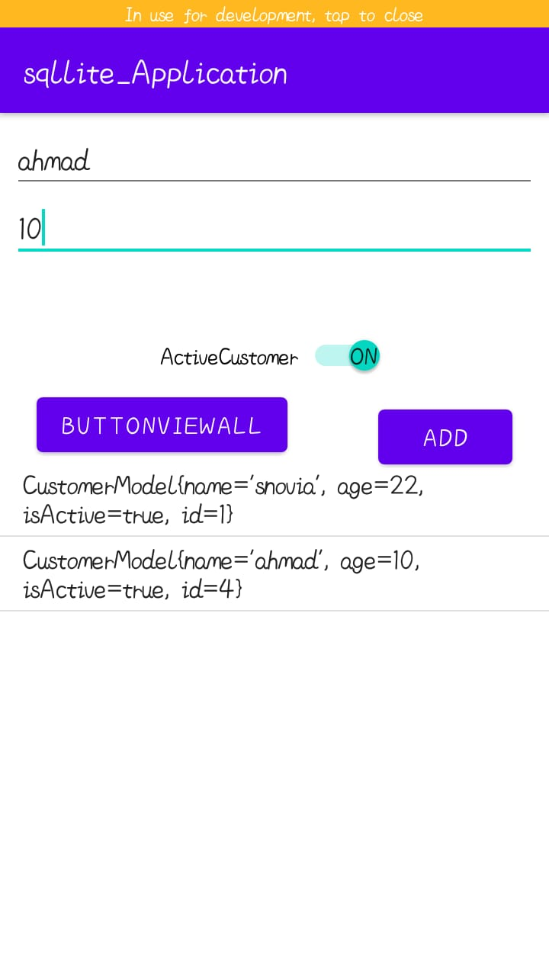

Push to GitHub:

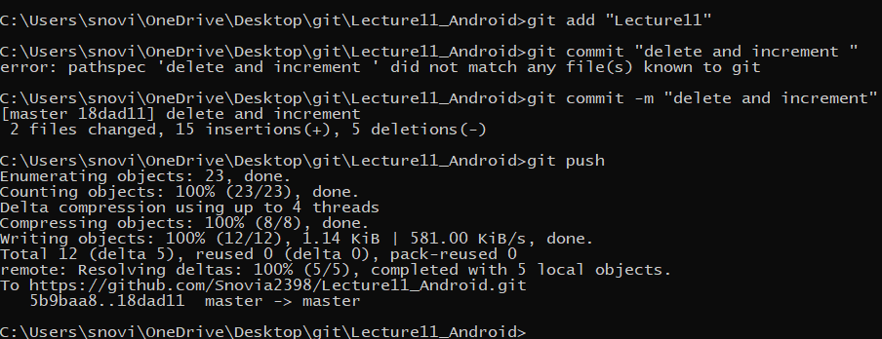

Added:

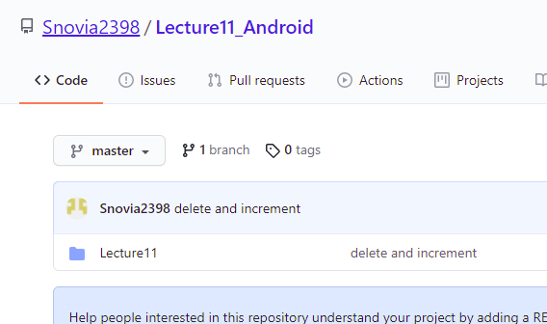

Add word file to GitHub:

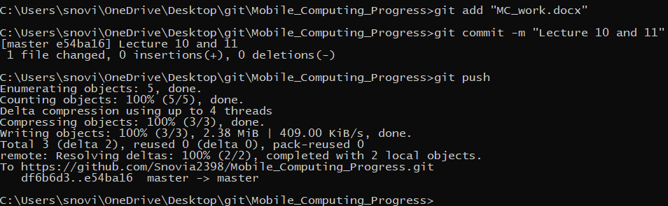

Added:

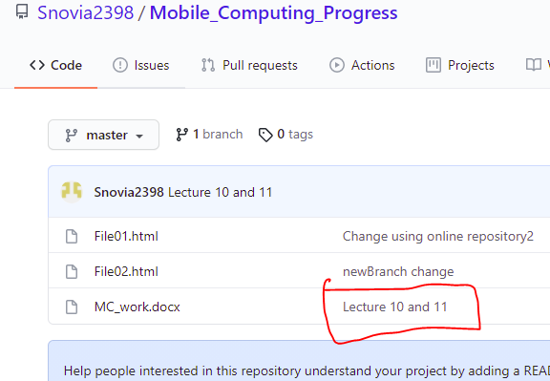

**LECTURE:12**

Create a new repository named Lecture12_Android:

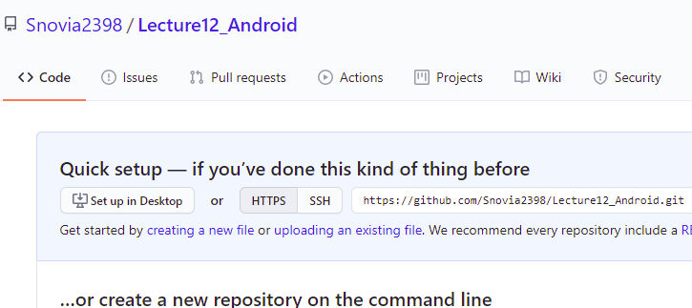

Go to git folder and create clone of this repository as:

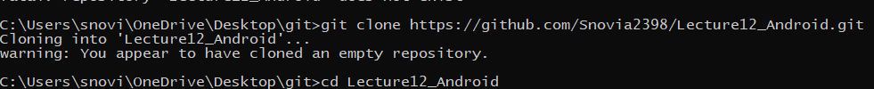

In this clone create a folder Lecture12 and in that folder create android project named navigation practice:

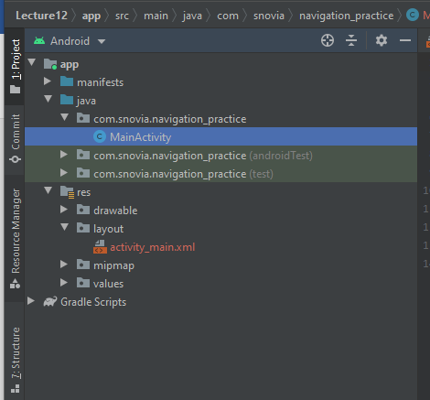

Now start work:

We can add image from builtin function by right click drawable and then new then asset and select image:

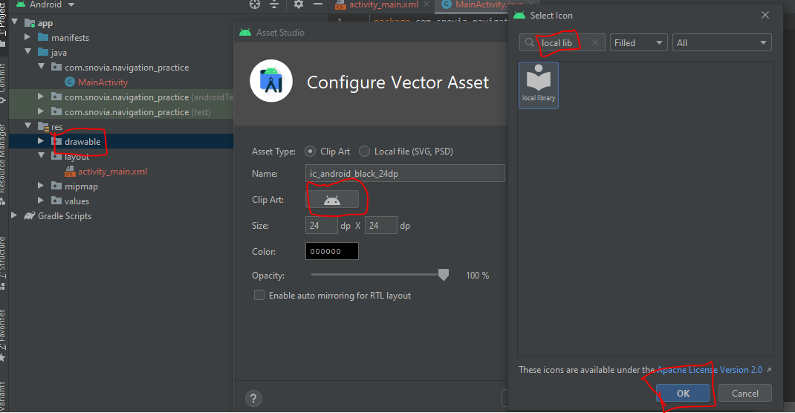

We can change the color of this asset:

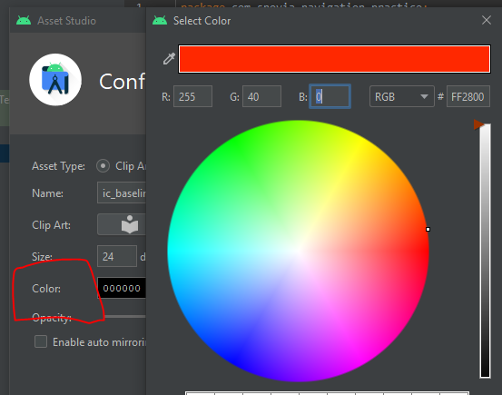

Here is the icon and we can now use it:

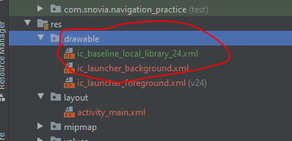

Now create header.xml file in which image and textView is added:

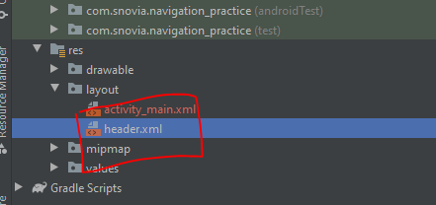

Write code in header.xml:

Make orientation vertical and add imageView and two text views in it and also add background color purple200:

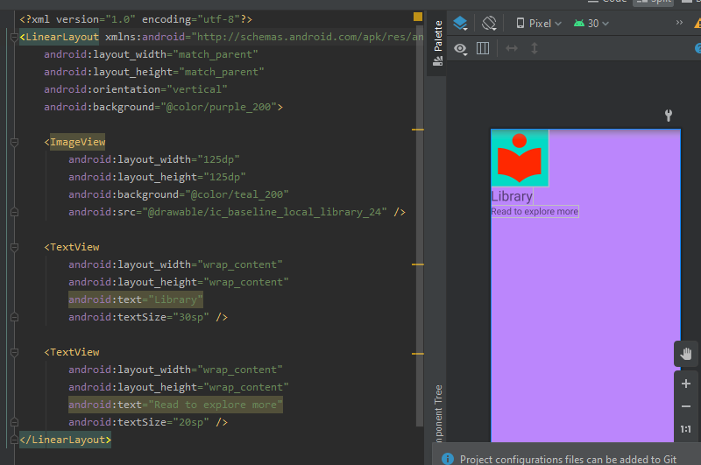

Now create a new folder in resources named menu and in this create main_menu.xml file and put our things in it:

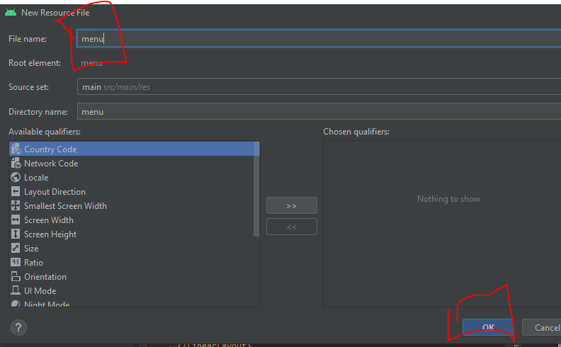

This is the result:

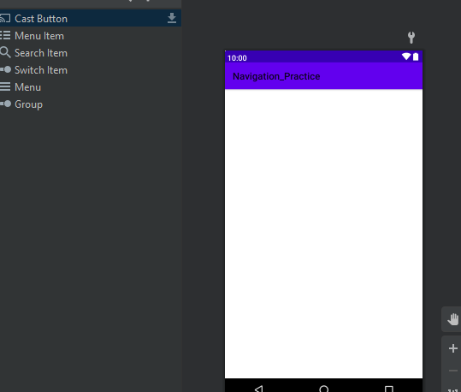

We downloaded or add all icons from vector asset we needed:

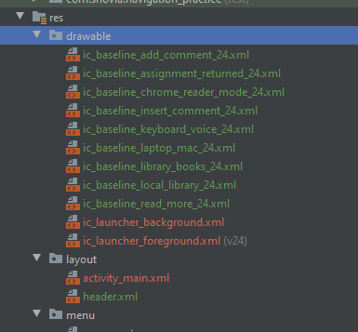

Write code in main menu.xml to add items:

First, we add book, return laptop and voice in group:

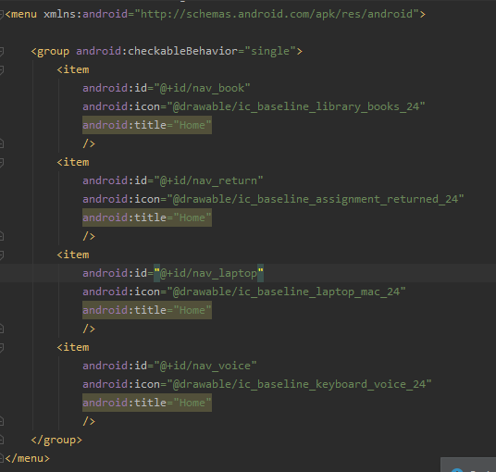

Now add items in one other group but in title reading:

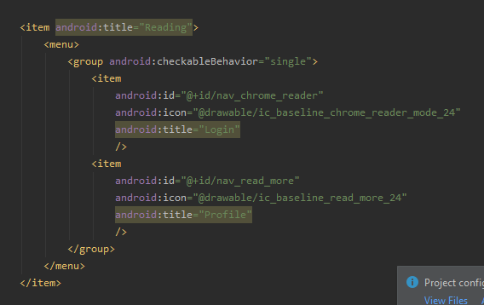

Again, add items in another group but in title comments:

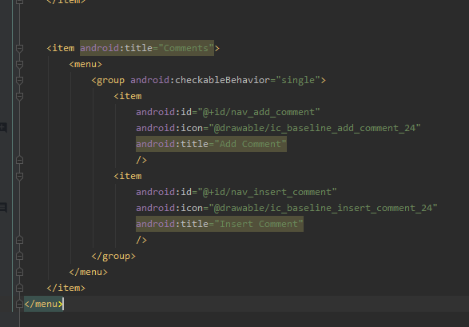

It look like this:

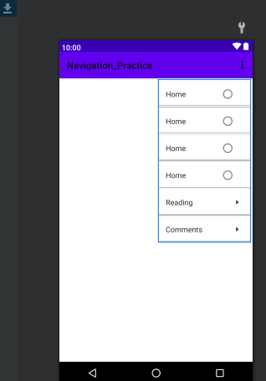

Now display this by writing code to main activity.xml file:

Create navigation view and add properties to it like height, width and add header and menu one by one:

First add header:

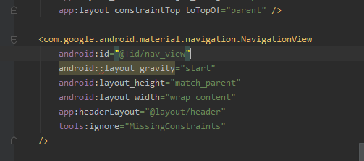

Output is:

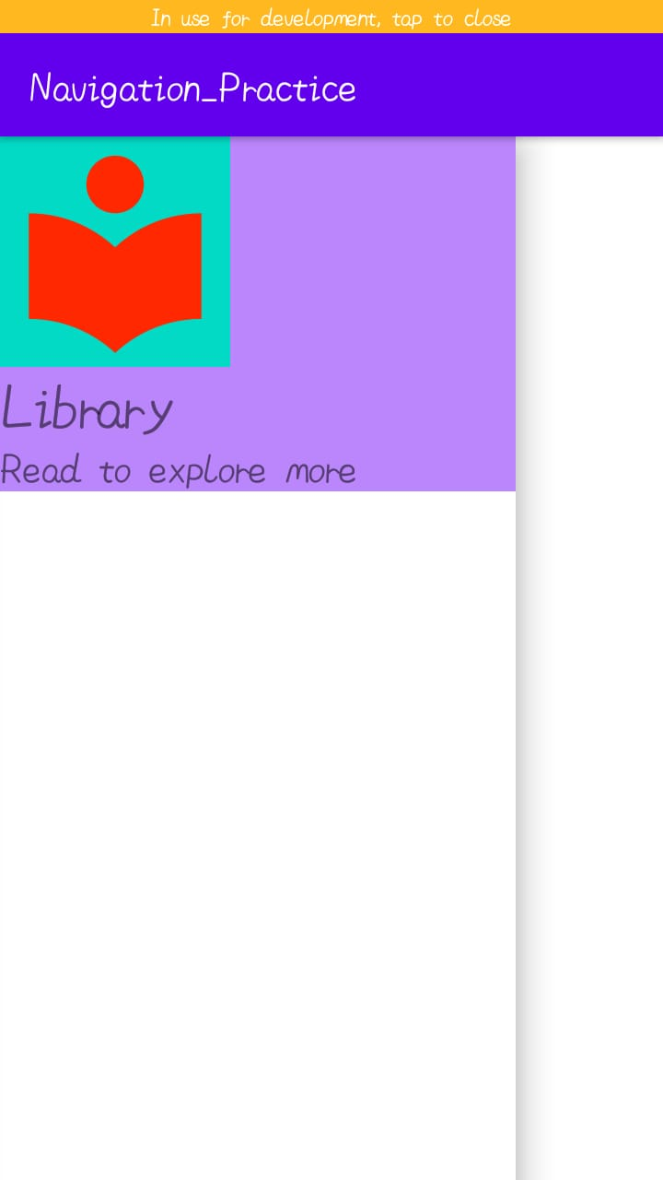

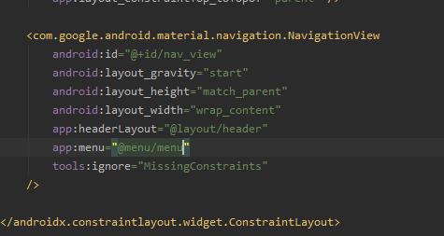

Run code and see output:

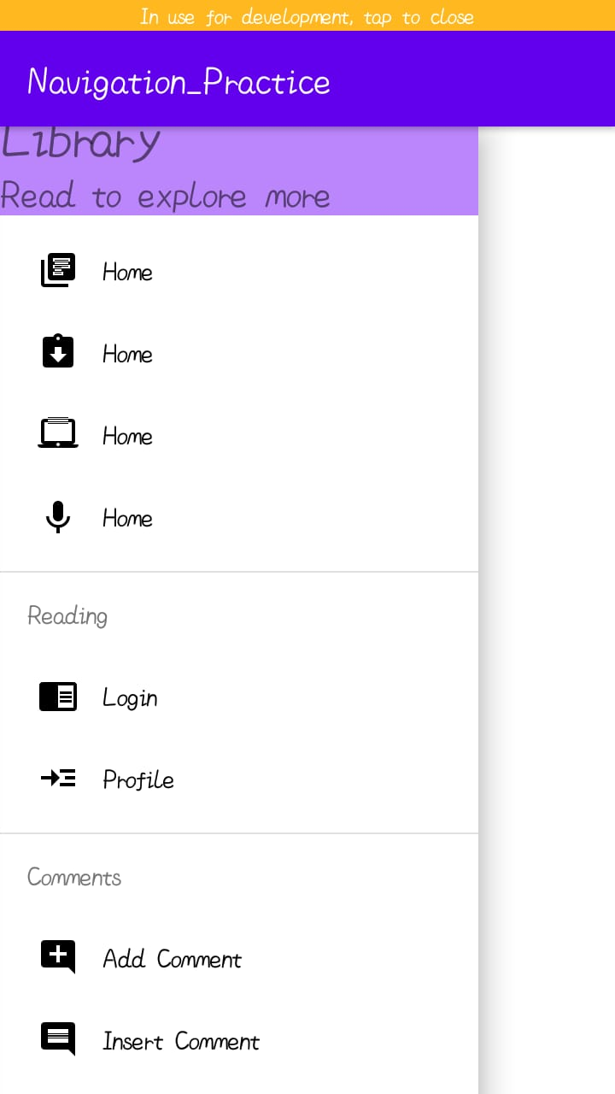

Now add toolbar:

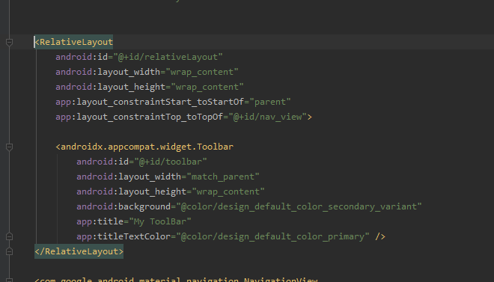

Run and see result:



Now add click listeners:

Push to GitHub:

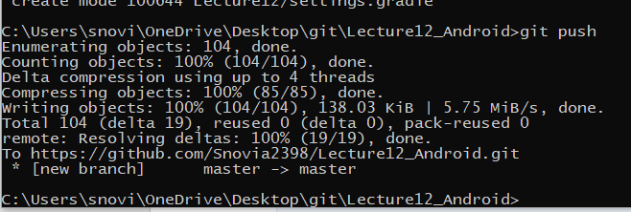

Added:

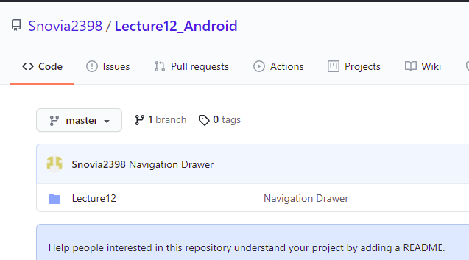

Add this file to GitHub:

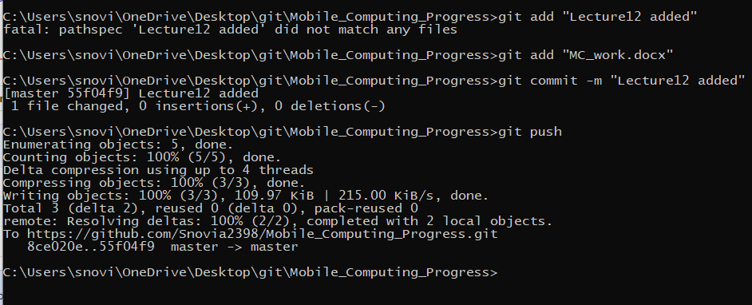

Added:

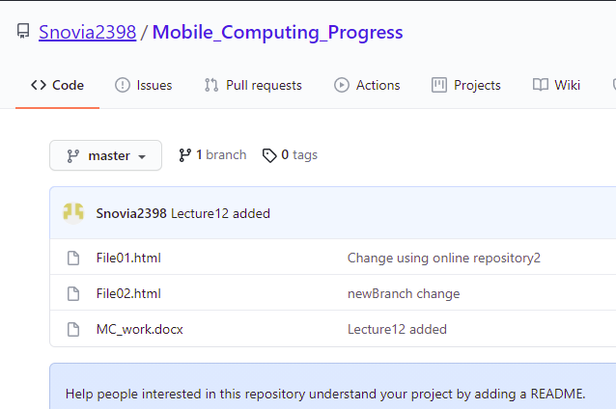

Problem occur that navigation view not appears it is because height or width is not set, mow I change it and also, I add text box in activities book, voice, laptop, return, chrome reader, read more, add comment, insert comment. I show only one for example book:

Book.xml:

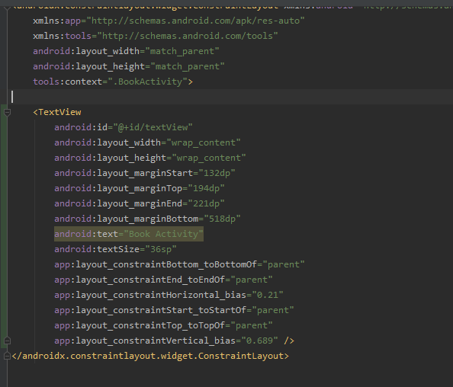

Book.java:

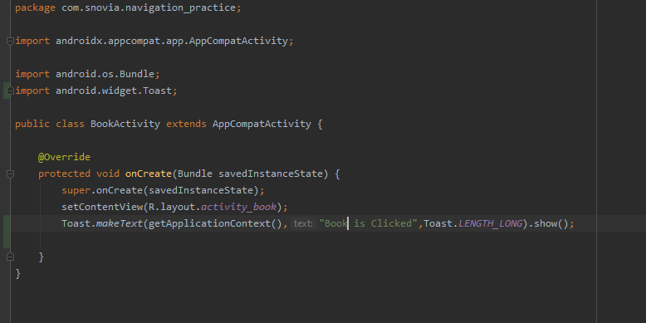

Now run code and see output:

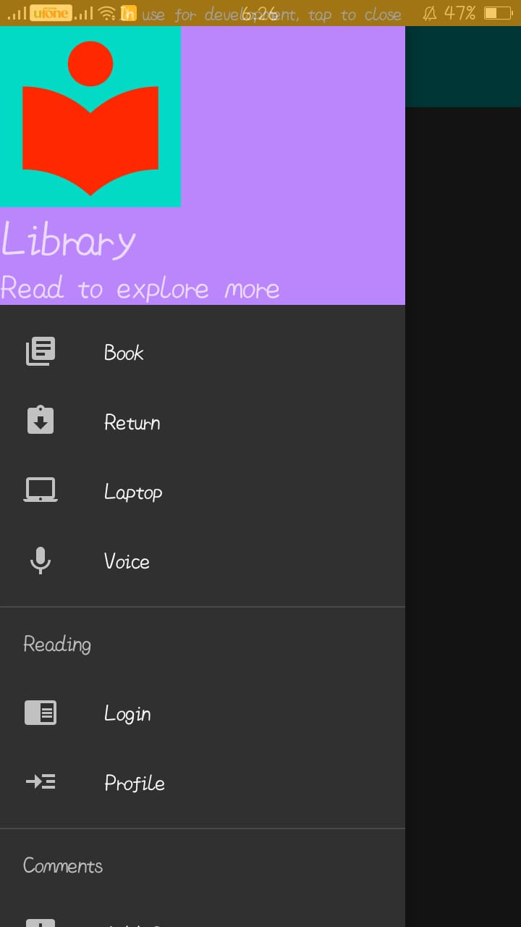

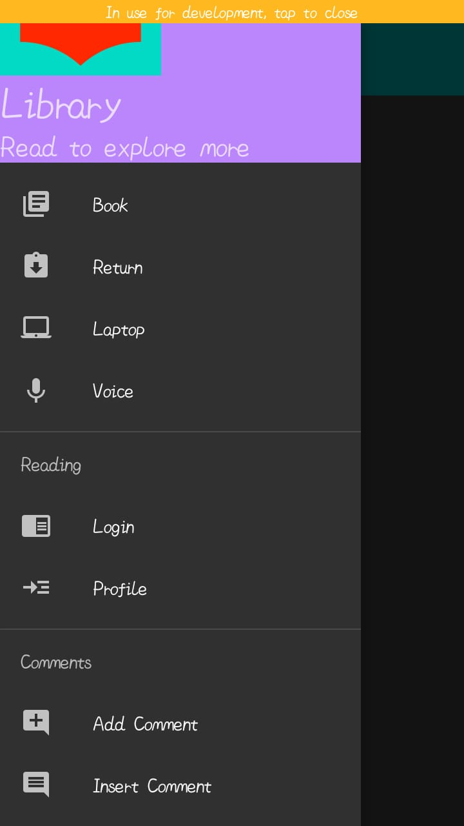

When we click on voice, output is:

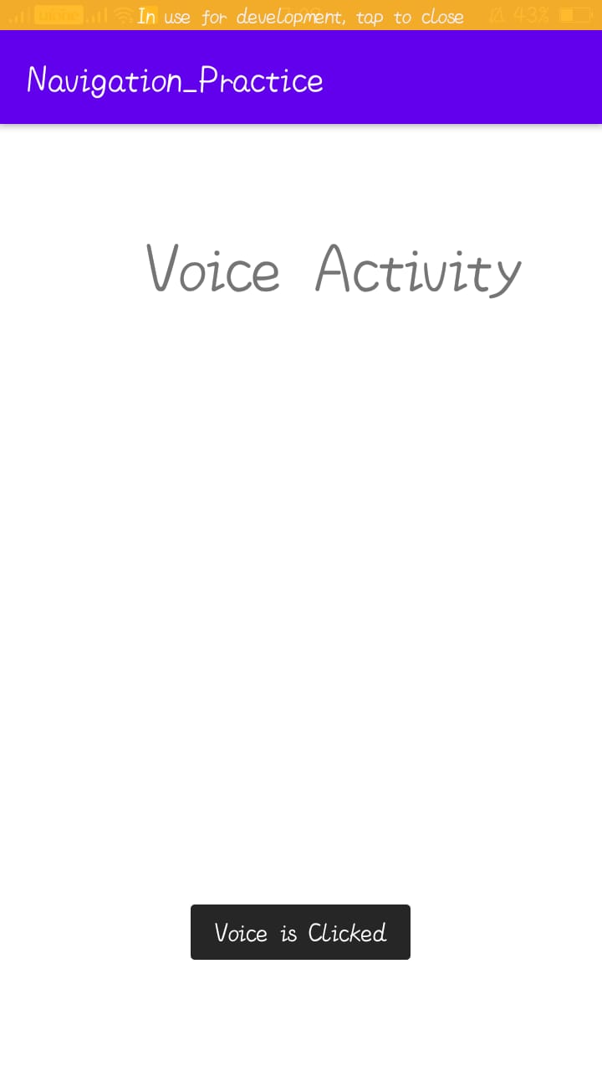

Push to GitHub:

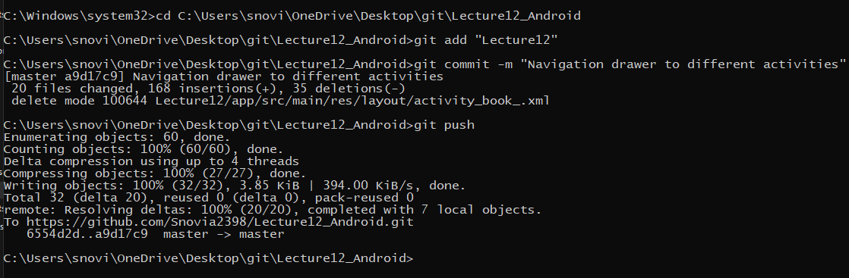

Added:

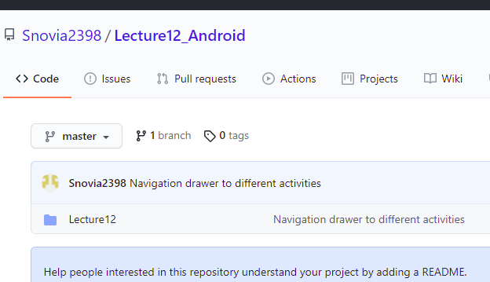

Add this file to GitHub:

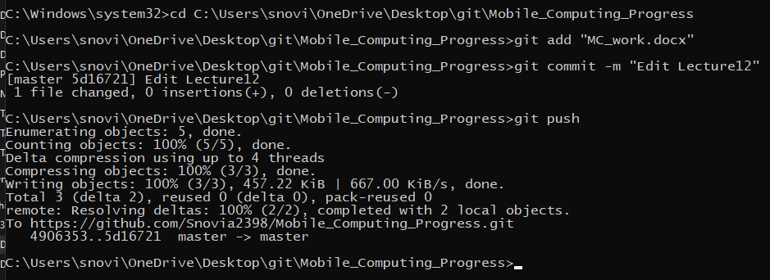

Added:

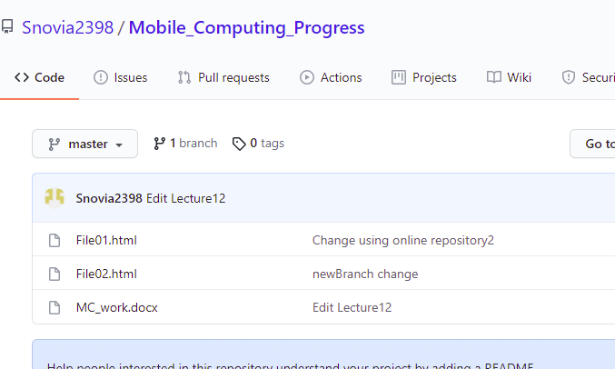

**LECTURE:13**

Create a new repository named Lecture13_Android:

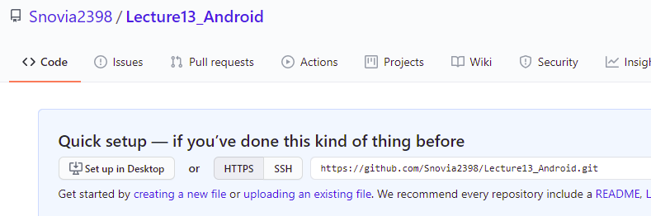

Go to git folder and create clone of this repository:

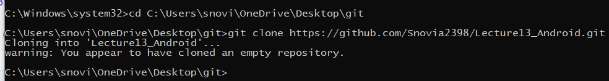

In this create new folder named Lecture13 and create android project in it:

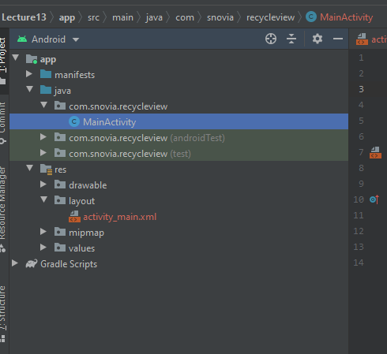

Now add code:

Create a new activity friends which define the attributes or parameters of object and its setter getters:

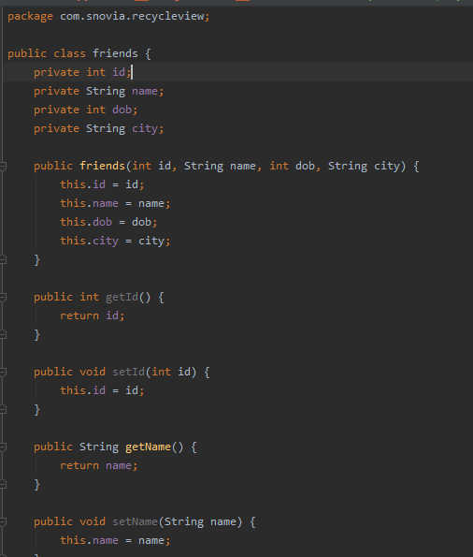

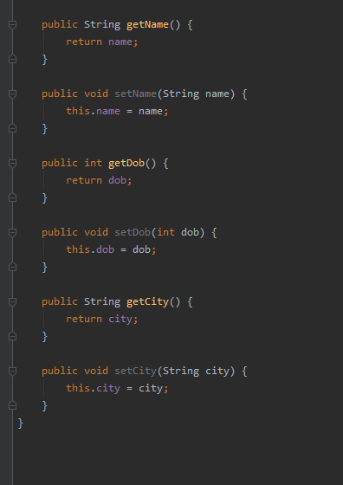

In friends.xml file add text views, image view and view for divider and give them constraints and height, width:

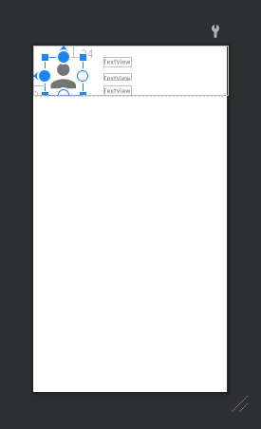

In main activity.xml file create recycler view and give it constraints and height width etc.:

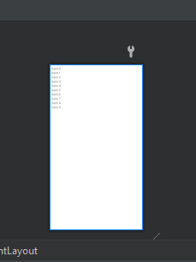

In main activity.java create objects of recycler view, recycler view adapter and recycler view layout manager.

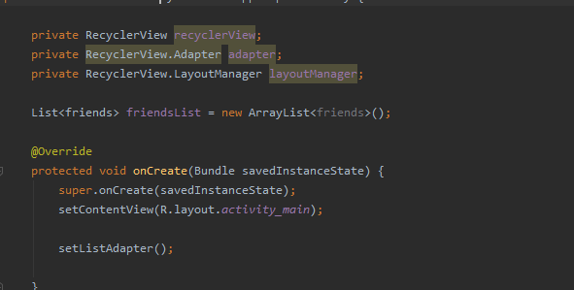

Now add list which we want to add:

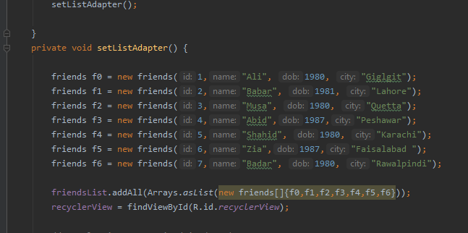

Now create recycler view handler class to handle list view when we scroll the screen. Holder hold the data and recycle through function:

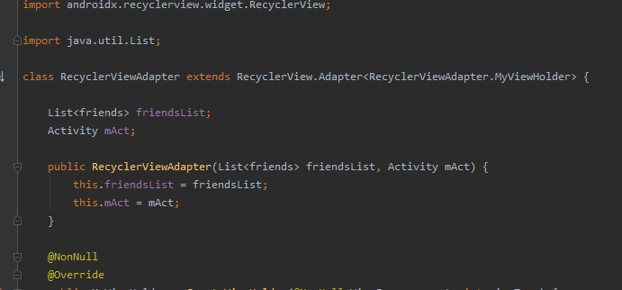

In create and bind function write this code to get data accordingly:

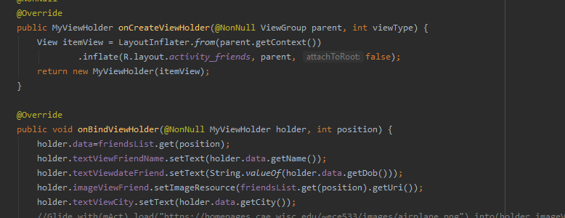

Get count give the size of list and view holder to get elements by id:

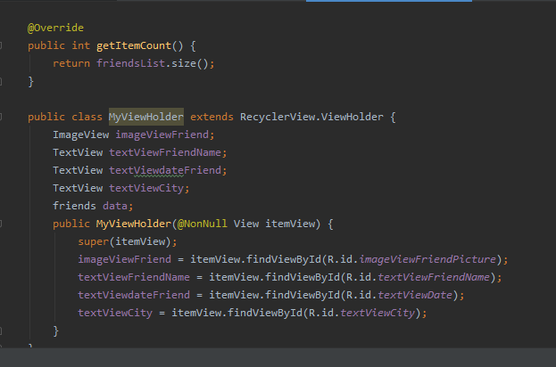

Now in main activity write this code:

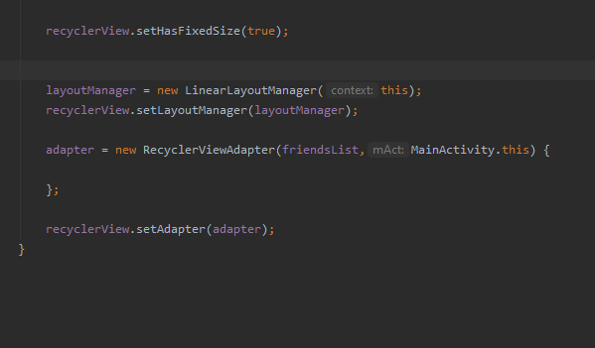

Make list of images and add images from vector asset in drawable and get them is array of integers:

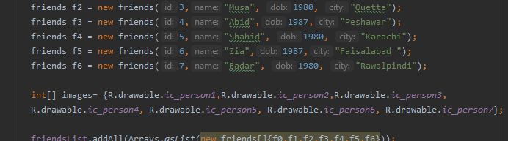

Now add this:

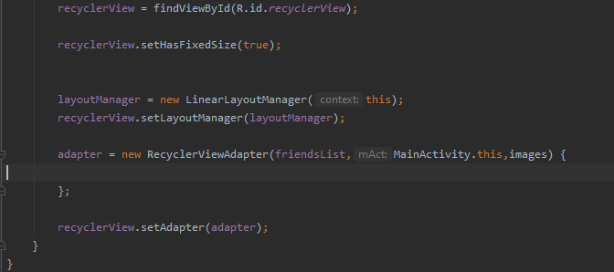

Run code and see result:

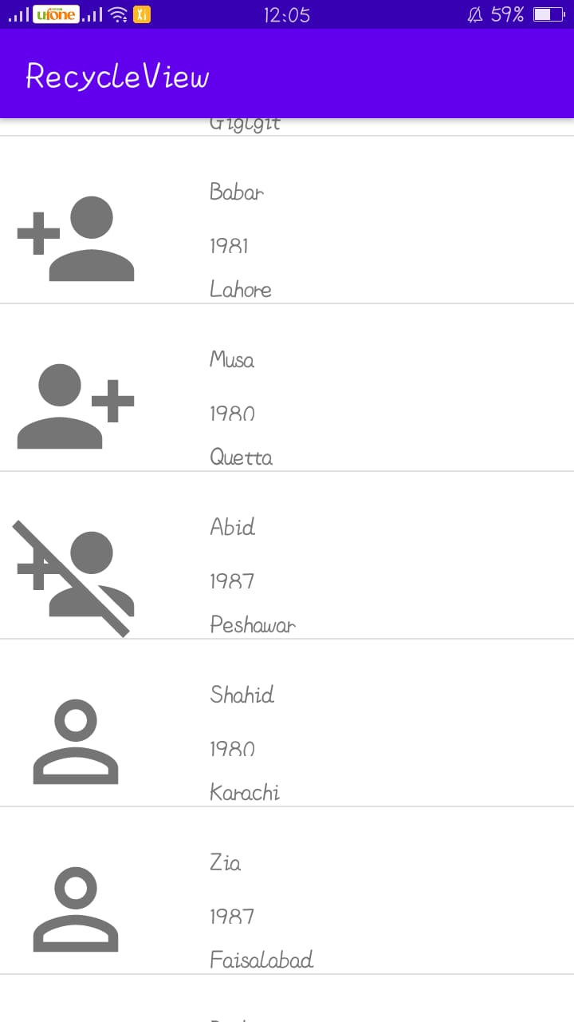

Push to GitHub:

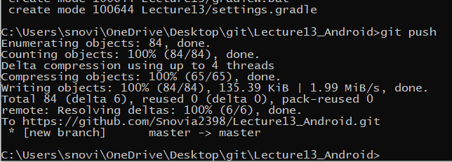

Added:

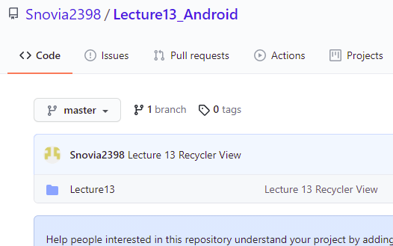

Add this file to GitHub:

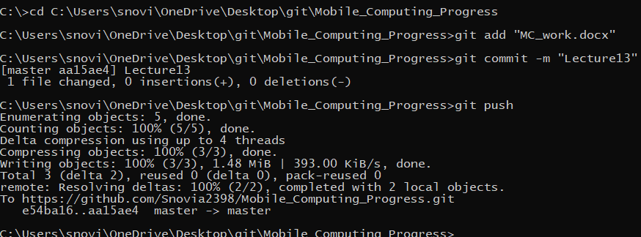

Added:

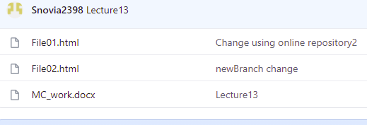

Push this file for assignment01 commit:

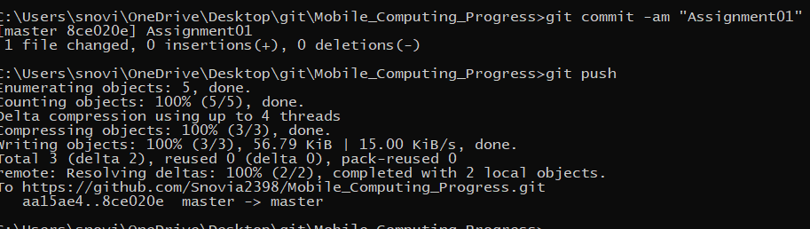

Added:

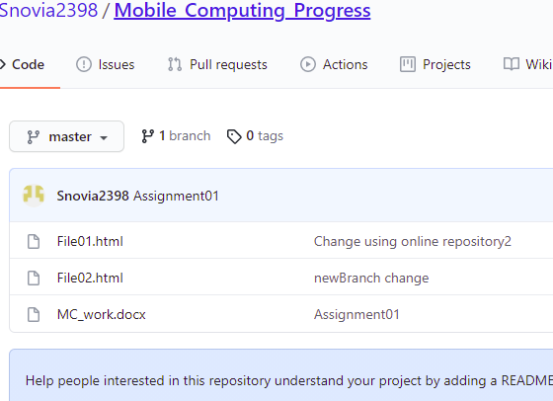

**LECTURE:14**

Create a new repository named Lecture14_Android :

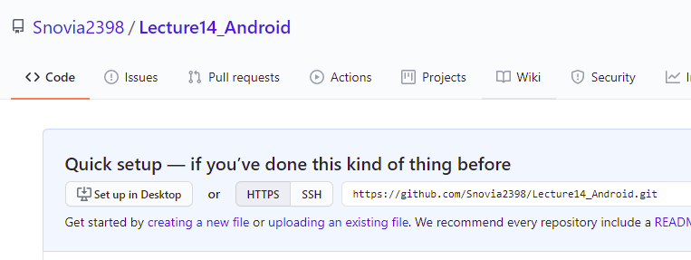

Go to git folder and create a clone of this repository:

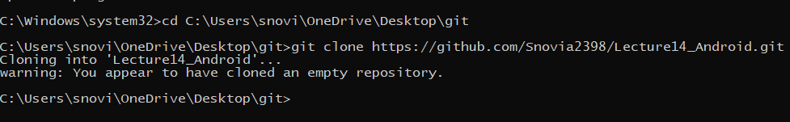

Go to this clone and create a folder named Lecture14 and in this folder create new android project:

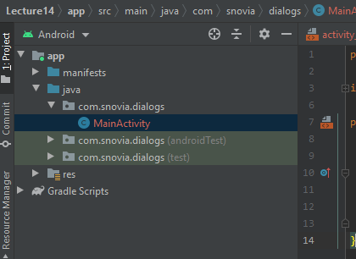

Now in Main Activity.xml create a button by drag and drop and add constraints to it:

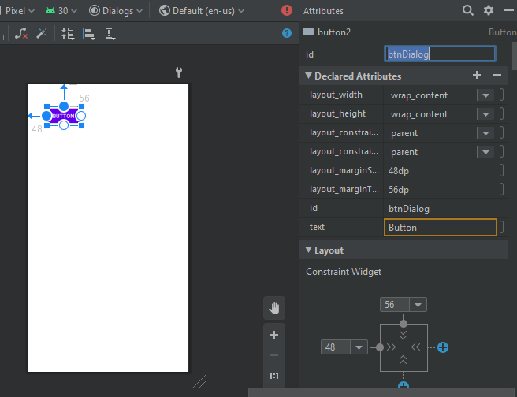

Add onClick event listener and change text to click me:

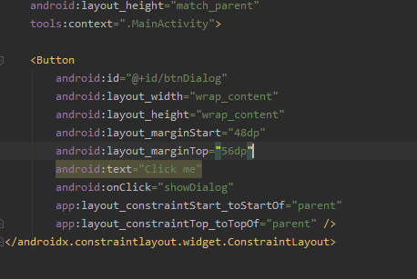

In java class create function for showDialog:

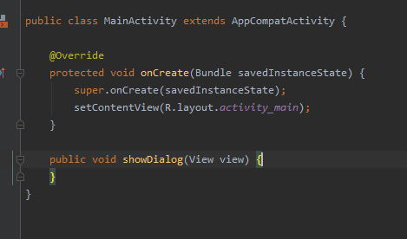

First create instance of button and get by id:

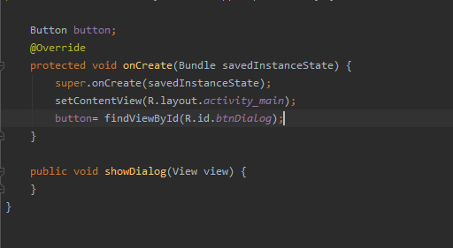

In showDialog function first create alert box builder and then set title and message for it. If user accidently press outside the dialog or alert box, dialog not close, for this write line cancelable to false:

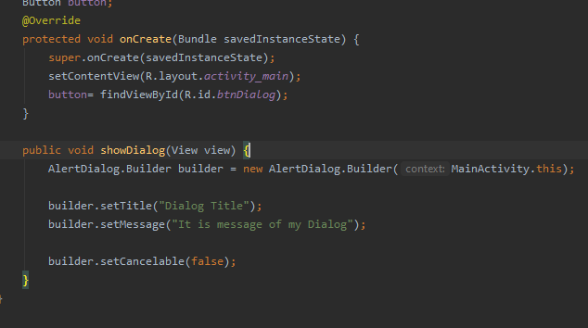

Now create two buttons positive and negative and onClick function for them. In onClick function show message through toast that which button is pressed:

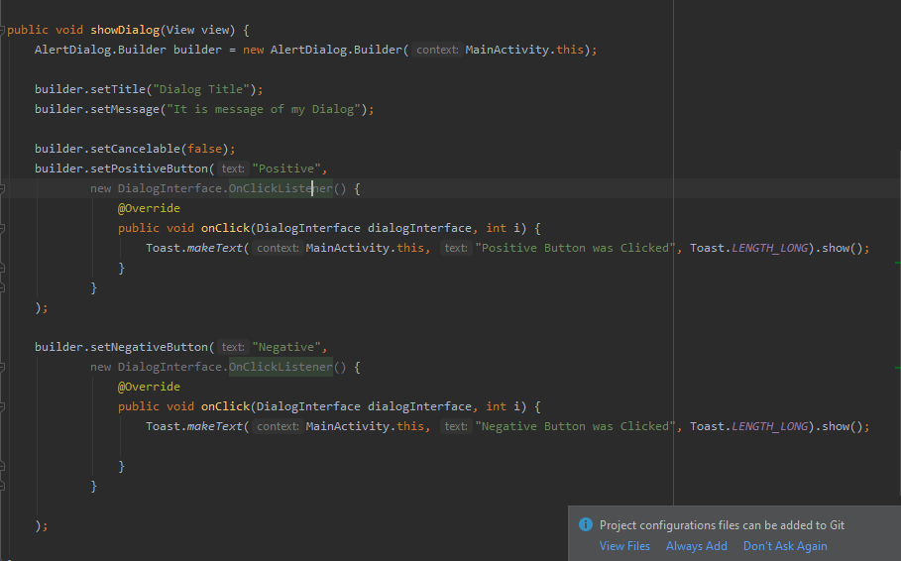

Now write two lines to show the alert box or dialog:

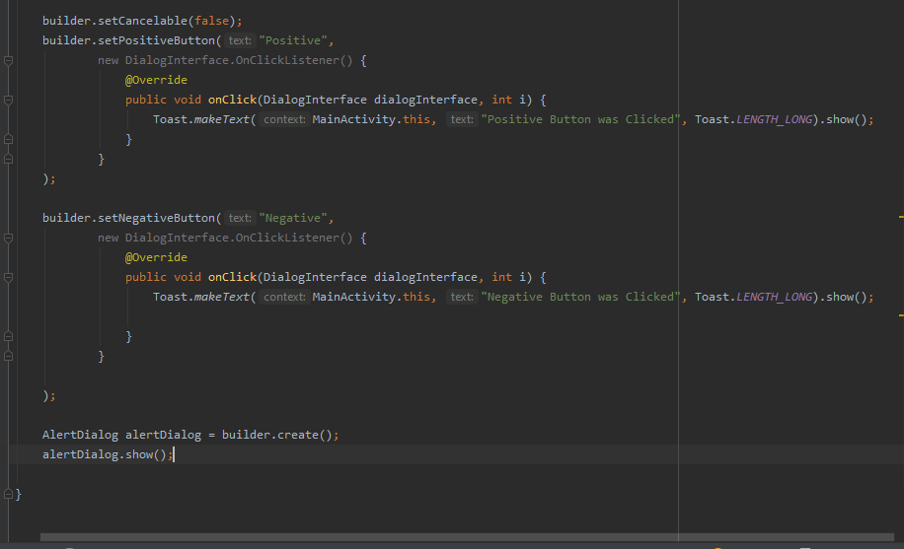

Run the code and see output:

First page look like this:



When we click on button dialog appears:

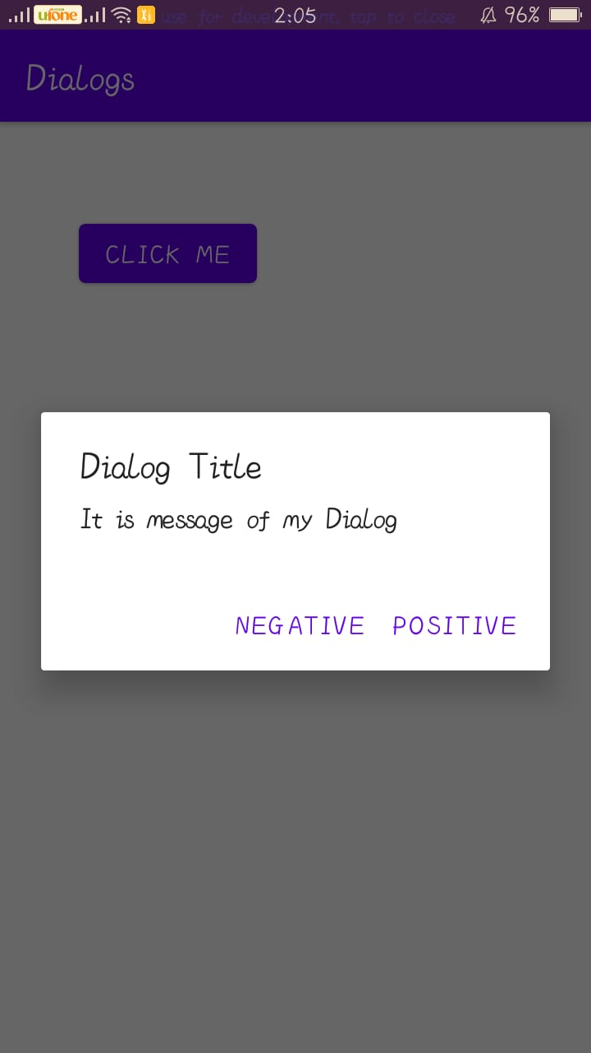

When we click on positive button:

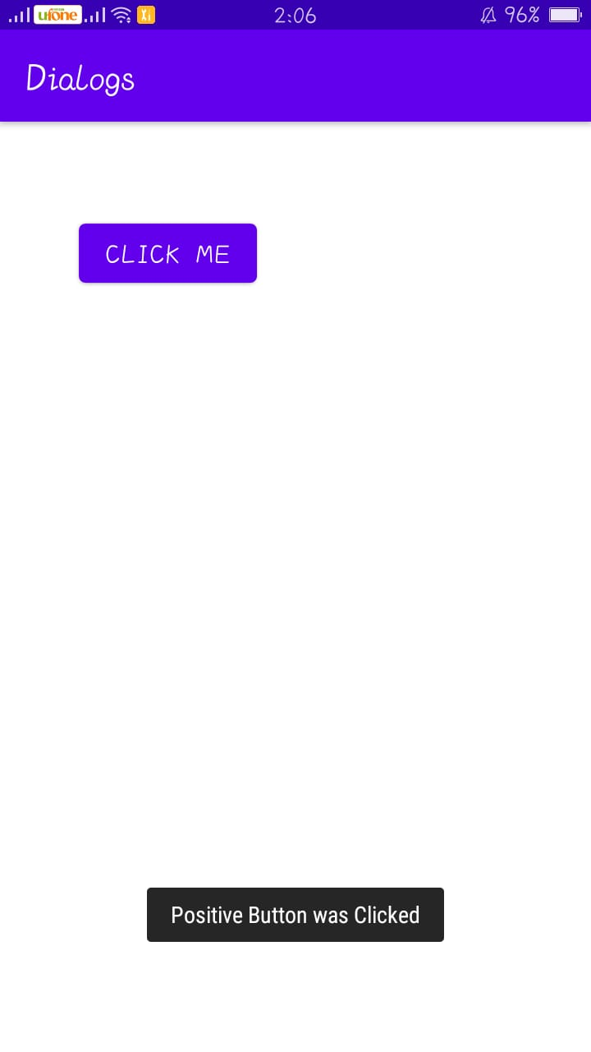

When click on negative button:

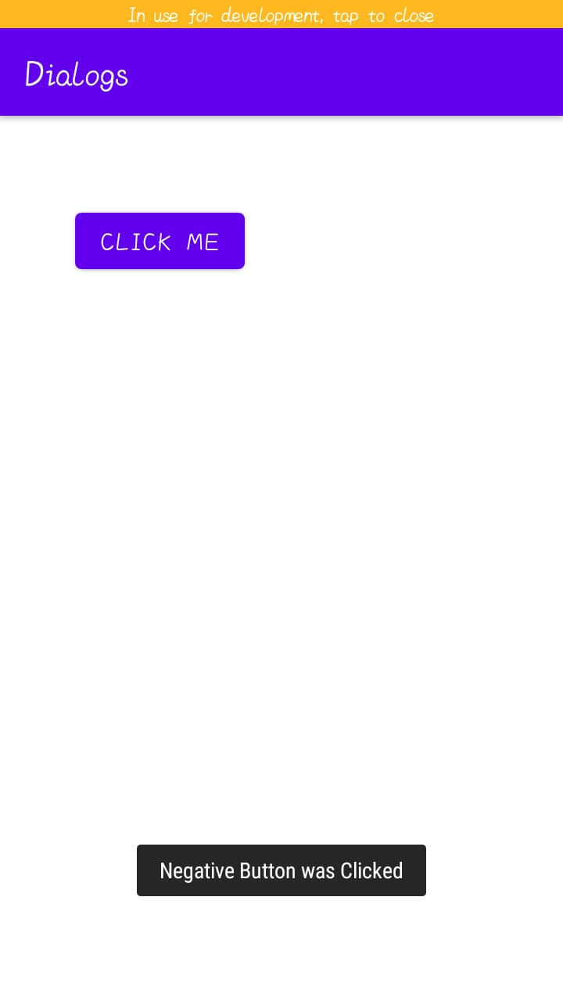

Push this to GitHub:

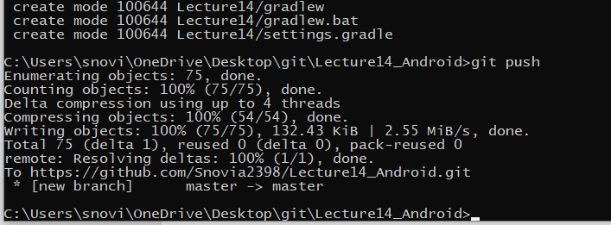

Added:

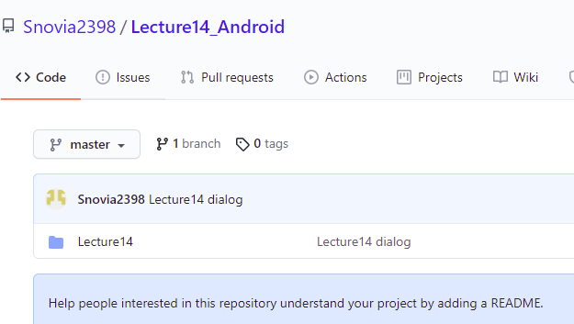

Now to add things of our own choice in dialog create a new xml file named my_new_dialog.xml:

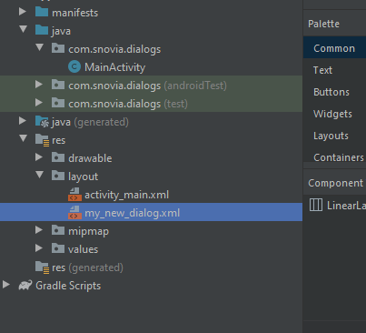

Add text view, plain text and a button:

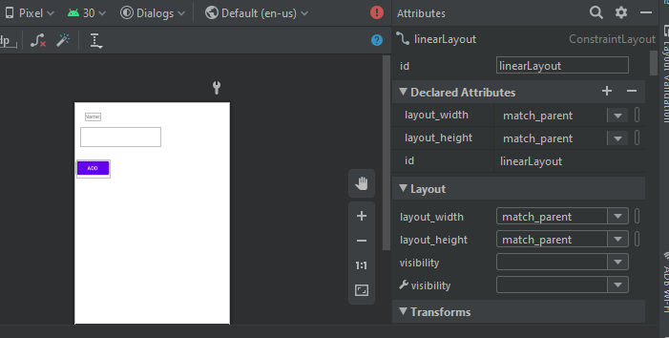

In main activity.java class write code to add this too in dialog:

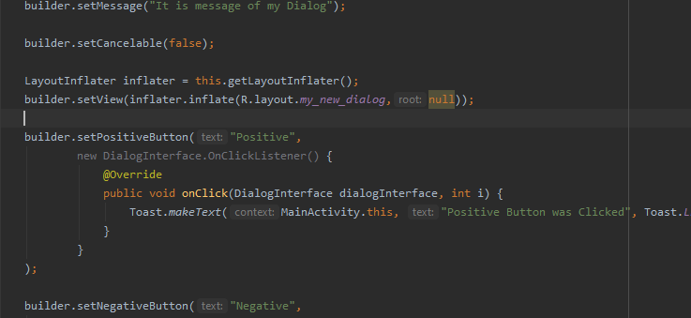

Now run code and see output:

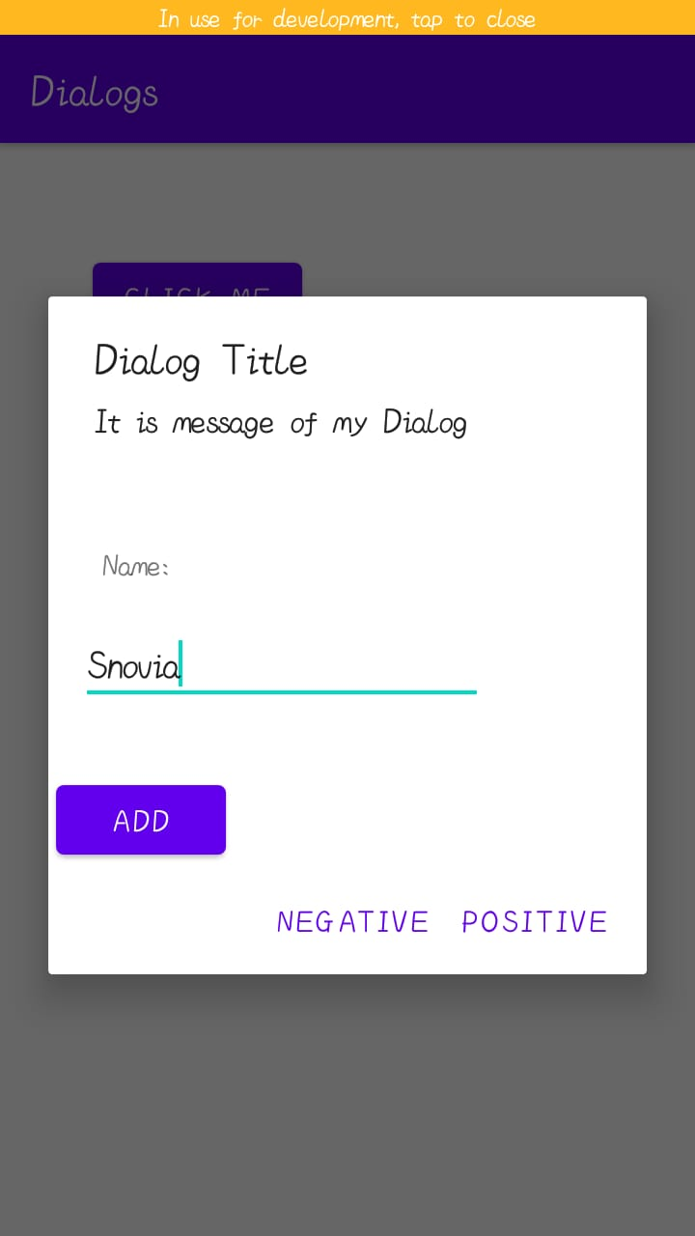

Push to GitHub:

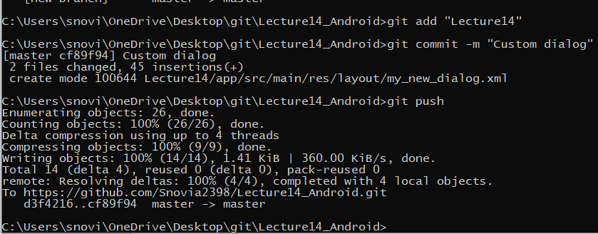

Added:

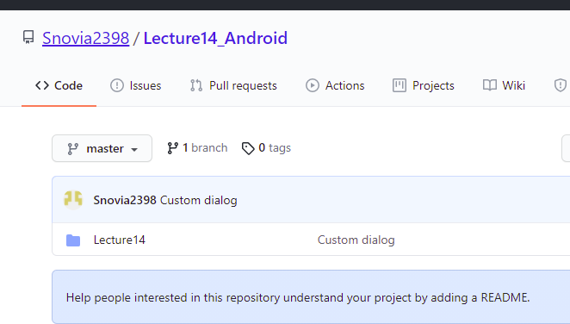

Now add this word file to GitHub:

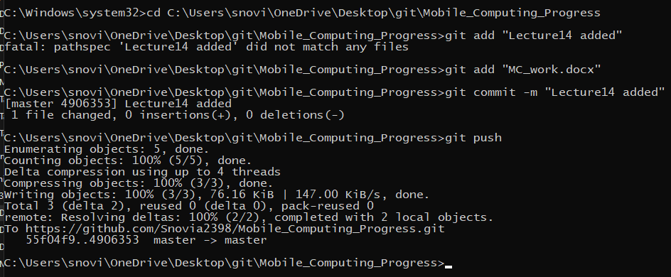

Added:

